Energy2D Overview
Install Energy2D from here: https://energy.concord.org/energy2d/download.html
Download the Energy2D files:
https://www.dropbox.com/s/aazffbibzjq6r5g/laws.e2d?dl=0
https://www.dropbox.com/s/flx52onqtgd4nrx/compare-conductivity.e2d?dl=0
The following pages will help get you familiar with the functionality within Energy2D. The laws file is to be used to get familiar with functionality. Once completed, open the compare-conductivity file and play around with the simulation there.
Open the file “laws”. You will see this screen. 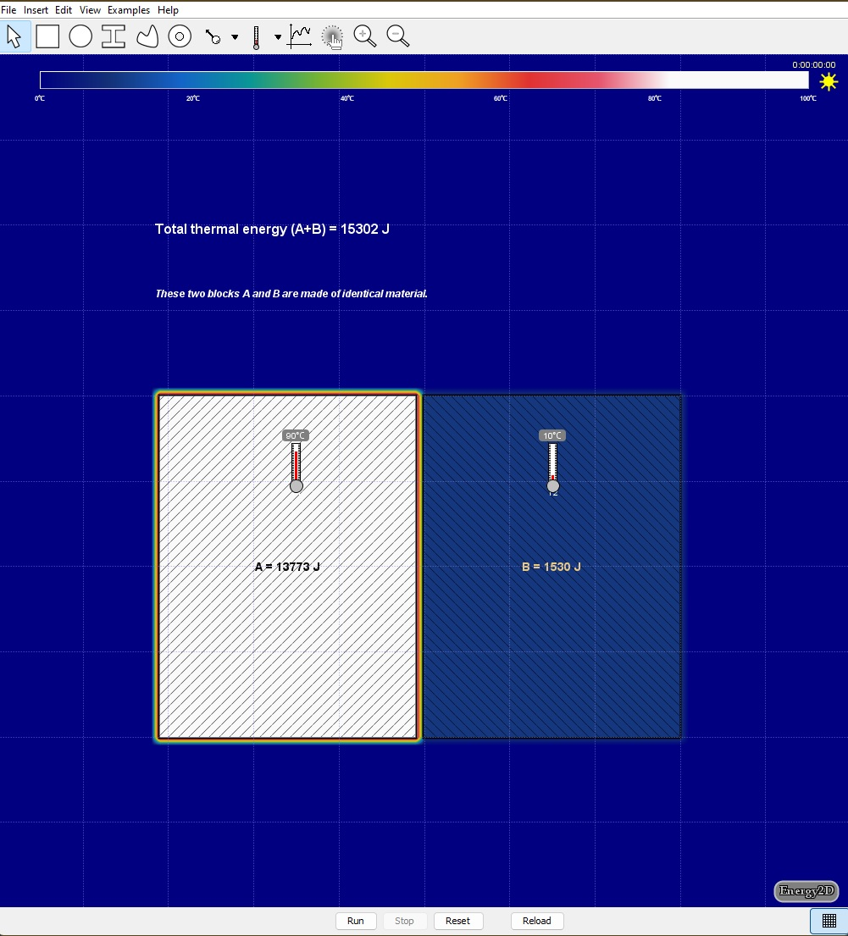
This is the Energy 2D interface. The shapes allow the user to draw objects, insert objects, and overlay a graph. At the bottom, user controls are available.

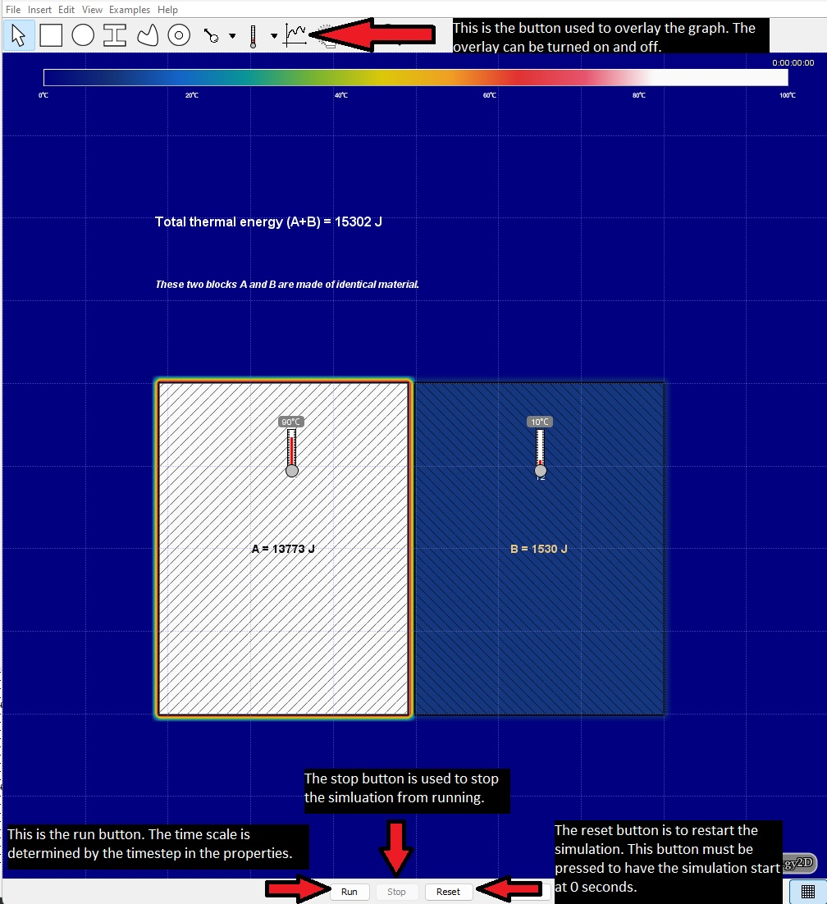
As seen in the picture, the buttons that we will need to know are highlighted by the arrows. Being familiar with running a simulation, stopping it, resetting it, and overlaying the graphs are required.
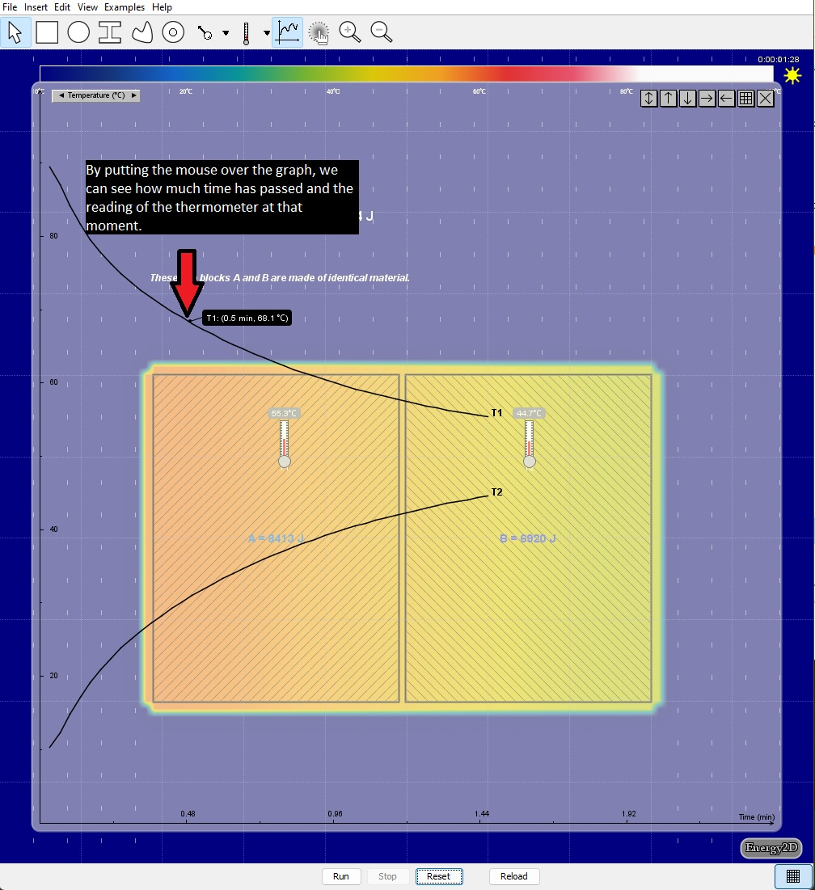
With the graph overlay up, we can the temperature on the Y-axis and the time on the X-axis. If we take the mouse and put the cursor over the graph line, we are able to see the exact temperature and time at that given moment.
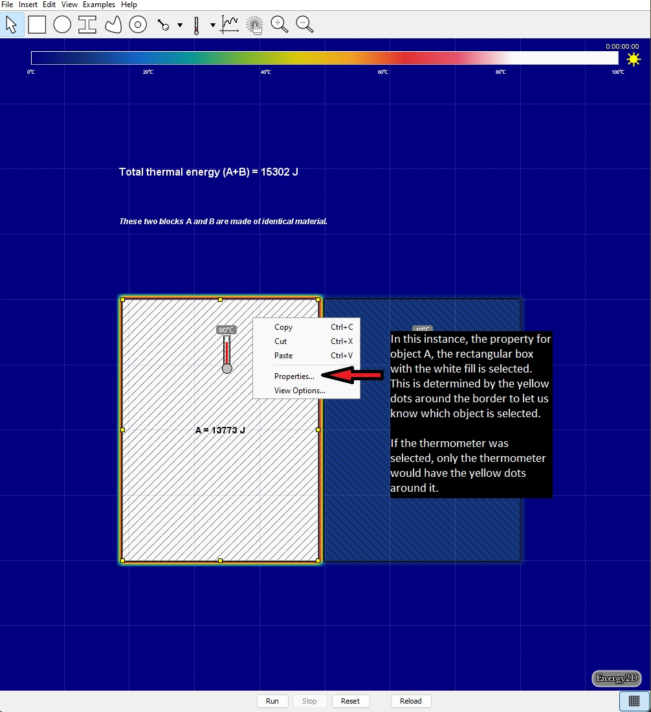
One additional thing that we will need to be familiar with is the property menu. Every object in Energy 2D, including things like thermometers have property fields associated with them. They can be accessed by right-clicking the object and selecting property.
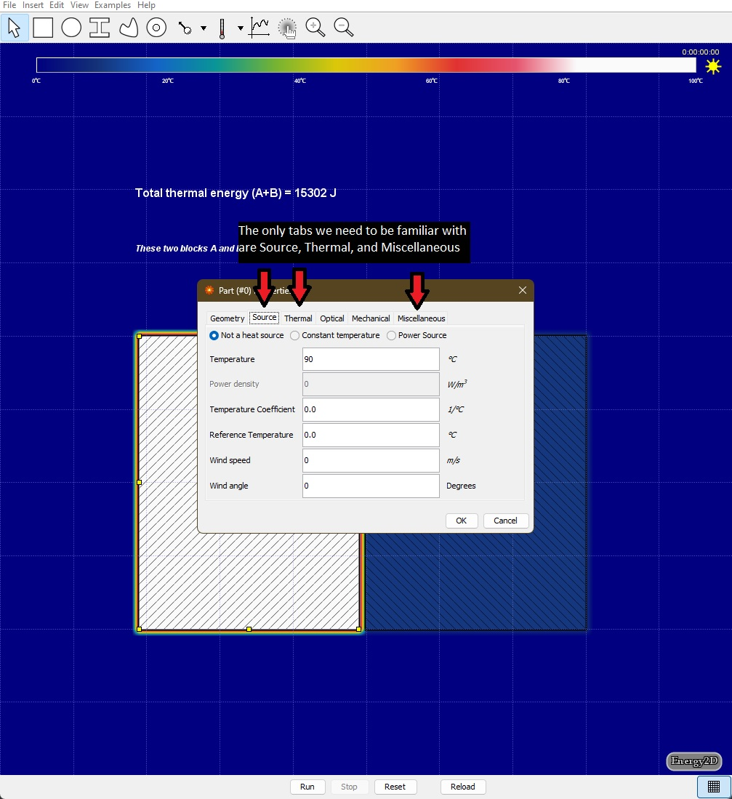
In the properties windows, source is how we set the temperature of the object. The thermal tab is how to set the thermal conductivity, heat, and density of the object. This website is used to get data for the thermal tab: https://thermtest.com/thermal-resources/materials-database. Students will be given a simplified handout version of this with a select number of materials. The miscellaneous tab is used to label the objects.
Play around with the simulation and change values to see what happens. If anything “breaks” simply hit the “reload” button at the bottom or exit the software and re-open the file.

