Hypersonics
Understanding Heat Flow

Name:

Hypersonics

Take the Play-Doh at your table and create whatever comes to mind when you read the Hypersonic. You may also draw in the space below instead of creating with the Play-Doh. (15-20 minutes)
This introduction serves to as an informal assessment on prior knowledge related to the concepts around thermodynamics. There are no required words for this activity, but some examples could include the following: heat, flow, energy, hyper, and sonic. Allow students up to 5 minutes per word. Have students share what they have created and how they made those connections. The last two words of this activity are “hyper” and “sonic”.
- After having students share their understanding of the words hyper and sonic, ask students “what does hypersonic mean?”
  - Explain to students, hypersonic is in reference to a speed above Mach 5. When people say “speed of sound” they are referring to Mach 1. So hypersonic speed is 5 times faster than that.
    - Another way to think about that is, a normal flight across the United States is about 5-6 hours. At hypersonic speed, that would only take 30 minutes!
- Explain to students that hypersonic sonic has one big problem. Ask students what do they think happens what happens when something goes super fast.
  - If students are having trouble, ask students what happens when they rub their hands together fast. (They should be getting hot. Looking for the answer friction)
  - Ask students, “What happens when something is going super fast and also becoming super hot?”
    - Looking for the answer explosions or disintegration.
    - Explain to students that objects aren’t really meant to stay together at these speeds, but we’ve been dealing with this problem since the 1960s.
    - Ask students if they know of anything that travels at these types of speeds (looking for space shuttles).
      - Humans have been studying the role of hypersonic flow, because we want our space crews to return safely after going to and back from space. Space shuttles actually go up to Mach 25, which is beyond hypersonic speeds and yet return safely. Companies like SpaceX and Blue Origin are now trying to figure out how to do reusable parts space flight.
*Transition to the mug demonstration*
Take your heat plate(s) set them to 40-50C. Allow students to touch and feel the mugs before making their predictions. Place one ice cube inside after predictions are made on page 3.
PART I – What is Hypersonics? What are the challenges?
GOAL: To define Hypersonic, identify why it is difficult, and understand the challenges apply elsewhere. (20 minutes total)
MATERIALS
- Computer with Energy2D installed (PC, Linux, Mac)
- Heat plate
- 3-4 Mugs of same volume, but different material
- Ice cubes
- Pen/Pencil

o 1. Looking at the four different mugs, rank the order at which the ice cube will melt. 1 being last to melt and 4 being first to melt. What information are you using to make your prediction?
Copper | Ceramic | Glass | Stainless Steel
4 | 2 | 1 | 3

o 2. While the mugs are heating up on the heat plate, open the “laws” file. It will open the app Energy2D with a blue grid and two blocks on it. (10 minutes)
Use this time to allow students to get familiar with the simulation software.
Energy in Block A | Temperature in Block A | Energy in Block B | Temperature in Block B | Total Energy
13773 J | 90 C | 1530 J | 10 C | 15302 J

o 3. Click “Run” at the bottom. Wait for the timer to reach 5 minutes. It can be seen on the top right.

o 4. Fill out the table again.
Energy in Block A | Temperature in Block A | Energy in Block B | Temperature in Block B | Total Energy
7657 J | 50 C | 7644 J | 49.9 C | 15302 J

o 5. Did the energy change in Block A and Block B? If so, how did it change?
Energy in Block A decreased while energy in Block B increased. Energy between the two blocks became closer to each other.
o 6. Did the total energy between Block A and Block B change?
No, total energy remained the same between Block A and Block B.
What you just simulated with energy is the 1st Law of Thermodynamics, energy cannot be created or destroyed.
o 7. Did the temperature in Block A and Block B change? If so, how did it change?
Temperature in Block A decreased while temperature in Block B increased. Temperature between the two blocks became about the same.
What you have noticed with the temperature is connected to the 2nd Law of Thermodynamics, heat flow always moves from hot to cold unless energy is supplied to reverse the direction. Between our two blocks that are touching, heat flows from Block A to Block B until equilibrium is reached. Block B is getting heated up by Block A to equilibrium.

o 8. What conclusion can you make about energy and temperature over time based on this simulation?
Over time, energy and temperature come to an equilibrium.

o 9. Open the “compare-conductivity” file. You will see 4 bars of different materials in the simulation and two blocks in the bottom corners. Click and drag the bars to connect the two blocks to compare the conductivity of the materials. When you are ready to compare, click “Run” at the bottom. (10 minutes)
Check on the demonstration mugs. If the ice is melting significantly enough to show a difference between them, have students come up and look at the mugs to then fill out the table in question 12.
o 10. Rank the materials again from the simulation. 1 for the material that was the least conductive (last to turn white) and 4 for the material that was most conductive (first to turn white).
Copper | Ceramic | Glass | Stainless Steel
4 | 2 | 1 | 3
o 11. Did the simulation match the demonstration? If not, what was different and why do you think it was different?

o 12. Let’s go back to the mugs and heat plate. Record the results of the ice cubes melting in the mug. 1 being last to melt and 4 being first to melt.
Copper | Ceramic | Glass | Stainless Steel
4 | 2 | 1 | 3

o 13. Did your prediction match your results? Was there anything surprising about the results?

PART II – Design Your Water Flask
GOAL: To design a space shuttle hull that will keep the astronauts safe inside for 30 seconds (stay below 121°C). (35 minutes)
MATERIALS
- Computer with Energy2D installed (PC, Linux, Mac)
- Pen/Pencil
- Stopwatch/Cellphone

o 1. Open the “design” file. You will see various thin bars of materials. You will be designing a cross-section of a space shuttle (real space shuttles are less than an inch thick!). Your task is to design a space shuttle hull that will keep the astronauts safe inside for at least 30 seconds. Ambient temperature inside the space shuttle is roughly 70-75°F, or around 21°C, and space suits are meant to withstand up to 250°F, or 121°C. You may test as many times as you want. Record the results of at least three of your designs. You will write down the materials you used for each layer and how long it took for the interior of your space shuttle to go above 121°C.
o 2. Look at our layout for the space shuttle design simulation. At the top, you will see different sets of bars. Grey bars represent the body of the space shuttle, the purple bars represent the tiles that serve as a heat shield for the space shuttle.
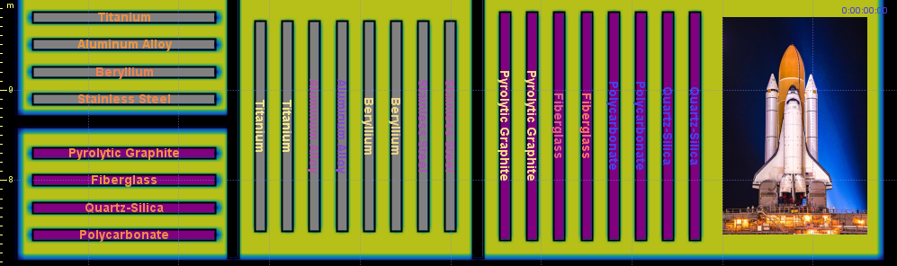

o 3. At the bottom of our model, we have out cross-section layout. Pay attention to how the grey bars are on the inner layer of the cross section and the purple bars are on the outer layer of the cross section. You will be placing your materials on top of the grey and purple bars already put there for you.
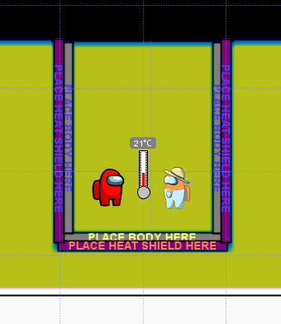
o 4. Here is an example of what it will look like after you drag your bars over the design platform. You do NOT need to use the same material for all parts of the cross-section. The only rule is that hull materials (grey bars) must be on the inner layer and the tile materials (purple bars) must be on the outer layer.
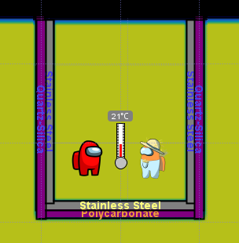
o 5. Once you have placed your materials for your space shuttle, write down your materials on the table. Now grab a stopwatch or use your phone. Start the timer when you click run. After 30 seconds, hit stop and record the observed temperature on the thermometer. You have about 25 minutes to design and test your space shuttle. (25 minutes)
Design # | Left Layer Combination (Outer/Inner) | Cone Layer Combination (Outer/Inner) | Right Layer Combination (Outer/Inner) | Temperature after 30 seconds (C°)
1 | Quartz-Silica/Stainless Steel | Polycarbonate/Stainless Steel | Quartz-Silica/Stainless Steel | 151° C
2
3

Conclusions (5 minutes)

Which combination of materials worked best for your design? What was the lowest temperature you were able to record after 30 seconds?

Varying combinations will net students different results. Most important is the cone/front of the space shuttle needs to have best insulation.

Did the thermal properties of any the materials stand out? If so, which ones and why?

Beryllium and titanium have the lowest thermal conductivity for the hull. Fiberglass has the lowest for the tiles. Pyrolytic graphite and polycarbonate are very similar in thermal conductivity.

Ask students where else they might see the need for insulation like this. (Thermos)

Final Takeaway (5 minutes)

Take the Play-Doh at your table and this time create what comes to mind given the question, “Why is heat transfer important?” or “Why do we want to keep things from getting too hot?” You may also draw in the space below if you do not want to create with the Play-Doh.

Just like beginning of activity, allow students to design and share. Ask students to why we care about heat transfer when it relates to speed and people. What benefits can society have from stopping very fast things from exploding? Think transportation. Another example is their cell phones overheating and the materials we use that conduct electricity.

