LESSON: River Crossing (Grades 2-3, 7-8)
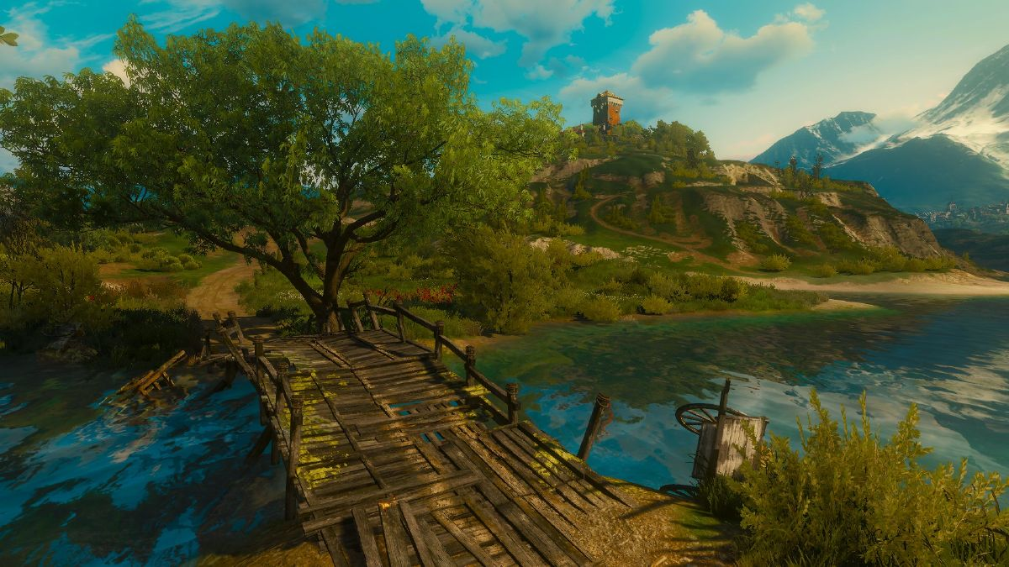
+ OVERVIEW
This Photo by Unknown Author is licensed under CC BY-SA
In this design challenge, students will learn about the history of westward expansion in the United States and the difficulties that migrants faced while traveling. Students will be presented with a scenario, which is crossing a river with all of their belongings, that many migrants faced when traveling west. The students will be presented with the following problem: In search of new beginnings, the Jacksons are on a journey to West Texas. However, they have come across a river that is too deep to cross with their wagon alone. The Jacksons must figure out how to get across the river to continue their journey. Students will put on their engineering hats to build a bridge that can safely deliver travelers across the river. Bonus points will be awarded to those who are able to add additional cargo to their wagon and successfully travel across the river.
+Current science TEKS covered in this design challenge
Grade 2 TEKS 2.5C, 2.5D
+ New Science TEKS covered in this design challenge (implementation 2024-2025)
Grade 2 TEKS: 2.6B, 2.6C
Grade 3 TEKS: 3.6D, 3.7B

+ Social Studies TEKS covered in this design challenge
Grade 7 TEKS: 7.10A
Grade 8 TEKS: 8.6B
+Math TEKS covered in this design challenge
Grade 2 TEKS 2.2B, 2.4A, 2.9D
Grade 3 TEKS 3.4A, 3.4G

+ The students will be able to meet the following objectives:
- Explain how physical properties can be changed through processes such as cutting, folding, sanding, melting, or freezing
- Demonstrate and explain how position and motion can be changed by pushing and pulling objects such as swings, balls, and wagons
- Combine materials to make a strong structure
- Demonstrate that small units can be combined or reassembled to form new objects for different purposes
- Explain the materials chosen based on their physical properties
- Add and subtract up to 100
- Multiply a two-digit number by a one-digit number
- Solve problems that deal with money
- Identify why migrant groups came to Texas and where they settled
- Understand the westward growth of the United States, including the Louisiana Purchase and Manifest Destiny
- Solve a problem using the engineering design process

+ Students will use the following STEM fluency skills:
- Communication
- Collaboration
- Creativity
- Critical Thinking
- Resilience
- Time/Resource Management
- Innovation
- Adaptability
+ Materials needed for this design challenge:

Grade 2 Grades 3, 7-8
- Wagon Free Free
- Cart Free N/A
- Small Popsicle Sticks 1 counter for 10 $10 for 10
- Large Popsicle Sticks 3 counters for 10 $30 for 10
- Straws 1 counter $10
- Glue 2 counters $20
- Tape 3 counters $30
- Rubber Bands 1 counter for 10 $10 for 10
- Chenille Stick 1 counter $10
- String 1 per 12 inches $10 per 12 inches
- Foam Sheet 2 counters $20
- Scissors 2 counters $20

+ Facilitator materials:

- Projector
- Computer
- Slide deck for the lesson
- Copies of the scorecard per group
- Two stacks of textbooks
- Toy car or wagon with a string attached to pull
- Cart to be attached to a wagon (for grade 2 only)
- Weights to be used for the carts
- Ruler to measure out the string

+ FACILITATION GUIDE
SECTION | PROCEDURE
INTRODUCTION | Slide 1: River Crossing  - Introduce today’s lesson on bridges and crossing rivers.  Slide 2: Westward Expansion  - Ask students to look at the map of the United States in 1800.  - Explain to students that, at this time, most people were farming or making goods that needed to be sold to other areas of the United States and to other countries.  - Ask students the question: What difficulties do you think farmers in western Kentucky faced that wouldn’t be experienced in coastal states?  - Explain to students that some trading occurred overseas, which meant getting your crops or goods to a port city on a coast. Transporting goods over land was a timely and costly process.  - Explain to students that one result of the Louisiana Purchase was to help give non-coastal states access to the Mississippi River and its port in New Orleans, Louisiana.  - Ask students the question: Why, after the Louisiana Purchase, did more people move west?  - Explain to students that from 1800 to 1860, the West held opportunities for people to make more money and create a new life for themselves.  - Many groups moved to the West in search of new opportunities. For example, some African Americans moved to establish new lives for their families after the Civil War. Ask students the question: With people moving west into unsettled regions, what difficulties do you think they experienced? Explain to students that much of this region was not developed, meaning there were few roads to travel on, shelters to stop at, or places to restock food. Many would also have to cross rivers along their travels that were too deep for their wagons to cross.  Slide 3: Types of Bridges  - Ask students if they know of any famous bridges. What is the purpose of a bridge? What do bridges you have seen look like?  - Explain that there are seven main types of bridges: arch, beam, cable-stayed, cantilever, suspension, truss, and tied arch.  - Go over each type of bridge with students and ask if they remember seeing a similar type of bridge somewhere before.  - The arch bridge is comprised of an arch supported on either end by supports called abutments.  - The beam bridge consists of a horizontal beam that is supported at each end by piers.  - The cable-stayed bridge includes one or more towers with cables (stays) connecting directly to the bridge deck.  - The cantilever bridge uses horizontal beams that are supported on only one end, usually a pier.  - The suspension bridge includes a roadway suspended by cables. The main cables are attached to towers at each end of the structure.  - The truss bridge structure is composed of many connecting elements, usually forming triangular units.  - The tied arch bridge combines features of beam and suspension bridges. There is usually an arch above the roadway with cables that connect directly down onto the roadway.  - Ask students what they think is the strongest bridge type. (Truss is considered the strongest type when considering strength-to-weight ratio.)  - Explain to students that each type of bridge has advantages and disadvantages. For example, a beam bridge is the simplest and quickest to build, a suspension bridge allows for tall heights and long distances, truss bridges have a lot of strength, etc.  Slide 4: Engineering Design  - Ask students the question. What is engineering?  - Explain to students that engineering is when engineers apply what they know to solve problems by designing a product or process.  - For example, telephones could only be used at home or in specific locations. Why is this a problem? (Needing to make a call outside the home). What solution did engineers design to fix that problem? (Cell phones).  Slide 5: Engineering Design  - Ask students the question. What are some examples of engineering jobs?  - Teacher’s Note: If students have trouble giving examples, ask students who they think makes the things they use. Who makes refrigerators, cars, helmets, cell phones, and sneakers?  Slides 6-8: Engineering Jobs  - Show students pictures related to engineering jobs connected to the challenge.  - Civil Engineering  - Ask students what they see in the pictures.  - Civil engineers use math and a type of science called physics to design, construct, and maintain the physical and natural environment, to help society They help bring water and electricity to buildings and help build transportation infrastructure like bridges, railroads, and airports.  - Structural Engineering  - Ask students what they see in the pictures.  - Structural engineers ensure that buildings and bridges can meet the intended design loads and withstand environmental effects like salt, strong winds, earthquakes, rain, and snow. When working with bridges structural engineers ensure bridges continue to work long after they are built.  - Geotechnical Engineering  - Ask students what they see in the pictures.  - Geotechnical engineers use their knowledge of soil and rock to solve problems. It is through understanding the land and subsurface materials and conditions that geotechnical engineers can help figure out how to best support a bridge when being built.  Slide 9: Engineering Design  - Ask students the question: who can be an engineer?  - Anyone!  Slide 10: Engineering Design Process  - Ask students if they think all engineers solve their problems in one try. Explain to students that getting something correct in engineering takes many tries. In engineering, there is no such thing as a mistake, only opportunities to learn. It is okay to fail. Just find the mistake and correct it. In engineering, there is never one correct solution. There are always many solutions to a problem and always improvements that can be made. The steps that engineers take to find these solutions are called the engineering design process.  - Ask students to read the first big step (Identify)  - What does identify mean? (To point out or find). Engineers design solutions; what do they need to know first before they can find the answer? (Problem)  - How do people know when they have found the correct answer? In engineering, there are no correct answers, just better ones. Explain to students that there are expectations that engineers must meet called criteria. For example, what does an engineer need to do when engineering a football? (Bounce, look a certain way, have laces, have air inside, etc.). Those things are all called criteria; by comparing the design to the criteria, an engineer knows a solution will work. Is a child-sized football the same as an adult football? The criteria for both footballs include leather, white laces for fingers, and the shape. However, the two footballs would have different criteria for size. The footballs are similar but different because of different criteria.  - Once the criteria are understood for the design challenge, what could make it difficult for an engineer to design their solution? (Money, time, materials, etc.) Explain to students that these rules are called constraints or rules that engineers must follow. Engineers are given constraints they must follow when finding the solution to a problem. Think about football again; what are college and professional footballs made from? (Leather). What if the rule (or constraint) was to not use leather, could another type of football be made instead? Many of the footballs for sale are made of rubber because the engineer had different constraints.  - Ask students to read the next step (Imagine)  - Ask students what imagine, or imagination, means. Are these things real or tangible? They may not be real, but they help give us ideas about what things could be. In this step, see what materials are available, then brainstorm or think about possible ideas/solutions to the problems.  - Explain to students that there are no right answers in engineering. Start with as many ideas as possible.  - Ask students to read the next step (Plan)  - The third step of the engineering design process is planning the idea. Make sure that what is designed can be repeated. A plan will help an engineer identify where mistakes happen so they can be fixed.  - When planning, begin with the brainstorming phase. Each team member will contribute their ideas, and then the team combines the different ideas!  - Once ideas are combined into a single group idea, determine what materials will be used for the solution and make sure the design has met the criteria and constraints of the project.  - Ask students to read the next step (Create)  - The fourth step is to create! Since this is the very first creation, it is called a prototype. A prototype is a first or preliminary model of something from which other forms are developed or copied. A prototype is created to test the engineer’s idea or concept. Engineers ask themselves, “Did the idea work the way we wanted it to?” After testing the idea, the engineer will make improvements to the prototype.  - Ask students to read the last step (Improve)  - Finally, the last step is to improve. How does an engineer know if the prototype did well on the test? It must meet certain expectations and follow some rules. But how do engineers determine how well it met the expectations and how well it followed the rules? In school, how do you know if you mastered something? (Grades). The prototypes made today will be scored using a scorecard or rubric. By looking at the score, each team will determine if the design could be better. If improvements should be made, the team will revisit the plan and decide how to improve the score. Remember, there are no correct answers in engineering, just better solutions.
IDENTIFY | Slides 11-12: Identify - Problem  - Have students read the bolded section.  - Ask students to identify the problem.  - Explain to students that they will put on their engineering hats to build a bridge that will allow people to travel across the river safely.  Slide 13: Identify - Criteria (Desired Outcomes)  - Ask students what criteria or desired outcomes mean.  - Explain to students those criteria are what engineers use to determine if they are successful.  - Ask students what determines if the solution is successful today.  - The bridge must meet the following criteria:  - Span across the river  - Support the weight of the wagon and cart  - Allow for the transportation of the wagon and cart  - Stay together while being used  Bonus points will be awarded if the bridge is able to support heavier loads.  - Teacher’s Note: For grades 3, 7, and 8, students will not be given a cart for their wagon. They will need to build the cart that gets attached to the wagon.  Slides 14-17: Identify - Constraints (Limitations) *Instructional Note: Hide the slides that are not relevant to the grade level you are instructing*  - Ask students what constraints or limitations mean.  - Explain to students those constraints are rules the engineers must follow.  - Explain the constraints for this engineering design activity are the following:  - Time Limit: Students will have 30 minutes to build the bridge (and cart for grades 3, 7, and 8).  - Materials: Students may only use the available materials.  - Budget: Students will have $200 to complete this challenge.  - Teacher’s Note: For grade 2, 10 counters will be given to each group. Pre-bag the counters for easy distribution to each group. When students go to the supply table, they will hand the teacher one counter for each item they buy.  - Collaboration: One design element from each team member must be used in the final design. Explain to students that a design element is taking one part of someone’s idea and adding it to another.  - Redesign: Each team can test their prototype as many times as needed during the 30-minute design phase. Remind students what a prototype is. It is the first creation of our design.  - Teacher’s Note: When a team is ready to test their design, they should raise their hand, and the teacher should assist the team with their score. If the team receives a low score on any part of the design, the team should redesign if they still have time.
IMAGINE | Slides 18-19: Imagine - Explore Materials  * Instructional Note: Hide the slides that are not relevant to the grade level you are instructing*  - Students will be presented with the materials needed to build their bridge (and cart for grades 3, 7, and 8). The teacher or facilitator will hold up the wagon that will be used. It will be attached to the demonstration cart. The teacher or facilitator should show how the wagon and cart will travel by pulling the wagon with string. Let students know there are additional points available if their bridge is able to support additional weight loaded onto the cart.  - Teacher’s Note: It is up to the teacher or facilitator to determine how to represent the river. The easiest method would be stacking textbooks to create the width of the river that needs to be crossed and maintain a dry environment (see Image 1 below). A tub of water can also be used with stacked textbooks outside the end of the tub to model the river crossing (see Image 2 below).  - Image 1  - Image 2  Slide 20: Imagine - Brainstorm  - Give students 1 minute to individually design and draw a plan of what they think their bridge (and cart for grades 3, 7, and 8) should look like. Emphasize that students should not talk during this minute or share ideas. Remind students that their ideas will be used as design elements for the final design.  - After a minute, give students 5 minutes to present and share their ideas with their group. Let students know that they should focus on key aspects of their idea that they like and want to be used as design elements for the final design when sharing.  - Teacher’s Note: If students are struggling with an idea for their design, provide ideas without giving a solution. For example, “This is a design that I tried earlier but failed. What could I do to improve it?” Emphasize that the design failed to reinforce that it is okay to fail and to let students know they cannot copy the design and expect success.
PLAN | Slide 21: Plan - Plan Development  - Hand out the scorecard that will be used during the design challenge. Review the testing criteria with the class and answer questions. The testing criteria will inform their design decisions.  - Have students collaborate to come up with a final design. Let students know they must include at least one element from each team member for their final design.  - Ask students again what the design criteria are:  - The bridge must include the following:  - Span across the river  - Support the weight of the wagon and cart  - Allow for the transportation of the wagon and cart  - Stay together while being used  Bonus points will be awarded if the bridge is able to support heavier loads.  - Students will need to select the materials to be used for the design and develop a budget for the project. Students will have $200 (or 10 counters for grade 2) to purchase materials for their build at the classroom supply table. The prices used in this challenge can be found in the materials list. Students will raise their hands when they are ready to purchase materials. The teacher will make sure the appropriate amount of money is spent on purchasing each material but will not guide students on following their budget. Students can go over budget if they want to but remind them that they will lose points on their scorecard.  Slide 22-23: Plan - Team Member Responsibilities  ** Instructional Note: Hide the slides that are not relevant to the grade level you are instructing.  - Each team member must be given responsibility, such as materials manager, banker, head engineer, and quality control manager.
CREATE | Slide 24: Create - Design Your Bridge  - Let students know to have fun, be creative with their designs, and work together.  - Remind students that being an engineer is not about getting the solution on the first try. There is no right answer, just better solutions.  Slide 25: Identify - Criteria  - Reminder slide for students to look at while working.  Slides 26-29: Create - Test  ** Instructional Note: Hide the slides that are not relevant to the grade level you are instructing.  - Students will calculate their scores when testing in front of the teacher or facilitator. The teacher or facilitator will go through each of the categories on the scorecard with the students. The students will mark their scores and calculate the total.  - The teacher or facilitator will recap the point total with the students and how many points the team received for each category to make sure it matches with what the students recorded.  - Students should explain how they are adjusting to either increase the strength of their bridge (or the stability of the cart for grades 3, 7, and 8).
IMPROVE | Slide 30: Improve - Redesign: Discussion  - Students will reflect on their score and discuss:  - What worked?  - Teacher’s Note: Focus on the materials being used and ask why they think those materials were helpful. Have students compare designs and see what seemed to work best and why. Ask students how they could reinforce their bridge to make it stronger.  - What did not work?  - Teacher’s Note: Focus on the materials being used and ask why they think those materials did not work as well. Have students compare their designs and what seemed to create difficulties and why. Ask students where they think the weak points are on their bridge.  - What do you want to improve?  - Teacher’s Note: Focus on engineering aspects with students. Ask students why they were designing a prosthesis. Ask students if they found a solution or just part of one. Reinforce that it is okay not to succeed on the first try and that engineering is about making improvements over time. Ask students if they would design their bridge (and carts) differently if they had no rules, how? Ask students if working together was difficult. Learning to work together is very important and it is easier to find a solution with many ideas rather than just one idea.  This challenge was inspired by a lesson written by Jack Raspberry, an education student at Texas Tech University.

