LESSON: Stable Figures (Grades 3-5)
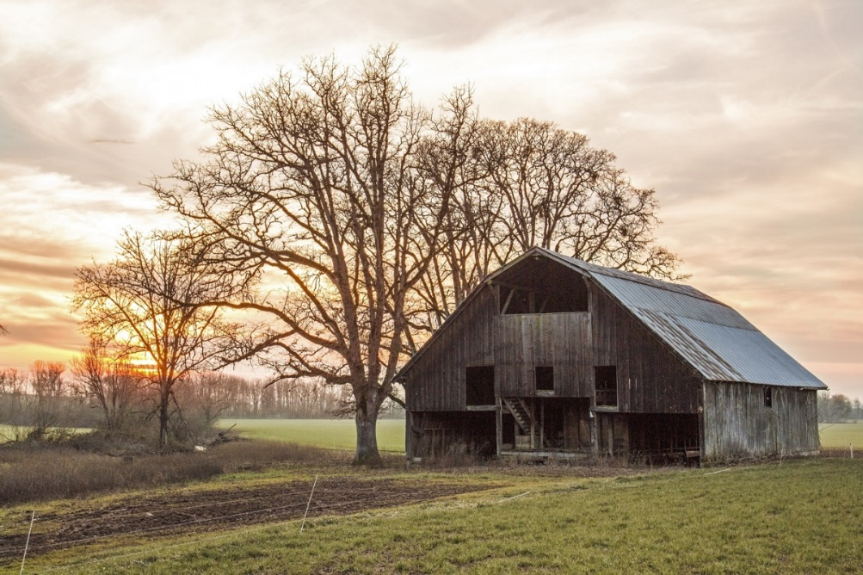
+ OVERVIEW
In this design challenge, students will review a variety of mathematical equations and concepts. The students will then be presented with the following problem: The Jeffersons, a retired couple, are thinking about purchasing 2 horses, 5 chickens, and 3 pigs for their farm. They have already begun the process of purchasing the animals; however, they don’t want to go any further without securing a construction company to build their dream barn. Today, you will put on your engineering hat to design and create the initial design for the Jeffersons’ dream barn. They are looking for a group that can give them the best value. The Jeffersons’ dream barn should include shapes and angles that create a unique design and a large enough area and perimeter for livestock animals and should be strong enough to survive a windstorm.
This Photo by Unknown Author is licensed under CC BY-SA
This Photo by Unknown Author is licensed under CC BY-ND
This Photo by Unknown Author is licensed under CC BY-ND
+ Math TEKS covered in this design challenge
Grade 3 TEKS 3.1A, 3.1B, 3.1C, 3.1D, 3.2D, 3.3C, 3.4C, 3.4G, 3.4K, 3.6C, 3.7B, 3.9C
Grade 4 TEKS 4.1A, 4.1B, 4.1C, 4.1D, 4.4A, 4.4D, 4.5A, 4.5C, 4.5D, 4.6A, 4.6C, 4.8C
Grade 5 TEKS 5.1A, 5.1B, 5.1C, 5.2B, 5.4G, 5.4H, 5.6B
+ Current Science TEKS covered in this design challenge
Grade 3 TEKS 3.10A
Grade 4 TEKS 4.10A
Grade 5 TEKS 5.10A
+ New Science TEKS covered in this design challenge (implementation 2024-2025)
Grade 3 TEKS 3.1B, 3.1D, 3.1G, 3.2D, 3.3A, 3.3B, 3.3C, 3.4A
Grade 4 TEKS 4.1B, 4.1D, 4.1G, 4.2D, 4.3B, 4.4A
Grade 5 TEKS 5.1B, 5.1D, 5.1G, 5.2D, 5.3B, 5.4A
+ Students will use the following STEM fluency skills:
- Communication
- Collaboration
- Creativity
- Critical Thinking
- Resilience
- Time/Resource Management
- Innovation
- Adaptability
+ Materials needed for this design challenge:

Materials Cost
- Ruler No cost
- Popsicle Sticks (half/whole) $3/$5 per stick
- Straws (half/whole) $3/$5 per straw
- Thick Foam Sheet (half/whole) $25/$50 per sheet
- Cardboard (half/whole) $20/$40 per board
- Construction Paper $20 per sheet
- Aluminum Foil Sheet $25 per sheet
- Hot Glue Gun $75 per gun
- Hot Glue Sticks $5 per stick
- Duct Tape $50 per roll
- Scotch Tape $25 per roll
- Scissors $25 per pair

+ Materials needed by the facilitator:

- Computer
- Fan
- Projector
- Slide Deck for the Lesson
- Copies of the Scorecard (per group)
- Timing Device
- Graph Paper

+ FACILITATION GUIDE
SECTION | PROCEDURE
INTRODUCTION | Slide 1: Stable Figures  - Introduce today’s lesson on math concepts.  Slide 2: Engineering Design  - Ask students the question. What is engineering?  - Explain to students that engineering is when engineers take what they know and apply it to solve problems by designing a product or process.  - For example, telephones could only be used at home or in specific locations. Why is this a problem? (Needing to make a call outside the home). What solution did engineers design to fix that problem? (Cell phones).  Slide 3: Engineering Design  - Ask students the question. What are some examples of engineering jobs?  - Teacher’s Note: If students have trouble giving examples, ask students who they think makes the things they use. Who makes refrigerators, cars, helmets, cell phones, and sneakers?  Slides 4-5: Engineering Jobs  - Show students pictures related to engineering jobs connected to the challenge.  - Structural Engineering  - Ask students what they see in the pictures.  - Explain to students that a structural engineer analyzes designs and the structural support systems for buildings, bridges, tunnels, and other structures.  - Civil Engineering  - Ask students what they see in the pictures. Ask them: How does civil engineering look different from architecture?  - Explain to students that what they see in the pictures is called civil engineering. Architects and civil engineers are also different because while architects mainly focus on buildings, civil engineers will build many structures like bridges, highways, towers, and water systems! While architecture combines art and science to build buildings, civil engineers use math and a type of science called physics to design, construct, and maintain the physical and natural environment to help people. In this case, they are constructing a barn to protect the animals.  Slide 6: Engineering Design  - Ask students the question: who can be an engineer?  - Anyone!  Slide 7: Engineering Design Process Steps  - Ask students if they think all engineers solve their problems in one try. Explain to students that getting something correct in engineering takes many tries. In engineering, there is no such thing as a mistake, only opportunities to learn. It is okay to fail. Just find the mistake and correct it. In engineering, there is never one correct solution. There are always many solutions to a problem and always improvements that can be made. The steps that engineers take to find these solutions are called the engineering design process.  - Ask students to read the first big step (Identify)  - What does identify mean? (To point out or find). Engineers design solutions: what do they need to know first before they can find the answer? (The problem)  - How do people know when they have found the correct answer? In engineering, there are no correct answers, just better ones. Explain to students that there are expectations that engineers must meet called criteria. For example, what does a football need to do when engineering a football? (Bounce, look a certain way, have laces, have air inside, etc.). Those things are all called criteria. An engineer knows a solution will work by comparing the design to the criteria. Is a child-sized football the same as an adult football? The criteria for both footballs include leather, white laces for fingers, and the shape. However, the two footballs would have different criteria for the size. The footballs are similar but different because of different criteria.  - Once the criteria are understood for the design challenge, what could make it difficult for an engineer to design their solution? (Money, time, materials, etc.) Explain to students that these rules are called constraints or rules that engineers must follow. Engineers are given constraints they must follow when finding the solution to a problem. Think about football again; what are college and professional footballs made from? (Leather). If the rule (or constraint) was to not use leather, could another type of football be made instead? Many of the footballs for sale are made of rubber because the engineer had different constraints.  - Ask students to read the next step (Imagine)  - Ask students what imagine, or imagination, means. Are these things real or tangible? They may not be real, but they help give us ideas about what things could be. In this step, see what materials are available, then brainstorm or think about possible ideas/solutions to the problems.  - Explain to students that there are no right answers in engineering. Start with as many ideas as possible.  - Ask students to read the next step (Plan)  - The third step of the engineering design process is planning the idea. Make sure that what is designed can be repeated. A plan will help an engineer identify where mistakes happen so they can be fixed.  - When planning, begin with the brainstorming phase. Each team member will contribute their ideas, and then the team combines the different ideas!  - Once ideas are combined into a single group idea, determine what materials will be used for the solution and make sure the design has met the criteria and constraints of the project.  - Ask students to read the next step (Create)  - The fourth step is to create! Since this is the very first creation, it is called a prototype. A prototype is a first or preliminary model of something from which other forms are developed or copied. A prototype is created to test the engineer’s idea or concept. Engineers ask themselves, “Did the idea work the way we wanted it to?” After testing the idea, the engineer will make improvements to the prototype.  - Ask students to read the last step (Improve)  - Finally, the last step is to improve. How does an engineer know if the prototype did well on the test? It must meet certain expectations and follow some rules. But how do engineers determine how well it met the expectations and how well it followed the rules? In school, how do you know if you have mastered something? (Grades). The prototypes made today will be scored using a scorecard or rubric. By looking at the score, each team will determine if the design could be better. If improvements should be made, the team will revisit the plan and decide how to improve the score. Remember, there are no correct answers in engineering, just better solutions.
IDENTIFY | Slides 8-9: Identify - Problem  - Have students read the bolded section.  - Ask students to identify the problem.  - Explain to students that they will put on their engineering hats today to build the Jefferson’s dream barn according to the project criteria.  Slides 10-15: Identify - Criteria (Desired Outcomes) (Different slide for each grade)  - Ask students what criteria or desired outcomes mean.  - Explain to students that those criteria are what engineers use to determine if they have successfully solved the engineering problem.  - Ask students how we will know if we are successful engineers today.  - (3rd Grade) In 10 minutes, design a barn that is in the shape of a polygon that includes:  - A perimeter greater than 50 inches  - An area of less than 200 square inches  - A roof  - A structure strong enough to survive a windstorm  - A floor plan  - Ask students how we will know if we are successful engineers today.  - (4th Grade) In 10 minutes, design a barn that includes:  - Separate pens for horses, pigs, and chickens  - A perimeter greater than 50 inches  - An area of less than 200 square inches  - Right, obtuse, and acute angles  - A structure strong enough to survive a windstorm (cannot tape to the table)  - A floor plan (area and perimeter)  - Ask students how we will know if we are successful engineers today.  - (5th Grade) In 15 minutes, design a barn that includes:  - Separate pens for horses, pigs, and chickens  - Provide students with the dimensions of the animal figures. Students must build pens based upon the dimensions of animal figures; they aren’t allowed to bring animal figures to their building area.  - A perimeter greater than 50 inches  - An area of less than 200 square inches  - A height that’s greater than or equal to 6 inches  - Right, obtuse, and acute angles  - A structure strong enough to survive a windstorm (cannot tape to the table)  - A floor plan (area and perimeter)  Bonus Points: Convert floor plan from sq. in. into sq. ft.  Slides 16-17: Identify - Constraints (Limitations)  - Ask students what constraints or limitations mean.  - Explain to students that those constraints are rules the engineers must follow.  - Explain the constraints for this engineering design activity are:  - Time Limit: Students will have 30 minutes to design their prototype.  - Materials: Students can only use the available materials.  - Budget: Students will have $500 to complete this challenge.  - Collaboration: One design element from each team member must be used in the final design. Explain to students that a design element is taking one part of someone’s idea and adding it to another.  - Redesign: Each team can test their prototype as many times as needed during the 30-minute design phase.  - Teacher Note: When a team is ready to test their design, they should raise their hand. The teacher will then ask them to test their design at the testing station. If a team received a low score on any part of the design, the team should redesign if they still have time.
IMAGINE | Slide 18: Imagine - Explore Materials  - Introduce materials to students by showing each item as you go through the materials list. Explain to students that when engineers describe items, they discuss properties like color, size, and flexibility.  Slide 19: Imagine - Brainstorm  - Give students one minute to individually design and draw a plan of what the barn will look like. Emphasize that students should not talk during this minute or share ideas. Remind students that their ideas will be used as design elements for the final design.  - After a minute, give students five minutes to present and share their ideas with the group. Let students know that they should focus on key aspects of their idea to be used as design elements for the final design when sharing.  - Teacher’s Note: If students struggle with an idea for their design, provide ideas without giving a solution. For example, “This is a design that I tried earlier but failed. What could I do to improve it?” Emphasize that the design failed to reinforce that it is okay to fail and to let students know they cannot copy the design and expect success.
PLAN | Slides 20-25: Plan - Plan Development  - Hand out the scorecard that will be used during the design challenge. Review the testing criteria with the class and answer questions. The testing criteria will inform their design decisions.  - Have students collaborate to come up with a final design. Let students know they must include at least one element from each team member for their final design.  - Ask students again what the design criteria are.  - Students will need to select the materials to be used for their design process and develop a budget for the project. Students will have $500 to purchase materials for their design at the classroom supply table. The prices used in this challenge can be found in the materials list. Students will raise their hands when they are ready to purchase materials.  Slide 26: Plan - Team Member Responsibilities  - Each team member must be given responsibility, such as project manager, structural engineer, architect, and construction finance manager.
CREATE | Slide 27: Create - Design Your Barn  - Let students know to have fun, be creative with their designs, and work together.  - Remind students that being an engineer is not about getting the solution on the first try. There is no right answer, just better solutions.  Slides 28-33: Create - Test  - Students will calculate their scores when testing in front of the teacher or facilitator.
IMPROVE | Slide 34: Improve - Discussion  - Students will reflect on their scores and discuss:  - Final Dimensions  - Teacher’s Note: Each group can discuss the final dimensions of their barn. Ask students why they chose the size that was built.  - Total Cost of supplies  - Teacher’s Note: Explain to students that budgeting is an important life skill. Ask students how they were able to save money throughout the process.  - Labor Cost  - Teacher’s Note: Discuss the meaning of labor. Allow students to explain the labor cost billed to the Jeffersons.  - Total Cost of Project  - Teachers Note: The Jeffersons were looking for the group that could give them the best bang for their buck. As a group, discuss the total cost for the Dream Barn project.  Slide 35: Improve - Redesign: Discussion  - Students will reflect on their scores and discuss:  - What worked?  - Teacher’s Note: Focus on the materials used and ask why they think they were helpful. Ask students what characteristics of the barn helped with the windstorm.  - What did not work?  - Teacher’s Note: Focus on the materials being used and ask why they think those materials did not work as well. Ask students what characteristics of the barn made it difficult to build.  - What do you want to improve?  - Teacher’s Note: Reinforce that it is okay not to succeed on the first try and that engineering is about making improvements over time. Ask students how they would design their barn differently if they had no rules? Ask students if working together was difficult. Learning to work together is very important and it is easier to find a solution with many ideas rather than just one idea.

