Hypersonics
Understanding Heat Flow

Name:

Hypersonics

Take the Play-Doh at your table and create whatever comes to mind when you read the word Hypersonic. You may also draw in the space below instead of creating with the Play-Doh.

PART I – What is Hypersonics? What are the challenges?
GOAL: To define Hypersonics, identify why it is so complex, and understand how the challenges apply elsewhere.
MATERIALS
- Computer with Energy2D installed (PC, Linux, Mac)
- Heat plate
- 3-4 Mugs of same volume, but different material
- Ice cubes
- Pen/Pencil

o 1. Looking at the four different mugs, rank the order in which the ice cubes will melt, with 1 being last to melt and 4 being first to melt. What information are you using to make your prediction?
Copper | Ceramic | Glass | Stainless Steel

o 2. While the mugs are heating up on the heat plate, open the “laws” file. It will open the app Energy2D with a blue grid and two blocks on it.
Energy in Block A | Temperature in Block A | Energy in Block B | Temperature in Block B | Total Energy

o 3. Click “Run” at the bottom. Wait for the timer to reach 5 minutes. It can be seen on the top right.
o 4. Fill out the table again.
Energy in Block A | Temperature in Block A | Energy in Block B | Temperature in Block B | Total Energy

o 5. Did the energy change in Block A and Block B? If so, how did it change?

o 6. Did the total energy between Block A and Block B change?

o 7. Did the temperature in Block A and Block B change? If so, how did it change?

o 8. What conclusion can you make about energy and temperature over time based on this simulation?

o 9. Open the “compare-conductivity” file. You will see 4 bars of different materials in the simulation and two blocks in the bottom corners. Click and drag the bars to connect the two blocks to compare the conductivity of the materials. When you are ready to compare, click “Run” at the bottom.

o 10. Rank the materials again from the simulation. 1 for the material that was the least conductive (last to turn white) and 4 for the material that was most conductive (first to turn white).
Copper | Ceramic | Glass | Stainless Steel

o 11. Did the simulation match the demonstration? If not, what was different and why do you think it was different?

o 12. Let’s go back to the mugs and heat plate. Record the results of the ice cubes melting in the mug. 1 being last to melt and 4 being first to melt.
Copper | Ceramic | Glass | Stainless Steel

o 13. Did your prediction match your results? Was there anything surprising about the results?

PART II – Design Your Space Shuttle
GOAL: To design a space shuttle hull that will keep the astronauts safe inside for 30 seconds (stay below 121°C).
MATERIALS
- Computer with Energy2D installed (PC, Linux, Mac)
- Pen/Pencil
- Stopwatch/Cellphone

o 1. Open the “design” file. You will see various thin bars of materials. You will be designing a cross-section of a space shuttle (real space shuttles are less than an inch thick!). Your task is to design a space shuttle hull that will keep the astronauts safe inside for at least 30 seconds. Ambient temperature inside the space shuttle is roughly 70-75°F, or around 21°C, and space suits are meant to withstand up to 250°F, or 121°C. You may test as many times as you want. Record the results of at least three of your designs. You will write down the materials you used for each layer and how long it took for the interior of your space shuttle to go above 121°C.

o 2. Look at our layout for the space shuttle design simulation. At the top, you will see different sets of bars. Grey bars represent the body of the space shuttle, the purple bars represent the tiles that serve as a heat shield for the space shuttle.
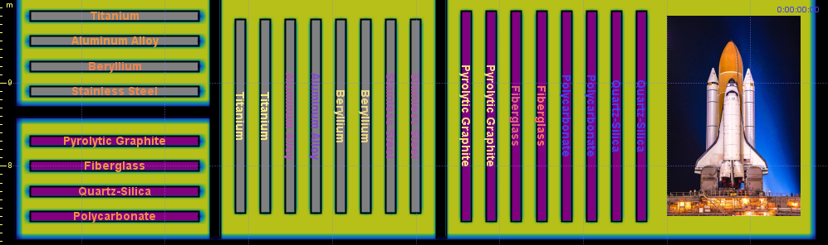

o 3. At the bottom of our model, we have our cross-section layout. Pay attention to how the grey bars are on the inner layer of the cross section and the purple bars are on the outer layer of the cross section. You will be placing your materials on top of the grey and purple bars already put there for you.
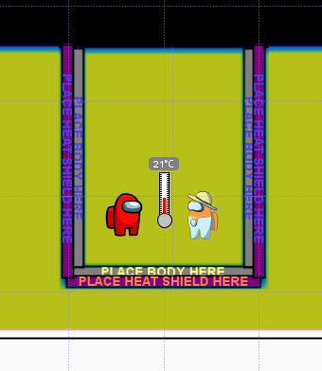
o 4. Here is an example of what your model will look like after you drag your bars over the design platform. You do NOT need to use the same material for all parts of the cross-section. The only rule is that hull materials (grey bars) must be on the inner layer and the tile materials (purple bars) must be on the outer layer.
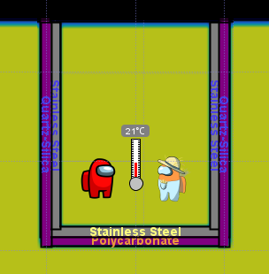
o 5. Once you have placed your materials for your space shuttle, write down your materials on the table. Now grab a stopwatch or use your phone. Start the timer when you click run. After 30 seconds, hit stop and record the observed temperature on the thermometer. You have about 25 minutes to design and test your space shuttle.
Design # | Left Layer Combination (Outer/Inner) | Cone Layer Combination (Outer/Inner) | Right Layer Combination (Outer/Inner) | Temperature after 30 seconds (C°)
1
2
3

Conclusions

Which combination of materials worked best for your design? What was the lowest temperature you were able to record after 30 seconds?

Did the thermal properties of any the materials stand out? If so, which ones and why?

Final Takeaway

Take the Play-Doh at your table and this time create what comes to mind given the question, “Why is heat transfer important?” or “Why do we want to keep things from getting too hot?” You may also draw in the space below if you do not want to create with the Play-Doh.

