|  |  |  |  |  |  |
| --- | --- | --- | --- | --- | --- |
| Name: | **[insert name]** | Period: | **[insert Period]** | Date: | **[insert date]** |

Atoms in Action

# Background

All things in the universe are made up of **matter**. Matter is just all the stuff that is around us from the planets, to our pets, and even us. Scientists found that all matter is made up of these tiny parts called **atoms.** Atoms are the smallest parts of all things.

Atoms are made up of three basic parts: electrons, protons, and neutrons. The proton and neutron are in the middle and the electrons circle around.

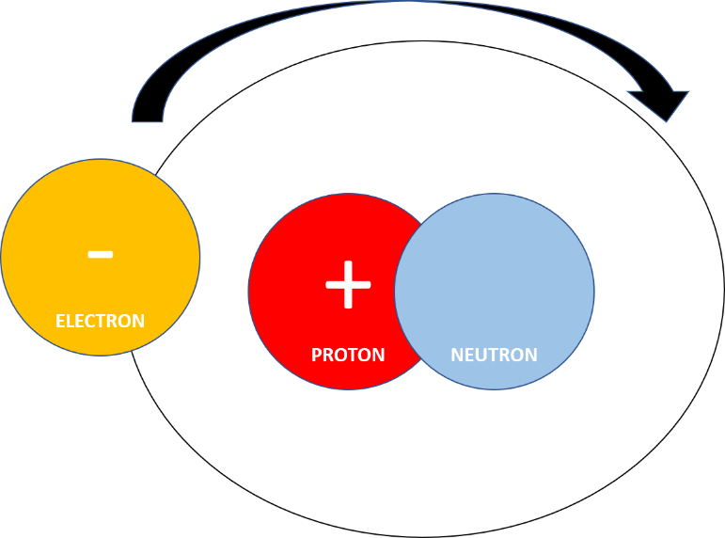

Electrons and protons have opposite charges. Electrons are negative and protons are positive. When a proton and an electron get close to each other they are pulled together or **attract.** This is because of their opposite charges. When two electrons get close together, they are pushed apart or **repel.** This is because they are the same charges. The way we remember this is:

**Opposite attract. Likes repel.**

When electrons move it creates electricity. There is the electricity that flows through the wires of your house, which we call an electrical current, and there is the electricity from having lots of electrons together without anywhere to go. This is called **static electricity**.

Static electricity happens when lots and lots of electrons build up on an object and do not have a place to move through a current or a discharge. This happens when things are rubbed together. In this experiment we are going to create static electricity so we can see electrons in action.

### 

### Asking Questions

It is a cold winter day and you have been walking around in your wool socks on the carpet. You go to open your bedroom door, grab the doorknob, and you receive a shock!

What questions do you have that might help you better understand this scenario?

|  |
| --- |
| **Your Questions** |
| **[Answers are intentionally BLUE]** |

# Running the Experiment

## Materials

* Crisped rice cereal
* Balloon
* Plate
* Wool material (optional)

## Protocol

1. Blow up a balloon and tie the bottom. Ask for help if needed.
2. Pour some rice cereal onto the plate.
3. Slowly move the balloon over the plate of cereal and write your observations next to number 1 in the table.
4. Rub the balloon on your hair or on the wool material.
5. Place the balloon over the plate and slowly lower it closer to the cereal and put your observations next to number 2 in the table. Be careful not to touch the balloon to the cereal.

### Observations

Using this table, describe what occurred when you placed the balloon over the plate of cereal.

|  |  |
| --- | --- |
| **Question/Prompt** | **Your Response** |
| 1. Did the cereal move? |  |
| 1. Did the cereal move after the balloon had been rubbed on your hair/wool? |  |

# 

# Conclusions

Answer the questions below to better understand how the cereal moved without touching the balloon.

|  |  |
| --- | --- |
| **Question/Prompt** | **Your Response** |
| 1. When you rubbed the balloon, you were covering it with electrons. So what charge did the balloon have? Highlight your answer. | 1. **Positive** 2. **Negative** |
| 1. Cereal is a form of matter and is made up of atoms. Think back to the atom model on the first page. Why do you think the cereal stuck to the balloon? Highlight your answer. | 1. **It has neutrons with no charge** 2. **It has protons with a positive charge** 3. **It has electrons with a negative charge** |
| 1. When you did not rub the balloon, the cereal did not move. Why not? Highlight your answer. | 1. **The balloon did not have a charge** 2. **The cereal was repelled** 3. **The balloon had a positive charge.** |
| 1. If you took two balloons and rubbed them both on your head, would they attract or repel each other? Highlight your answer. | 1. **Attract** 2. **Repel** |

## Think about it

Think back to the first scenario: It is a cold winter day and you have been walking around in your wool socks on the carpet. You go to open your bedroom door, grab the doorknob, and you receive a shock!

Describe the science behind this phenomenon using what you learned about electrons and static electricity.

|  |
| --- |
| **Your Response** |
|  |