Name: | [insert name] | Period: | [insert Period] | Date: | [insert date]

Balloon Rocket

Background
The use of rockets has been around for thousands of years. From the first rockets created in China that are the precursors of modern fireworks, to the rockets NASA sends into space to study the solar system; all rockets work due to the fundamental laws of motion.
Isaac Newton proposed the laws of motion in the 1600s. These laws developed over 300 years ago are used in how we develop most of our aerospace technologies today. One of the basic ways a rocket works can be understood by Newton’s Third Law. Newton’s Third Law says:
“For every action in nature there is an equal and opposite reaction.”
When a rocket is propelled, there are equal and opposite forces. A force is a push or pull on an object. The force created by burning fuel pushes the rocket allowing it to fly into space. While NASA uses fuel to propel their rockets into space, today we will be using air to demonstrate the same principles.
For deep space exploration, aerospace engineers will need to plan to bring enough food, water, and oxygen to last for a long trip. These engineers have to make sure there is enough fuel on the rocket to move all of the cargo in addition to any materials they pick up in space and need to bring back to Earth. These engineers use Newton’s second law to make their calculations.
In this experiment you will use a balloon and straw to make a rocket. By making observations, we will see how Newton’s Second Law works.

Applying Knowledge
Use your knowledge of Newton’s Third Law to predict the direction of the balloon and the direction of the air in the “rocket” below. Depict the motion of the air with a solid arrow and the motion of the balloon with a dotted arrow.

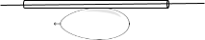

Running the Experiment

Materials
- Tape
- Balloon
- String
- Straw
- Small items (coins, buttons, batteries)

Protocol

Test 1
- Tie one end of the string to a chair, doorknob, or any stationary object on one side of the room.
- Thread the open end of the string through the straw
- Tie the loose end of the string to a stationary object on the other side of the room (at least 5-10 feet away). Make sure that the string is very tight.
- Place two pieces of tape over the straw so the sticky side attaches to the straw and has excess on either side.
- Blow up the balloon by exhaling 1 full breath into it and pinch the opening closed with your fingers or a clothespin.
- Tape the side of the balloon horizontally to the straw so that the opening of the balloon is closest to one of the stationary objects.
- Remove the clothespin from the balloon opening.
- Make your observations of what you saw occur in the Observation table below.

Test 2
- Remove the balloon from the straw and insert your small items. Adding 3-5 small items is ideal.
- Blow up the balloon by exhaling 1 full breath into it and pinch the opening closed with your fingers or a clothespin.
- Tape the side of the balloon horizontally to the straw so that the opening of the balloon is closest to one of the stationary objects.
- Remove the clothespin from the balloon opening.
- Make your observations of what you saw occur in the Observation table below.

Observations
Record your observations from Test 1 and Test 2 below.
- What happened when you released the balloon in Test 1?

- What happened when you released the balloon in Test 2? How did it compare to Test 1?

Making Predictions
Newton’s Second Law says:
“The acceleration of an object as produced by a net force is directly proportional to the magnitude of the net force, and inversely proportional to the mass of the object. In other words F_{net}=m*a.”
Answer the following questions using your knowledge from your balloon rocket.

- What provided the force to move the rocket for both tests (Test 1 and 2)? Was this forced a variable that was changed between tests?

- Compare the masses used in the rocket for Test 1 and 2. Which rocket had more mass?

- Based on Newton’s Second Law, which rocket do you think had the larger acceleration?

Data Analysis
To help in your exploration of Newton’s Second Law, our scientists conducted this experiment and collected time, position, and velocity data. You can view their collected data below.

Test 1 (Mass 0.008kg) |  |  | Test 2 (Mass 0.031 kg)
Time (s) | Position (m) | Velocity (m/s) | Time (s) | Position (m) | Velocity (m/s)
0 | 0 | 0 | 0 | 0 | 0
0.1 | 0.07 | 0.7 | 0.1 | 0.06 | 0.6
0.2 | 0.43 | 3.6 | 0.2 | 0.21 | 1.5
0.3 | 1.06 | 6.3 | 0.3 | 0.42 | 2.1
0.4 | 1.74 | 6.8 | 0.4 | 0.70 | 2.8
0.5 | 2.44 | 7.0 | 0.5 | 1.10 | 4.0

Graphing Data
By selecting appropriate data from above, create a graph which allows you to determine the average acceleration of each rocket. Be sure your data for Test 1 is depicted in red and your data for Test 2 is depicted in blue on your graph. Make sure to label your axes and give your graph a title.

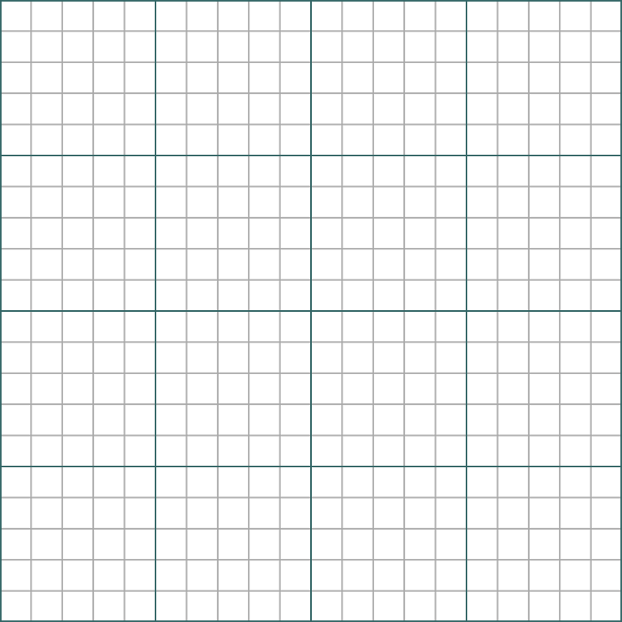

Drawing Conclusions
Use Newton’s Second Law and the graph you created to explain the differences you noticed between the motion of the rocket in Test 1 and Test 2.

