|  |  |  |  |  |  |
| --- | --- | --- | --- | --- | --- |
| Name: | **[insert name]** | Period: | **[insert Period]** | Date: | **[insert date]** |

Candy Chromatography

# Background

Chromatography is a method used to find out what a mixture is made of by separating it into its different parts. When crime scenes are being investigated, the police work together with forensic scientists who use chromatography to identify the different clues left behind. These scientists can match things like blood and lipstick to the suspects to help solve crimes. It is also used by scientists who study the ocean, lakes, and rivers to identify if there are pollutants in the water that can make people and animals sick.

Paper chromatography works by putting a small amount of a mixture on the bottom of a piece of paper and placing it a layer of solvent. A **solvent** is a liquid that can dissolve other substances like water or vinegar. A **mixture** is made of two or more materials that are combined and do not create a chemical reaction. As the solvent travels up the paper due to capillary action it brings with it the different particles in the mixture based on their different chemical properties. One of these properties is it’s polarity or overall charge. As the solvent moves up the piece of paper, particles that are more polar are strongly attracted to the solvent and travel further up the paper.

The outer shells of candies like M&Ms© and Skittles© are made up of a food dye that is a mixture of pigments. For example, a green M&Ms©  is likely to contain blue and yellow dyes in it’s coating. In this experiment we will use paper chromatography to see what color pigments can be found in these candy dyes and compare them to each other to identify if they have the same or different pigments.

## Making Predictions

Before we begin the experiment, we must first make an educated guess of what we expect to happen. In the table below, highlight the word you think best completes the sentence.

|  |  |
| --- | --- |
| **Finish the sentence below** | **Word choices** |
| Candies with different colors will contain ___________ components. | SAME  DIFFERENT |

# 

# Running the Experiment

## Materials

* Skittles© and/or M&Ms©
* Paper towel or coffee filter
* Aluminum foil
* Water
* Two cups
* Salt
* Ruler or tape measure
* Scissors
* Pencil
* Mixing bowl or pitcher

## Part 1: Preparing your Materials

### Create your chromatography paper

1. Draw a rectangle on your coffee filter or paper towel that is 3 inches tall and 4 inches wide.
2. Divide the rectangle into 4 equal rectangles that are 1 inch wide. See below for help.
   1. 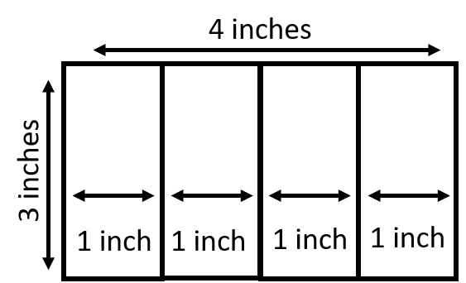
3. Cut out each rectangle with scissors.
4. Label one end of the rectangular strip with the color and type of candy you are testing with your pencil. For example, green M&M©, red Skittle©, etc. If you have them, try to use a Skittle© and M&M© of the same color.
5. Draw a line 1 cm or ¼ inch from the opposite end of the strip with your pencil. Use the image below to see how a strip should look.



### 

### Extract the Dye

1. Cut four small pieces of aluminum foil for your 4 candy samples (approximately 2 inch squares).
2. Put one drop of water on the foil and place your candy sample on top.
3. Leave the candy in the water for 1-3 minutes or until the water changes color.

### Prepare the Salt Water Solution

1. Combine 3 cups of water with ¼ teaspoon of salt in a mixing bowl or pitcher.
2. Stir until the salt is completely dissolved.

## Part 2: Using Chromatography to separate dyes

1. Use the tip of a pencil or the end of a popsicle stick to transfer a dot of dye onto its corresponding strip of paper. The drop should be placed on the line drawn at the bottom of the paper. For help see below.

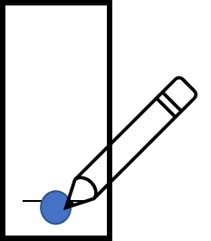

1. Let the drop dry completely dry.
2. Repeat steps 1-2 for your remaining 3 samples.
3. Tape the top of each strip to a skewer or pencil. Two strips can be taped on the same skewer but be careful that they do not touch each other.
4. Place the skewers on the top of the two cups with the strips hanging inside.
5. Pour the salt water solution into each cup until it just reaches the very bottom of the paper strip. Be careful not to get water on the strips.

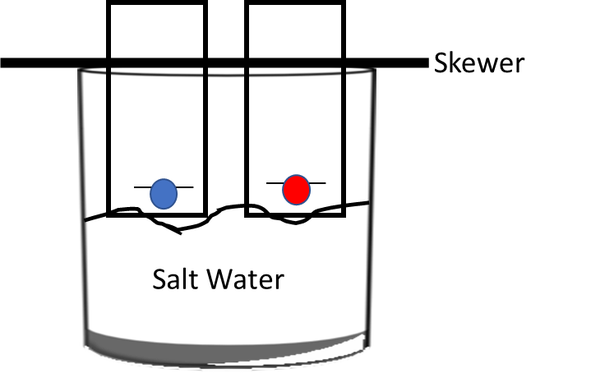

1. Leave the strips in the water until the water has traveled up the strip and almost reaches the skewer.
2. Take your strips out of the cup and observe your results!
3. Measure the distance from the starting line at the bottom of your paper to the center of where the dye has traveled for all samples and record these with your results below.

# Results

Edit the image below in Google Drawing to show the results you saw.

|  |
| --- |
| **Your Results** |
|  |

# Conclusions

Answer the questions in the table below.

|  |  |
| --- | --- |
| **Question/Prompt** | **Your Response** |
| Were the dyes on the candies made up of one component or a mixture of different components? |  |
| Did any of your candies contain the same components? How do you know? |  |