Name: |  | Period: |  | Date:

DNA Extraction

Background
All living things are made of cells. Cells are the basic units of organisms. Cells are like factories that contain the machinery for making you who you are and just like a factory, there is a boss giving the instruction. In cells, this boss is called DNA. DNA stands for Deoxyribonucleic Acid. In all cells, DNA acts as the code needed to synthesize the proteins that help cells perform their different functions.

Amazingly, the structure of DNA is exactly the same across all organisms. Yet how DNA is packed in cells is different between prokaryotes (or bacteria) and eukaryotes (multicellular organisms). The DNA in prokaryotes floats in the cytoplasm and is usually found in a circular form. Eukaryotic DNA (like the one pictured below) is found in an organelle called the nucleus. The nucleus allows the cell to better regulate how it uses DNA. This allows eukaryotic cells to create all types of proteins to produce all the different types of cells with the same DNA.

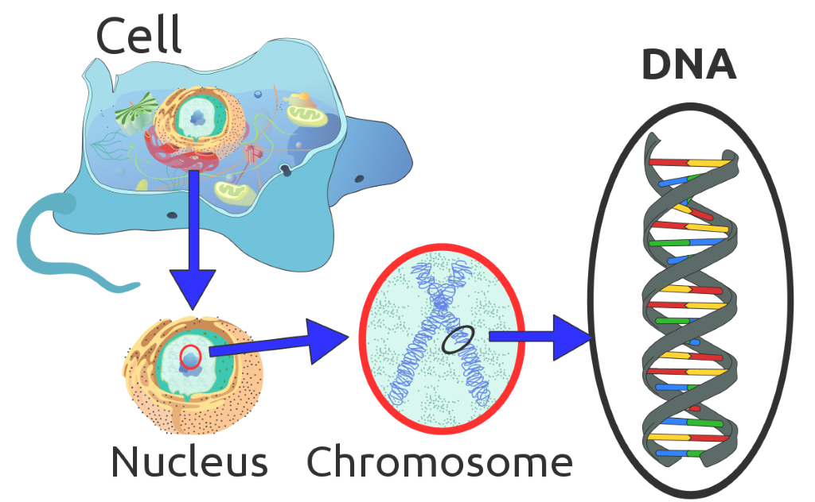
Today, you will perform a DNA extraction to determine whether or not the fruit of a plant is biotic or abiotic . Biotic means something that is living and abiotic is something that is not alive like rocks or air. If something is biotic it is made up of cells and therefore will contain DNA. In order to get the DNA out of eukaryotic cells, we must first break them open.

Quick Check
Using your resources and the information above, answer the questions below.

- What is DNA?

- Where is DNA found in different cell types?

Running the Experiment

Materials

- Soft fruit (Ex. bananas, strawberries, blueberries
- Sandwich sized plastic bag
- Clear plastic cup
- ½ tbsp and 1 tsp dish soap or shampoo
- 1 cup water
- ½ tsp salt
- ½ tbsp and 1 tsp baking soda
- 1-2 tsp Isopropyl alcohol
- Coffee filter

Make a Hypothesis
In the table below, make your hypothesis about whether or not the fruit will have DNA. Don’t forget to make sure it is an “if, then” statement.

Your Hypothesis

Protocol

Making Extraction Buffer
- Add the following to your 1 cup of water.
  - ½ tsp salt
  - ½ tbsp and 1 tsp baking soda
  - ½ tbsp and 1 tsp dish soap
- Stir to mix until dissolved and transparent.

Quick Check
Answer the question below.

Question/Prompt | Your Response
Why do we need soap in our extraction buffer? | [Answers are intentionally BLUE]

Isolating DNA
- Place a one inch section of fruit into the sandwich bag.
- Add 3 tsps of water to the bag.
- Use your fingers to break up the fruit into a paste or slurry.
- Add 3 tsps of extraction buffer to the bag. Then close the bag and use your fingers to mix the buffer into your fruit paste.
- Moisten your coffee filter and then place on top of your clear cup.
- Cut the corner of the sandwich bag and slowly pour the mixture over your coffee filter.
- Add 1-2 tsp of isopropyl alcohol to your cup (or enough to cover the mixture). Do NOT mix the fruit mixture and the alcohol together. There should be two distinct layers- the fruit mixture on the bottom and the alcohol on top.

Observations
Using this table, describe what occurred after you added the isopropyl alcohol.

Question/Prompt | Your Response
Describe what you see in the top layer (alcohol layer)? Be sure to include the color and shape of what you see. | [Answers are intentionally BLUE]

Conclusions
Using your observations, answer the questions below.

Question/Prompt | Your Response
Based on your observations, is the fruit of a plant biotic or abiotic? How do you know? | [Answers are intentionally BLUE]
The DNA of an apple and an apple tree leaf were extracted and the DNA was exactly the same. Explain how this can be

