Name: |  | Period: |  | Date:

Properties of Water

Background
Have you ever looked at a water droplet on a leaf after a rain shower? The water forms beautiful round droplets. Or have you ever watched a water strider walking across the top of water almost magically? These are both possible due to the surface tension of water.

Water has cohesive and adhesive properties. Cohesion holds the hydrogen bonds together to create surface tension on water. Since water is attracted to other molecules, adhesive forces pull the water toward other molecules and allow water to move up or appear to defy gravity. It takes a lot more force to break through the surface of a liquid than it does to go through the liquid.
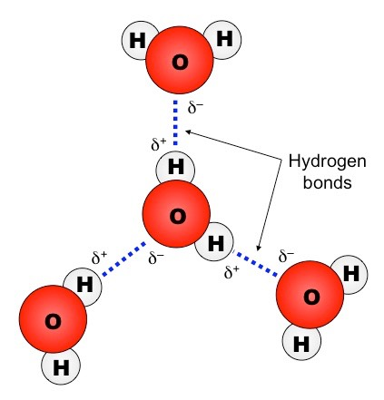

A water molecule consists of two hydrogen atoms bonded to an oxygen atom, and its overall structure is bent. This is because the oxygen atom, in addition to forming bonds with the hydrogen atoms, also carries two pairs of unshared electrons. All electron pairs—shared and unshared—repel each other.

When in the liquid state, electrostatic force doesn't make much of a difference for water because each molecule is being pulled all directions towards other molecules. But on the surface of the liquid, the molecules aren't being pulled up at all because there are no molecules there to pull the others up. Rather, there is a strong force between the molecules pulling them down. This creates a strong barrier at the liquid-gas interface allowing the water striders to “walk on water”.

Think about what happens when we wash dishes. In a soap-and-water solution, the hydrophobic (greasy) ends of the soap molecule do not want to be in the liquid at all. Those that find their way to the surface squeeze their way between the surface water molecules, pushing their hydrophobic ends out of the water and cleaning your dishes. This separates the water molecules from each other. Since the surface tension forces become smaller as the distance between water molecules increases, the intervening soap molecules decrease the surface tension.

Different liquids have different properties and we will explore those today by comparing water to isopropyl alcohol.

Key Words

Surface tension: The tension of a liquid caused by the attraction of the particles in the surface layer by the bulk of the liquid, which tends to minimize surface area.

Capillary Action: The ability of a liquid to flow in narrow spaces without the assistance of, or even in opposition to, external forces like gravity.

Cohesion: The action or property of like molecules sticking together, being mutually attractive.

Adhesion: The tendency of dissimilar particles or surfaces to cling to one another. The forces that cause adhesion and cohesion can be divided into several types.

Electrostatic forces: the forces that attract molecules to each other. With water the slight dipole makes the molecules particularly attracted to each other, making it able to form a tight knit cohesive unit.

Hydrophobic: “Water-fearing” molecules are molecules that do not like to be near water. Water molecules have a dipole, meaning that one side of the molecule has a slightly positive charge and one part has a slightly negative charge.

Running the Experiment

Materials

Walking Water
- Food coloring (red, yellow, blue)
- 5 clear cups
- 3 cups of water
- 4 paper towels
- Ruler

Drops on a Penny
- Penny
- Water
- Isopropyl alcohol
- Transfer pipette or eye dropper

Procedures

Part 1: Walking Water
- Position your 5 clear cups in a line and pour water in every other cup so they are ¾ of the way full. See picture below for set up.
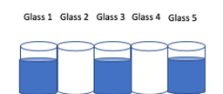
- Add a few drops of food coloring to the cups with water as follows: cup 1- red food coloring, cup 3- yellow food coloring, and cup 5- blue food coloring. Stir the food coloring to mix in.
- Fold each paper towel in half horizontally twice and then in half vertically. Your paper towel should be in a V shape when you finish. You should end up with 4 folded paper towels.
- Next using your ruler, measure out one inch increments along one of your paper towels.
- Place one end of your paper towel into the cup with liquid and the other end into the neighboring empty cup. See picture below for set up.

- Take note of where the liquid started on your measured paper towel in the table below.
- Set a timer for 10 minutes, and record the new measurement of where the water is on your measured paper towel in the table below.
- Continue to take measurements every 10 minutes for a total of 80 minutes.

Data Collection
Using this table, record where the water is on your measured paper towel below to the nearest inch.

Time (min) | 10 | 20 | 30 | 40 | 50 | 60 | 70 | 80
Measurement on paper towel (in)

Data Analysis

Using your data above, answer the question below.

Question/Prompt | Your Response
- How far did the water travel over 80 minutes?
- What property of water allowed for the water to move from one cup to another?

Part 2: Drops on a Penny
- Rinse a penny in tap water and dry completely.
- Using your transfer pipette or eye dropper, pick up water and place one drop at a time on the penny until any amount of water runs over the edge. Record your total number of drops in the table below.
- Repeat steps 1 and 2 three more times and then calculate your average.

Water on a Penny
Trial 1 | Trial 2 | Trial 3 | Trial 4 | Average

- Rinse a penny in tap water and dry completely.
- Using your transfer pipette or eye dropper, pick up isopropyl alcohol and place one drop at a time on the penny until any amount of alcohol runs over the edge. Record your total number of drops in the table below.
- Repeat steps 4 and 5 three more times and then calculate your average.

Alcohol on a Penny
Trial 1 | Trial 2 | Trial 3 | Trial 4 | Average

Data Analysis
Use your data collected above, to answer the following question:
What inference can we make about the electrostatic force of water compared to that of alcohol?

Think about it
Surface tension has been recorded for the following liquids. Surface tension is calculated as the force experienced divided by the length along which the force is felt.

Liquid | Surface Tension (mN/m) at 20 ℃
Liquid soap | 45.2
Water | 72.7
Isopropyl Alcohol | 21.79

Based on your findings and background knowledge, which liquid has the highest strength of electrical forces between particles? Rank these with 1 being the lowest and 3 being the highest regarding their electrical forces between particles. Provide an explanation of your rankings using the supplied surface tension data to explain how it relates to the strength of electrical forces between the particles.

Your Ranking:

Your Explanation:

