|  |  |  |  |  |  |
| --- | --- | --- | --- | --- | --- |
| Name: | **[insert name]** | Period: | **[insert Period]** | Date: | **[insert date]** |

Rainbow in a Tube

# Background

What is the difference between the two images below?

**Cup A Cup B**

They look identical, right? There is a small difference that you were not able to catch by observing these two images. The cup on the right (cup B) has 6 tablespoons of sugar in it. Although we cannot recognize this with our eyes, we can do an experiment to prove this claim. But first we need to talk about matter!

Matter is any substance that has mass and takes up space by having volume. Look around the room it is full of matter. However, all matter does not look the same. Matter exists in the form of solids, liquids, gases, and plasmas. Sometimes matter cannot be seen or felt, like the air we breathe.

Matter has properties and those are referred to as the traits we can measure . One of the properties of matter is density. Density is how many particles are packed into a material. Think about the water in the images above. Because they have the same volume, they most likely have the same number of water molecules. But for the cup on the right the sugar was added and dissolved even though you may not see it with the naked eye. The sugar occupies the space in between the water molecules and increases the density of the solution. Look at the image below- which one has more molecules in it? This is the one that is more dense!

**Cup A Cup B**

 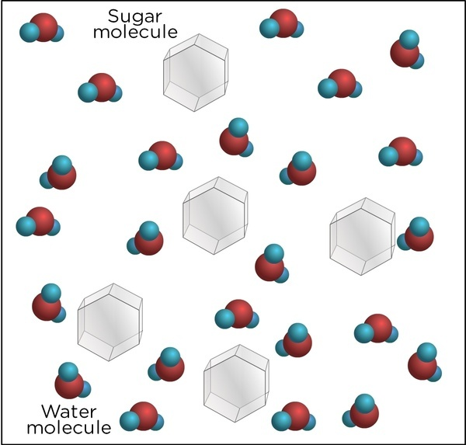

# Running the Experiment

## Materials

* 4 cups of the same size
* Warm water
* 1.25 cups sugar
* Tablespoon measure
* Clear straw or tube
* Red, yellow, blue, and green food coloring
* Spoon or stirring utensil

## Protocol

1. Number each of your cups 1-4.
2. Fill cup 1 with warm water, 2 tbsp sugar, and two drops of red food coloring.
3. Fill cup 2 with warm water, 4 tbsp sugar, and two drops of yellow food coloring.
4. Fill cup 3 with warm water, 6 tbsp sugar, and two drops of green food coloring.
5. Fill cup 4 with warm water, 8 tbsp sugar, and two drops of blue food coloring.
6. Use your spoon to stir each cup to mix until the sugar is dissolved.
7. Using your straw, place it about ½ inch into cup 1. Then place your thumb over the end of the straw to keep the liquid from falling back into the cup.
8. Place the straw about 1 inch into cup 2. Quickly release your thumb and place it back over the end to draw up and hold the liquid.
9. Place the straw about 1.5 inches into cup 3. Quickly release your thumb and place it back over the end to draw up and hold the liquid.
10. Place the straw about 2 inch into cup 4. Quickly release your thumb and place it back over the end to draw up and hold the liquid.

## Observations

Record your observations from the experiment below.

1. What do you see in your tube?
2. Which solution is on the bottom? Is this the most or the least dense? Does it have the most or the least particles?

# 

# Using a model

Below is an image showing your straw at the bulk scale (what we can see) and at the particle scale (what we can’t see with our eyes). Draw on the image to add water and sugar molecules for each colored layer. Represent water with circles and sugar with stars.

