Name: | [insert name] | Period: | [insert Period] | Date: | [insert date]

Reaction Times

Background
Have you ever baked cookies and as the smell wafts out of the oven your mouth starts to water? How did your mouth know that you were ready to eat cookies? Well your body used it’s sense of smell to identify that cookies were nearby and your brain used that information to create a reaction- your mouth watering.
Our brain, hidden away under our nice hard skulls, has the job of taking information from our senses, processing the information,, and then creating a response. Information can be sensed in a lot of different ways, but the main senses are touch, taste, smell, sound, and sight.
In this experiment, we want to see which sense has the fastest reaction: sight, sound, or touch.

Think About It
Think about your senses as you answer the questions below.
- What part of our body is responsible for our sense of touch?

- What part of our body is responsible for our sense of taste?

- What part of our body is responsible for our sense of smell?

- What part of our body is responsible for our sense of sound?

- What part of our body is responsible for our sense of sight?

Forming a Hypothesis
Which sense do you think will have the fastest reaction time? Circle your answer below!

SIGHT SOUND TOUCH

Running the Experiment

Materials
- Ruler, meter stick, or yard stick
- Partner

Protocol
- For this experiment, you will need a partner. You can either test the reaction times of your partner or your partner can help you test your reaction time. The person having their reaction times tested will be the participant and the one measuring their reactions will be the experimenter.
- The participant will hold out their dominant hand with their thumb and pointer finger close together, ready to pinch closed.
- The experimenter will hold the ruler so that 0 cm is directly above the participant’s thumb. Instruct the participant to catch the ruler between their thumb and pointer finger when they SEE it dropped. Be sure not to tell the participant when you are going to let go of the ruler.
- Look at the top of the participant's thumb and record the nearest 0.1 centimeter in the table below under “Sight”.
- The participant will stand the same as in step 2, but this time with their eyes closed.
- The experimenter will hold the ruler so that 0 cm is directly above the participant’s thumb. Instruct the participant to catch the ruler between their thumb and pointer finger when they HEAR the word “Drop”. The experimenter will drop the ruler at the same time as saying the word “Drop”. Be sure not to tell the participant when you are going to let go of the ruler.
- Look at the top of the participant’s thumb and record the nearest 0.1 centimeter in the table below under “Sound”.
- The participant will stand the same as in step 2, but this time again with their eyes closed.
- The experimenter will hold the ruler so that 0 cm is directly above the participant’s thumb. Instruct the participant to catch the ruler between their thumb and pointer finger when they FEEL their arm touched. The experimenter will drop the ruler at the same time as they touch the participants upper arm. Be sure not to tell the participant when you are going to let go of the ruler.
- Look at the top of the participant’s thumb and record the nearest 0.1 centimeter in the table below under “Touch”.

Results
Record your results from the experiment below. Remember each record should be to the nearest 0.1 centimeter.
SIGHT | SOUND | TOUCH

Using a Model
Using the information you learned from the experiment, fill in the model on the next page for what happened when the participant’s eyes were closed and they were listening for the word “Drop”. Your answers will go in the red boxes. An example has been completed for the vision reaction test already.

Example: Vision
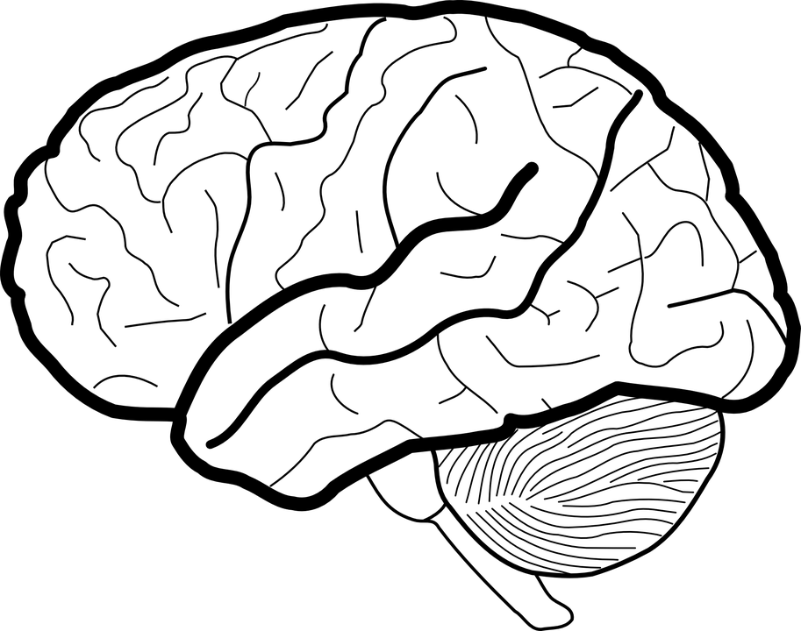

Information
Falling ruler

Receptors
Vision- eyes

Processing
The ruler has been dropped

Action
Pinch thumb and finger to catch ruler

Sense of Sound Model

Information

Receptors

Processing

Action

