Name: | [insert name] | Period: | [insert Period] | Date: | [insert date]

Yeast Balloon

Background
Have you ever wondered why bread is so soft and airy? It is because of one important ingredient, yeast!
Did you know that yeast is, in fact, alive? Yeast is a single celled organism that we use to make things from pastries to alcoholic drinks like wine. And just like all living things, yeast consumes food, breaks it down, and then pushes out waste. Just as humans need nutrients from our food and oxygen from the air to make energy, so do yeast. In addition to that energy, water and carbon dioxide are also created. Carbon dioxide can be toxic to living things in high concentrations so they have to make sure to excrete, or remove, it as it’s created.
So what does this have to do with bread? The yeast releases carbon dioxide gas which gets stuck in the elastic dough and causes the dough to expand and rise as it fills with carbon dioxide bubbles.
In today’s experiment, we will see how sugar affects the yeasts ability to create carbon dioxide gas!

Forming a Hypothesis
After reading the background information, fill in the table below to form your hypothesis.

Question/Prompt | Your Response
One trial in our test will contain yeast, water, and sugar. Do you think this will create carbon dioxide gas?
Our second trial will contain only yeast and water. Do you think this will create carbon dioxide gas?
Now that we have some predictions, write your hypothesis for this experiment. Keep in mind our scientific question:

“Does sugar affect yeast’s ability to create carbon dioxide gas?”

Running the Experiment

Materials
- Two empty water bottles
- Two balloons
- Warm water
- Sugar
- Measuring spoons
- Funnel
- Yeast
- Marker

Protocol
- Remove the lids of both water bottles and with a marker label one bottle “Sugar” and the other “No Sugar”.
- Using a funnel, add 2 ¼ tsp of yeast (one packet) to each water bottle.
- Using a funnel, add 2 tsp of sugar to the bottle labeled “Sugar”.
- Using a funnel, add ½ cup of warm water to each of the bottles.
  - The water should be warm to the touch, but not so hot that you can’t touch it. If you have a thermometer, we should aim for the water to be about 100℉.
- Close the both bottles with their lid and gently swirl the bottles to make sure all of the ingredients are combined and dissolved.
- Remove the lids of both water bottles and place a balloon over each opening, being careful to ensure the entire bottle opening is covered.
- Leave the bottles undisturbed for one hour then record your observations below.

Observations
Record your observations from the experiment below.
Question/Prompt | Your Response
What happened to the bottle labeled “No Sugar”?
What happened to the bottle labeled “Sugar”?

Drawing Conclusions
Use your observations to answer the question below.
Question/Prompt | Your Response
Does sugar affect yeast’s ability to create carbon dioxide gas? Support your answer with the evidence you saw during the experiment and the background information from the beginning.

Using a Model
Using the drawing below and the information you learned from the experiment, label the system and its components as well as draw the arrows to show the motion of the components into or out of the system. The labels have been made and are shown in green boxes. Drag the label to the appropriate red box then draw an arrow connecting it to the system where this reaction is occurring.

Yeast Model
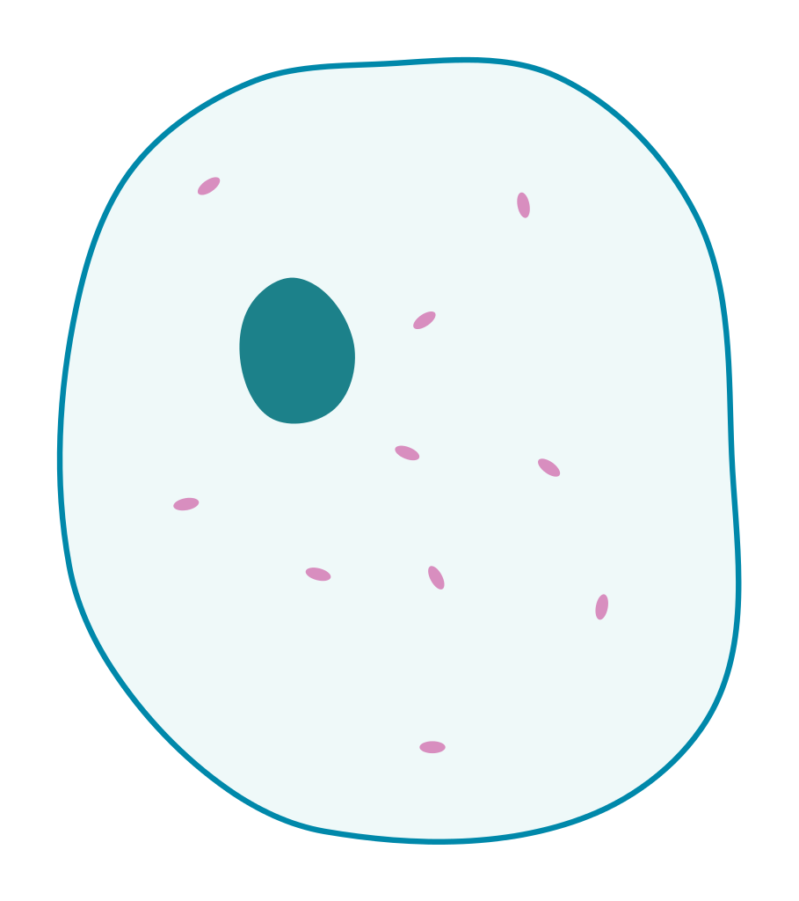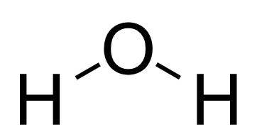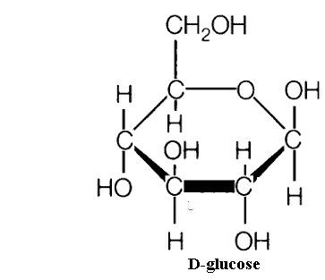
Sugar
Oxygen
Carbon Dioxide
Water
Yeast

Energy

Challenge
Use the model above to answer the following questions.

Question/Prompt | Your Response
How many carbon (C), oxygen (O), and hydrogen (H) atoms are found in the inputs to the system? | C:  O:  H:
How many carbon (C), oxygen (O), and hydrogen (H) atoms are found in the outputs to the system? | C:  O:  H:
What do you notice about the number of carbons, oxygens, and hydrogens present before and after the reaction? Explain why this is so?

