**STUDENT NAME:**

Creating a Plasmid

The production of insulin on a large scale has been detrimental in treating those with diabetes. Initially, pig insulin was used to treat human diabetes, but this was not easy or cost effective. Today. Insulin production is done using *recombinant DNA*. Recombinant DNA is a technology used by scientists to insert genetic material of one organism into another. By taking the gene for insulin and inserting it into bacteria insulin can be produced much easier and in larger quantities.

Getting insulin DNA into bacteria requires the formation of a *plasmid.* Plasmids are circular pieces of DNA that can be absorbed into bacteria and used to create proteins. This works because the bacteria’s own proteins can act on the plasmid just like it would act on its own DNA to express the gene.

To get the insulin gene into the plasmid, both the insulin gene and plasmid need to be cut by *restriction enzymes*. The DNA sequence surrounding the insulin gene and the plasmid are cut by the same enzymes which creates matching ends. The sites that restriction enzymes cut at are called *restriction sites*. These are specific for certain sequences of DNA. After being cut, the open ends are joined together by another enzyme called *ligase*.

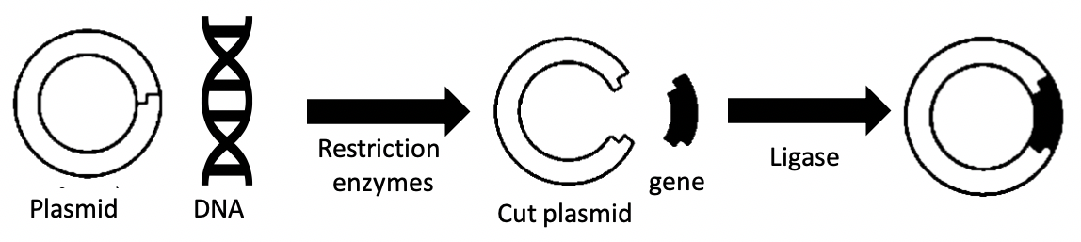

In this lab, we will be modelling a plasmid that will carry the gene for insulin. We will “cut” the DNA sequence containing the insulin gene and the plasmid and ligate them together.

Create the plasmid

1. Print out the DNA sequences for the plasmid and insulin [Worksheet](https://drive.google.com/open?id=1BQHDd4WxZH8Aw_NXQp_eMns1aGulMXyF) .

2. Tape the ends of the plasmid DNA together with scotch tape. This is your plasmid

Find the recognition site

Restriction enzymes cut a specific base pair sequence. Since strands of DNA run in equal and opposite direction the sequence will be on both strands. The recognition site for our enzyme is below. The enzyme cuts between the two adenosines in both strands, causing the DNA to break apart.

3. Look through your plasmid and DNA sequences to find all possible restriction sites. Using the above diagram as a guide and draw in all the cut sites.

4. Use scissors to cut along the marked locations. There should be one located on the plasmid and two located in the DNA.

Your plasmid and DNA sequence should look like this:

Restriction Site

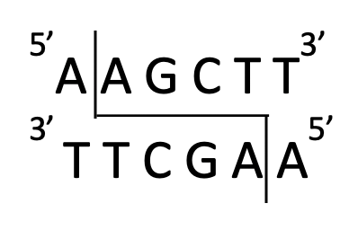

5. Now it is time to add your ligase. For this model, we will be using tape. If you have cut the ends correctly the pieces of plasmid and DNA should fit together like puzzle pieces. Tape them together and now you have your finished plasmid! If the pieces do not fit, just try again.

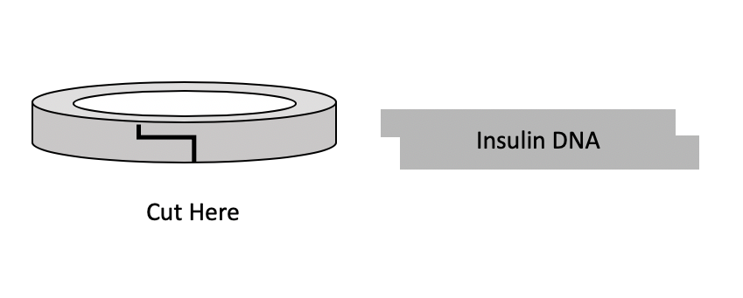

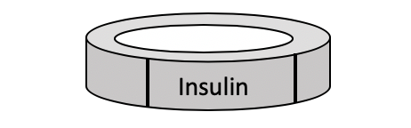

Adapted from the *TeachEngineering* digital library collection at *www.TeachEngineering.org*. All rights reserved."