**STUDENT NAME:**

Introduction to Bacterial Transformation

Visit this [link](http://labcenter.dnalc.org/labs/transformation/transformation_h.html) and answer the following questions:

1. Start by listening to Erin McKechnie talk briefly about bacterial transformation.
2. Click on the DNA strand on the bottom left hand corner of the screen and read through the background information about this topic.  
   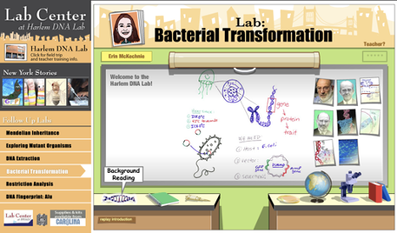
3. Which of the following is true about the bacterial transformation we are conducting today?

o It is a type of genetic engineering

o It involves jellyfish

o It is important in modern day medical advances

o If we are successful nothing should glow

1. What are plasmids and how do scientists use them?
2. List three modern day uses of bacterial transformation in the medical industry.

|  |
| --- |
| 1. |
| 2. |
| 3. |

3. Watch the “Transformation: Start to Finish” video to answer the following question.  
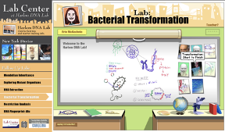

1. What is the function of a restriction enzyme?