**STUDENT NAME:**

Transformation Simulation

Visit the following link and go through a virtual simulation: [Transformation Simulation](https://www.pbslearningmedia.org/asset/biot09_int_geneclone/EN/)

Answer the following questions as you follow along with the simulation.

1. What is one use for altering an organism’s traits?

o

1. Draw and label the three regions of the plasmid.

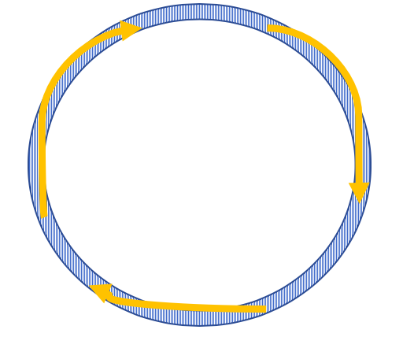

1. What happens at the origin of replication?

o

1. What is the purpose of the Lac Z region?

o

1. True or False: Without the restriction enzyme this experiment would not work.

o True

o False

1. What do you think will happen when we add the DNA to the plasmid solution?
2. the DNA will dissolve
3. the gene will bind to a plasmid
4. the plasmid solution will become hydrophobic

1. Fill in the blank. As the two complementary ends come in contact, _ _ bonds form between the nucleotide pairs.
2. What is the name of the enzyme that bonds the DNA’s phosphate backbone back together?
3. sucrose
4. glucose
5. ligase
6. tris
7. True or False some of the plasmids close up without bonding.

o True

o False

1. What is the purpose of placing our cuvette into the electroporation machine?
2. sanitize the sample
3. kill any non-bonded plasmids
4. create pores in the bacteria
5. increase the positive charge of the bacteria
6. Describe the process of electroporation that we saw on this simulation. Then compare the process of electroporation to heat shock which we used in the other lab.

o

1. What happens to the bacteria that picked up the plasmid?

o