**STUDENT NAME:**

Review Questions:

1. Circular DNA is called a ________________  
   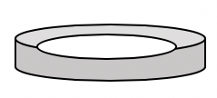
2. A restriction enzyme cuts DNA at the restriction site 5’GGATCC3’. Find the site in the sequence below and mark where the cut will occur.  
   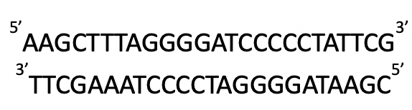
3. True or False.
   1. The plasmid and DNA insert are cut by different enzymes
      1. True
      2. False
   2. An enzyme is required to join the ends of the DNA and plasmid
      1. True
      2. False
4. Name a way that bacteria are used by scientists as a tool to treat diseases.