**STUDENT NAME:**

Transformation

Bacterial Transformation and Green Fluorescent Protein

In this activity, you will learn about the process of moving genes from one organism to another using genetic transformation. Genetic transformation literally means a change caused by genes, and it involves the insertion of a foreign gene into an organism. This process is also referred to as genetic engineering or gene splicing. Recall that genes are pieces of DNA that provide the instructions for making proteins. Proteins are essential molecules for all organisms and cause the expression of a trait, or phenotype, which is associated with that gene.

In this specific procedure, we will perform genetic transformation by inserting a plasmid into the bacteria, *E. Coli.* In addition to having one large chromosome, most bacteria contain small, self-replicating, circular pieces of DNA called plasmids. Plasmids have their own **origin of replication** (ori), which allows them to replicate independently of the chromosomal DNA, as well as genes for one or more traits that may be beneficial to bacterial survival. In nature, bacteria can transfer plasmids back and forth, allowing them to share beneficial genes and rapidly adapt to new environments. The recent occurrence of bacterial resistance to antibiotics, for instance, is due to the transmission of plasmids.

The plasmid we are inserting into *E. coli* contains a gene that codes for **green fluorescent protein** (GFP). Green fluorescent protein is found naturally in jellyfish and allows them to fluoresce. Following the transformation procedure, the bacteria can express their newly acquired jellyfish gene and, in the presence of sugar, will produce the fluorescent protein. This causes the bacteria to glow a brilliant green color under ultraviolet light.

The plasmid we will use is Bio-Rad’s pGLO plasmid that contains both the gene for GFP and a gene for **resistance to the antibiotic, ampicillin** (bla)**.** Since the transformed bacteria will be resistant to ampicillin, we can use nutrient plates that contain this antibiotic to select for the engineered bacteria (The antibiotic kills any non-transformed bacteria).

Finally, the pGLO plasmid also contains a gene regulation region that controls the expression of the fluorescent protein in transformed cells. This **regulation region** (araC) relies on the sugar arabinose to control GFP expression. When present in the cell, arabinose binds to the protein transcribed by the araC gene, which in turn promotes the expression of the GFP gene. Therefore, arabinose must be present for the GFP gene to be switched on and for GFP to be produced. This means that transformed cells will appear white (wild-type phenotype) on plates not containing arabinose and fluorescent green (mutant phenotype) when arabinose is included in the nutrient agar medium.

**PART I - Introduction**

1. Fill in the blanks using the bold works shown on the previous page and note how each of these regions helps us visualize our transformed bacteria.

**PART II - Bacterial Transformation**

1. Will the pGLO plasmid in the tube glow under UV light? What does the pGLO plasmid need to express its genes?
2. What will heat-shocking do to the bacteria?

1. When we add our LB to the tubes after heat shock we are starting the incubation period. Why is this incubation period, called the expression time, critical for the growth of the transformed bacteria?

**PART III - Hypothesize if the bacteria will grow and/or glow on each plate.**

1. Think about the genes contained in the pGlo plasmid as well as the regulatory system for transcribing those genes. Hypothesize what the results will be by checking whether or not the bacteria will grow and whether or not it will fluoresce.

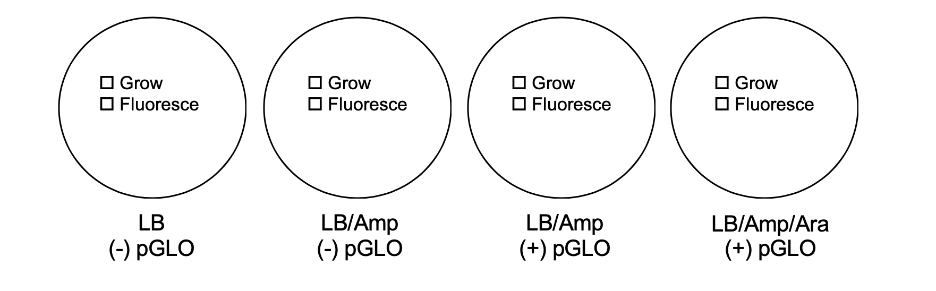

**PART IV - Data Analysis**

1. Observe the results obtained in the video. Carefully observe and draw what you see on each of the four plates.

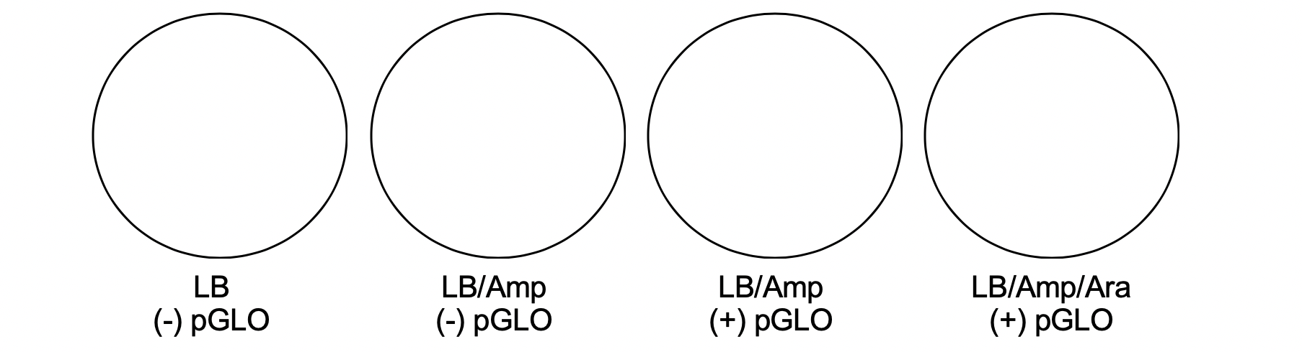

**PART V- Calculating transformation efficiency**

Now that you have completed the transformation process, you can calculate the transformation efficiency, the efficiency at which the cells picked up the pGLO plasmid, for transformed cells. This measurement is dependent on the amount of pGLO plasmid that was added to the cell culture. The calculation of transformation efficiency allows us to quantify how well the bacteria expressed the green fluorescent protein.

To calculate efficiency we need:

1. The total number of green fluorescent colonies on your LB/AMP/ARA plate.

2. The total amount of pGlo plasmid DNA in the bacterial cells spread on the LB/AMP/ARA plate.

1. Use the number of colonies from the experiment and the amount of plasmid used to calculate the efficiency of transformation. Each colony on the plate can be assumed to have been derived from a single cell.

Number of colonies: ______________

Amount of pGlo: 0.16 µg

Formula: # colonies = transformants/µg DNA

µg plasmid