**STUDENT NAME:**

Introduction to Waves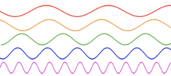

Waves come in many different shapes and forms. All waves, however, share basic properties and behaviors. Some waves can be distinguished from others based on their characteristics which allows us to categorize them.

A wave is a disturbance that transfers energy from one place to another. Some waves need a substance or a ‘medium’ to transfer through, whereas others do not. Waves can be described as oscillations or vibrations of a particle and its rest position. The direction of these oscillations/vibrations is the difference between two types of waves. Waves come in two forms; a Transverse Wave and a Longitudinal Wave.

A Transverse wave is a wave which moves the medium *perpendicular* to the motion of the wave. Examples of a Transverse wave include: a vibration of a guitar string or electromagnetic waves such as light and radio. When you recall a transverse wave, think of a slinky that is stretched out and a *pulse* is introduced causing the coils to move up and down.

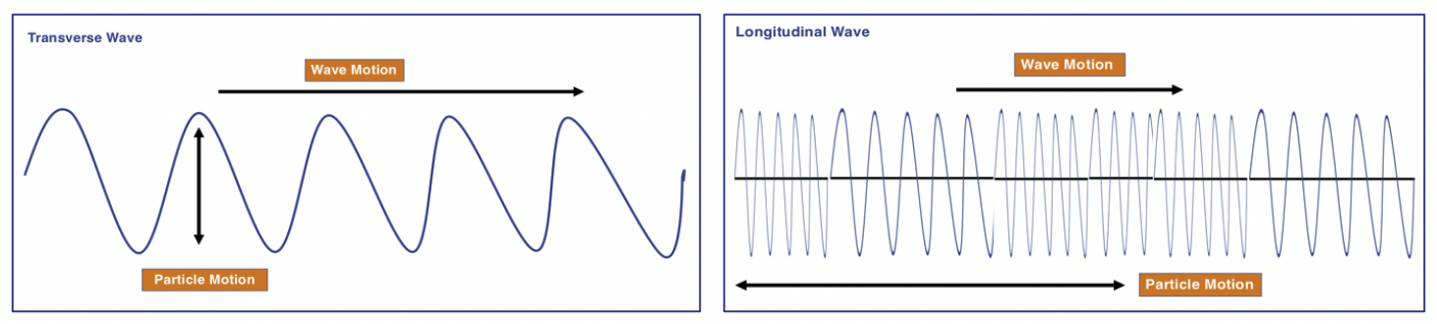

A Longitudinal wave, moves the medium *parallel* to the motion of the wave. Examples of Longitudinal waves include sound waves. When you recall a longitudinal wave, think of a slinky that you push and pull, causing the coils to move left to right.

Similar to the motion of the particles in a wave, we can categorize them based on their physical characteristics.

**Mechanical Waves** cause *oscillations* of particles in a solid, liquid, or gas and must have a **medium** to travel through. Once the wave has passed, the medium ends up back at its resting position. These waves are not capable of transmitting energy through a vacuum. A sound wave is an example of a mechanical wave, which is why there is no sound in space.

**Electromagnetic Waves** are capable of transmitting energy through a *vacuum* (empty space). These waves are produced by the vibration of charged particles. All light waves are examples of electromagnetic waves.

Wave Properties:

There are many properties to a wave. In a Transverse wave the **Crest** and **Troughs** represent the locations of maximum displacement of the particle from its resting position up or down. **Amplitude** is the measurement of maximum displacement. **Wavelength** is the distance of one complete wave cycle. For example; the distance from crest to crest or trough to trough would be 1 wavelength.

In a Longitudinal wave, the areas of maximum displacement are known as **Compressions** and **Rarefactions**. The stronger the wave, the more compressed and spread out the wave medium becomes.

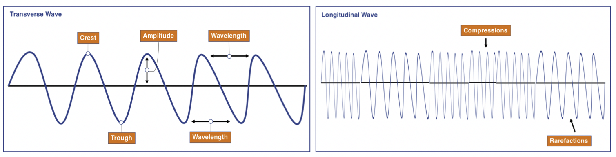

Part 1: Fill in the Blank

Using the overview above, fill in the blanks to the statements below.

1. The motion of a wave parallel to the wave direction describes a ___________________ wave.
2. A ___________________ is the maximum upward displacement in a Transverse wave.
3. One complete wave cycle is known as ___________________.
4. The motion of a wave perpendicular to the wave direction describes a __________________ wave.
5. A ___________________ or ___________________ is the maximum displacement in a longitudinal wave.
6. A light wave is an example of a(n) ____________________ wave.
7. The distance from one trough to another trough is called a ___________________.
8. The measure of displacement is called a wave’s ___________________.
9. ____________________ waves need a medium such as a solid, liquid, or gas to travel through.

Part 2: Velocity & Frequency 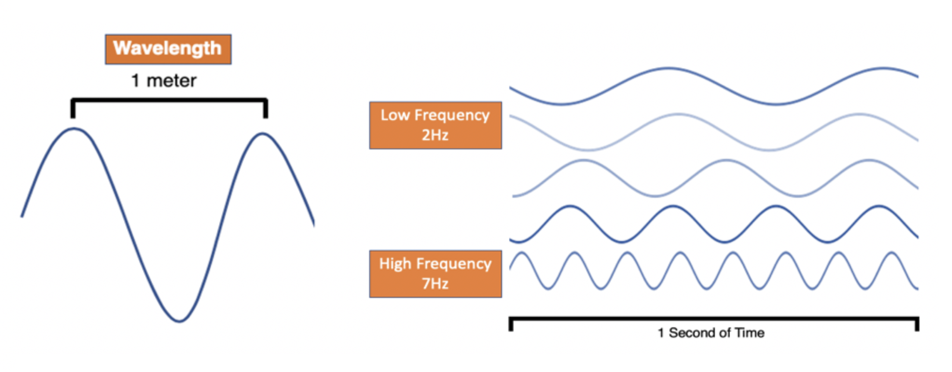

The **velocity (v)** of a wave is commonly referred to as the speed and direction. The velocity of a wave can be calculated using wavelength and frequency. Remember, **wavelength (λ)** is the length of one complete wave cycle and it is measured in meters. This can be measured Crest to Crest, Trough to Trough, or any other complete cycle of a wave. **Frequency (f)** is the number of waves or vibrations produced per second, also written with the unit Hertz.

The equation for calculating the velocity of a wave is:

* **Velocity = Wavelength x Frequency v = λ x f**
* **Wavelength = Wave Velocity/Frequency λ = v / f**

The equation works for any wave form: water, sound, or radio waves.

*EXAMPLE:* A wave has a Wavelength of 4 meters and a Frequency of 10 Hz.

* V = 4 x 10 ➜ V = **40** meters per second (m/s)

Solve using the equation for wave velocity: (Show your equation set up and math work)

1. A wave has a Wavelength of 6 meters and a Frequency of 12Hz. What is its velocity?
2. A wave has a Wavelength of 18 meters and a Frequency of .5Hz. What is its velocity?
3. A wave has a Wavelength of .2 meters and a Frequency of 100Hz. What is its velocity?
4. A wave has a Wavelength of 9 meters and a Frequency of 14Hz. What is its velocity?

CHALLENGE: *(Solve using the equation for wavelength)*

1. A wave has a Velocity of 30 m/s and a Frequency of 10Hz. What is its wavelength?