STUDENT NAME:
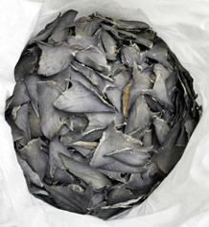
A high demand for shark fins, especially in the eastern part of the world, has resulted in the reduction of many shark populations. In response, the U.S. government has begun to protect the species of sharks that have become threatened due to overfishing. Customs agents have received a package that contains dried fins from an unidentified species of shark. It is suspected that this package may have fins that belong to the great white, one of the U.S.’s protected species. You will need to use genetic analyses in order to determine if any of the confiscated fins were illegally obtained.
Dr. Mahmood Shivji, a conservation biologist, has devised a test that can rapidly identify a species of shark by using small fragments of the DNA in the shark fin and a technique called Polymerase Chain Reaction (PCR). When examining the great white shark’s DNA, Dr. Shivji discovered a sequence of ribosomal DNA that is 1340 base pairs long. Unlike genomic DNA, this exact sequence of DNA is found in all species of shark. In addition, he discovered a species-specific fragment of DNA that is 580 base pairs and is only found in the great white species.
Dr. Shivji can use PCR to make millions of copies of these sequences of DNA. The technique involves a protein called polymerase that copies, or amplifies, specific sequences of DNA as the temperature of the sample changes. Scientists can pinpoint these specific regions of DNA by using primers that tell the polymerase the exact sections of DNA to copy. Dr. Shivji has created primers that target the 1340 base pair sequence of ribosomal DNA found in all sharks and the 580 base pair sequence of DNA found in only great whites.
Technicians have already extracted DNA from the confiscated fins and have used the ribosomal DNA primer and the great white-specific DNA primer to amplify the corresponding DNA. As a technician for the U.S. Fish and Wildlife Laboratory, it is your job to analyze these PCR results. To do so, you will utilize agarose gel electrophoresis, which uses electricity to separate DNA fragments according to their size (i.e. number of base pairs). You will need to compare the DNA fragment(s) in your unknown sample to great white and porbeagle shark DNA controls to determine if your unidentified fin is from a great white shark.

How will PCR help you determine if the confiscated fins come from a great white shark?

Agarose Gel Electrophoresis
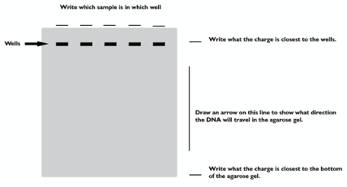
What affects the rate at which DNA travels through an agarose gel?

Which fragment(s) (the 1340 bp ribosomal DNA or the 580 bp great white-specific DNA) will be shown in the Porbeagle DNA control?

Which fragment(s) will be shown in the great-white shark control?

What does it indicate if no DNA is present on the gel?

Conclusion
Think about what conclusions you can make from the experiment. When making a conclusion, scientists have to interpret the results of the test. You can use the controls to make a determination about the unidentified fins.
Write a statement about your unknown sample when compared to the controls. Include your determination for the US Customs officials and an explanation of the results. This will be the statement that may be used in court if necessary.

The Basking shark is another shark species whose population is threatened. Could your unidentified fin belong to the Basking shark? How would you test this?

