**STUDENT NAME:**

Why Is There Such a High Prevalence of the Mystery Disease?

Student Challenge:

For this activity, your challenge is to come up with an explanation for why a seemingly deleterious allele (the allele for this mystery disease) is maintained in a population when, normally, deleterious alleles are removed from a population over time.

You will use some of the data that scientists used during the 1940s and 1950s to come up with your own explanation to account for the unusually high frequencies of this allele. The data are found on the following pages, and they come from Uganda, Africa.

Specifically, your goals will be to attempt to come up with theories to explain why:

a) There appear to be a high number (frequency) of carriers of the disease in certain locations.

b) Why there is such a mixture of high frequencies and low frequencies across the country

Provided documents:

· Uganda Tribes and Allele Frequencies

· Uganda Tribal Group Immigration Data

· Weather in Uganda

· Malaria’s Vicious Cycle

· Exposure to Malaria in Uganda

· Anthony Allison’s Research

Uganda Tribes and Allele Frequencies

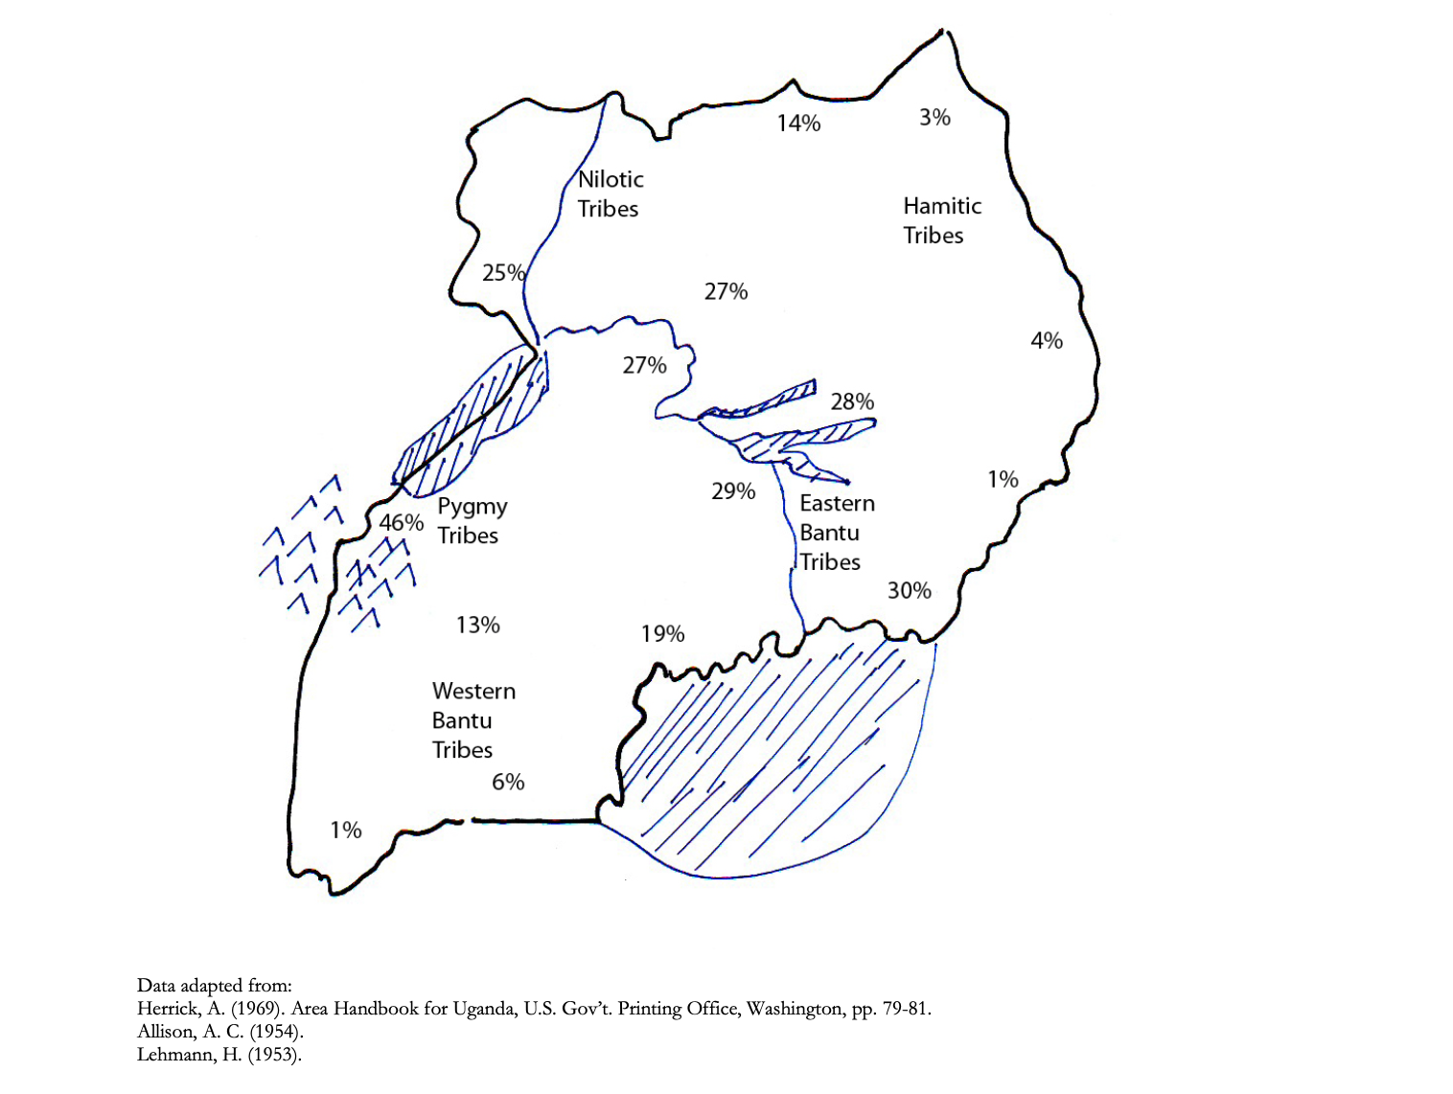

|  |  |  |
| --- | --- | --- |
| **Tribal Group** | **Allele Frequency** | **Between Group Contact\*** |
| Bantu (Eastern) | High | With Nilotic |
| Bantu (Western) | Moderate | None |
| Hamitic | Low | None |
| Nilotic | High | With Eastern Bantu |
| Pygmy | Very High | None |

*Contact means the amount of immigration, emigration, and intermarriage that occurred with potential neighbors

# Uganda Tribal Group Immigration Data Weather in Uganda

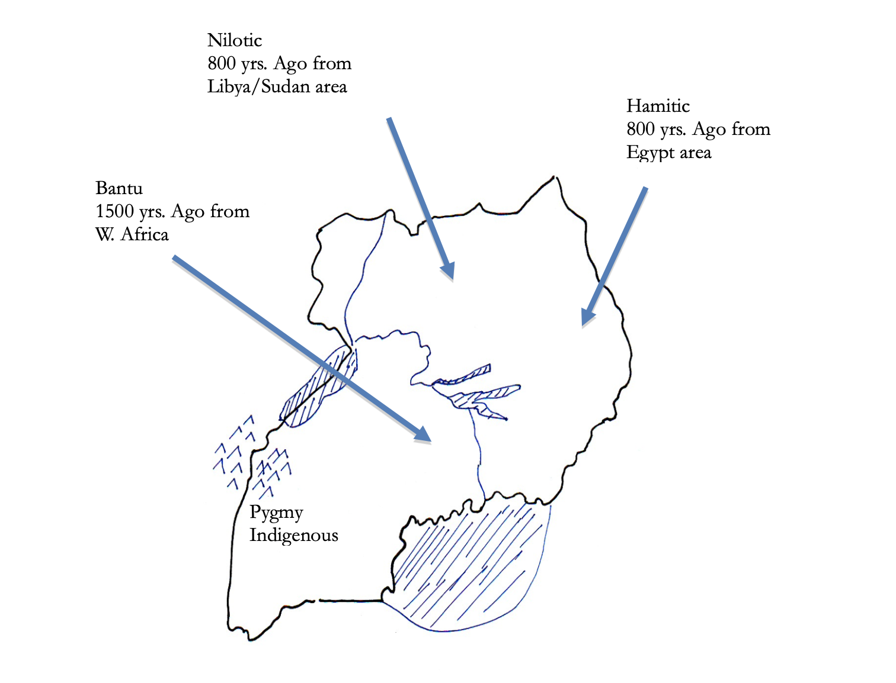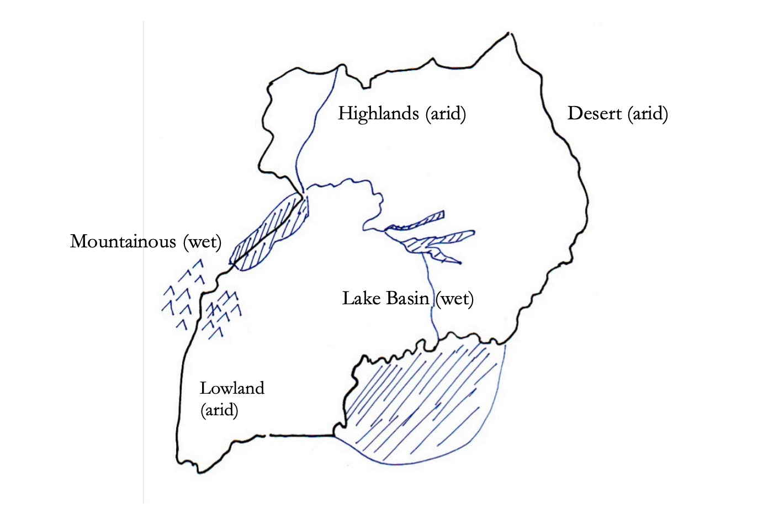

**1.** **Form a hypothesis that you think could explain the high frequency of sickle in some regions but not others.**

Malaria

While medical researchers were performing blood tests on various tribal groups in Uganda, they noticed that certain infectious diseases, such as malaria (*Plasmodium falciparum)*, were prevalent in the area. So, the researchers also qualified and quantified the degree of severity of malaria across Uganda.

Below is information regarding the malarial parasite’s life cycle and on the following pages are data regarding the incidence of malaria across Uganda.

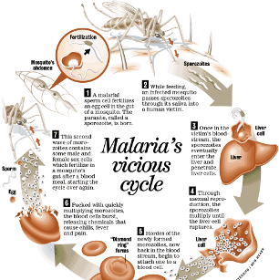

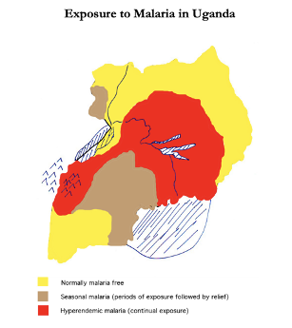

# 

# 

# 

# 

# Anthony Allison’s Research

Anthony C. Allison, a medical researcher in the early 1950’s, was interested in conducting further analyses on the apparent correlation between the seemingly high frequencies of the mystery disease and the presence of malaria in Uganda. Allison drew blood samples from Ugandan children to use for his research on the mystery disease. He analyzed the blood of each child to determine whether they were a carrier for the disease or had a normal genotype, and for the presence of the malarial parasite, *Plasmodium falciparum*, including its density in the red blood cells.

|  |  |  |  |
| --- | --- | --- | --- |
| **Genetic Disposition** | **Total Number of Children Examined** | **% Children with *P. falciparum*** | **Parasite Density Index** |
| Normal (N/N) | 247 | 46 | 5.9 |
| Carrier (N/S) | 43 | 28 | 4 |

Note: Parasite Density Index= a general measure of the amount of malarial parasites in the red blood cells per volume of blood.

(Adapted from: Allison, A.C. (1954) and Raper, A. (1959)).

**2.** **Form a new hypothesis that you think could explain the high frequency of sickle in some regions but not others.**

Malaria and Sickle Cell Anemia

Watch Biointeractive’s video about Anthony Allison’s research and answer the questions below.

1. Why are frequencies of the sickle cell gene higher in coastal Uganda and the region adjacent to Lake Victoria?

2. How did Allison test his hypothesis? What did he discover?

3. How does environment play a role in the natural selection of this allele?

4. How did the mutation in the hemoglobin gene occur? What other ways can mutations arise?

5. What does fitness mean in genetics?

6. Based on this information, explain how natural selection leads to adaptations of populations.

7. Why is sickle cell still seen in populations that don’t have malaria?