NEW STEPS TOWARDS THE CONSERVATION OF THE GREAT WHITE SHARK IN MEXICAN WATERS
Written By Dr. Oscar Sosa Nishizaki, Fisheries Ecology Laboratory, CICESE
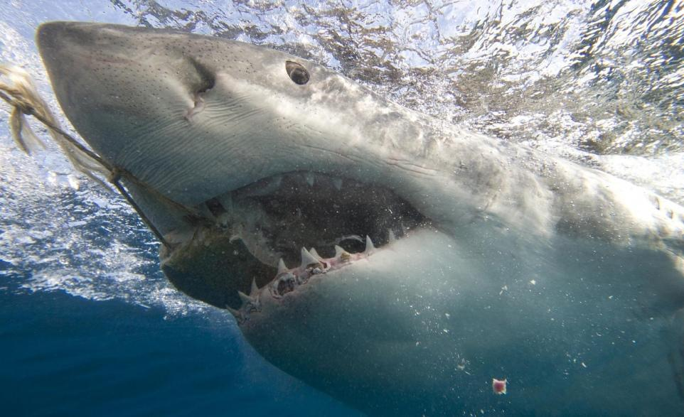
A large Great White Shark eating a piece of tuna off the coast of Port Lincoln in South Australia
© LeicaFoto

The Great White Shark (Carcharodon carcharias) inhabits the waters of northwest Mexico, including the Gulf of California. Every year, from August to February, sub-adult and adult individuals aggregate, perhaps to mate, in the waters around Guadalupe Island off the western coast of the Baja California Peninsula. Satellite tagging has shown that mature females move from Guadalupe Island towards the western Baja coast or into the Gulf of California, suggesting that these movements are related with pupping. Genetic analysis supports this connectivity.
Recently born and juvenile white sharks can be found along the west coast of Baja. Through satellite tagging, the movement of juvenile white sharks from the Southern California Bight, off the coast of Los Angeles, to Sebastian Vizcaino bay, in the central part of the peninsula, has been confirmed, suggesting that these waters are used as a nursery area. However, these waters are also used as fishing grounds for fisheries based in California and Baja California, and incidental catches of white sharks have been recorded on both sides of the US-Mexico border.
In Mexican waters, the main incidental catches of white sharks are taken during the summer months along Baja’s western coast by the local artisanal gillnet fishery that targets bony fishes, other shark species, and rays. In waters of the Gulf of California, juvenile and adults white sharks are also caught incidentally but the seasonal variation of these catches is still unclear.
Since 2002, a cage diving industry has developed based on the white sharks at Guadalupe Island. Today, the island is well recognized across the diving world, mainly for the crystal clear water that allows for a perfect view of the sharks. Due to its biodiversity, including endemic species, Guadalupe Island became a biosphere reserve in 2005; since then, several management actions have been taken to regulate the cage diving operations.
The white shark is protected in Mexico and is considered a threatened species. Since 2007, targeting white sharks has been prohibited in all shark fisheries. White shark conservation was further aided by a ban on shark fishing from May to July, which was established in 2012 for the entire Mexican Pacific coast to allow shark species to reproduce. Since incidental catches of white sharks continued to be recorded, in January 2014 the Mexican fisheries agency announced a new set of rules that prohibit bringing any white shark, whole or parts, especially jaws and fins, caught incidentally to port. The new rules also specify that the fisheries authorities and the Mexican Navy are responsible for enforcement.
Mexico understands its role in the protection of white sharks in the northeastern Pacific. At the end of 2013, the National Commission of Natural Protected Areas implemented an Action Program for the conservation of the white shark in Mexican waters. The program includes several actions related to research, outreach, incidental catch management, and conservation of the species across its distribution in the country. The first actions to be taken in 2014 are in regards to the management of cage diving at Guadalupe Island and the study of juveniles’ habitat at Vizcaino Bay.

