|  |  |  |  |  |  |
| --- | --- | --- | --- | --- | --- |
| Name: | **[insert name]** | Period: | **[insert Period]** | Date: | **[insert date]** |

Milk Comparison

# Background

The food Maria ate on the day she got her symptoms was the same that she normally eats at home, the only change was the milk that was in the refrigerator. Maria’s house usually has soy milk in the fridge, but her grandfather prefers fat free cow’s milk. Maria had cow’s milk on the day of the incident instead of her usual soy milk.

# 

# Ingredient Analysis

Below are the ingredients and nutrition facts about the soy milk Maria usually drinks and the cow’s milk she consumed on the day of the incident.

**Soy Milk (Silk Original)**

Ingredients:

Soymilk (Filtered Water, Soybeans), Cane Sugar, Vitamin and Mineral Blend (Tricalcium Phosphate, Calcium Carbonate, Vitamin A Palmitate, Vitamin D2, Riboflavin [B2], Vitamin B12), Sea Salt, Natural Flavor, Gellan Gum.

Nutrition Facts:

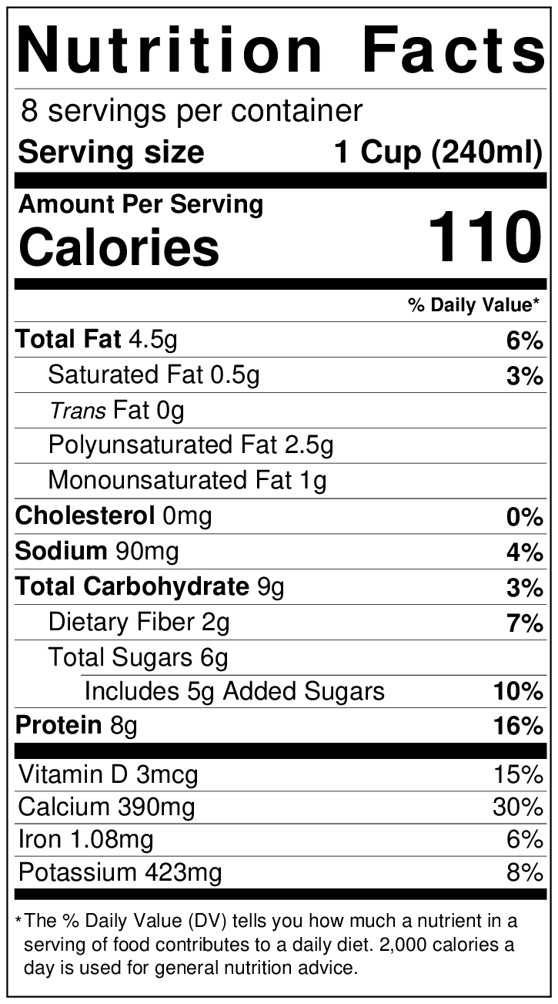

Carbohydrates present:

|  |  |
| --- | --- |
| Sugar | Percent of Total Sugars |
| Sucrose | 60% |
| Raffinose | 15% |
| Stachyose | 25% |

**Cow Milk (Organic Horizon Fat Free Milk)**

Ingredients:

Grade A Nonfat Organic Milk, Vitamin A Palmitate, Vitamin D3.

Nutrition Facts:

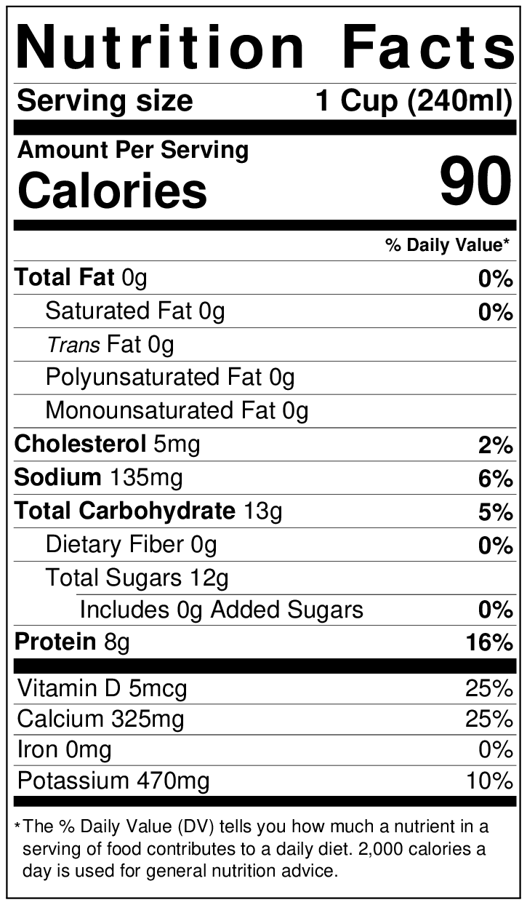

Carbohydrates present:

|  |  |
| --- | --- |
| Sugar | Percent of Total Sugars |
| Lactose | 99% |
| Glucose | <1% |
| Galactose | <1% |

## Data Analysis

Use the information on the previous page to answer the question below.

|  |  |
| --- | --- |
| **Question/ Prompt** | **Your Response** |
| 1. What similarities and differences do you notice between the two milks? |  |

## Using a Model

In the next section, you will use a computer model to look at the structures of the sugars found in these milks to see their similarities and differences.

### *Looking at Sucrose*

1. View the structure of [sucrose](https://www.biotopics.co.uk/jsmol/sucrose.html).
2. Answer the question below.

|  |  |
| --- | --- |
| **Question/ Prompt** | **Your Response** |
| Is sucrose a monosaccharide or a polysaccharide? How do you know? |  |

### Looking at Lactose

1. View the structure of [lactose](https://www.biotopics.co.uk/jsmol/lactose.html).
2. Answer the questions below.

|  |  |
| --- | --- |
| **Question/ Prompt** | **Your Response** |
| Is lactose a monosaccharide or a polysaccharide? How do you know? |  |
| Do you think the milk was the culprit of Maria’s symptoms (stomach pain, gas diarrhea)? Why or why not? |  |

### 