|  |  |  |  |  |  |
| --- | --- | --- | --- | --- | --- |
| Name: | **[insert name]** | Period: | **[insert Period]** | Date: | **[insert date]** |

Blood Count Data

# Background

In 2012, Dr. Akinsegun Akinbami and his team were looking to find out if patients with sickle cell anemia have different concentrations of their diverse blood cells than those without sickle cell anemia. Sickle cell anemia is a blood disorder that affects the red blood cells. The team analyzed the blood of 103 sickle cell patients and 98 controls and measured the amount of hemoglobin and white blood cells in each subject.

## Data Analysis

The concentrations for hemoglobin and white blood cells are presented below in the chart. Use the data to answer the questions on the following page.

|  |  |  |  |  |  |  |
| --- | --- | --- | --- | --- | --- | --- |
|  | **Mean values of blood count parameters** | | | | | |
|  | **CASES** | | | **CONTROLS** | | |
|  | **MALE** | **FEMALE** | **OVERALL** | **MALE** | **FEMALE** | **OVERALL** |
| Hemoglobin (g/dL) | 8.11 ± 1.53 | 7.78± 1.42 | 7.93± 1.4 | 13.83± 1.32 | 11.96± 3.10 | 13.83± 1.32 |
| White Blood Cells (cells x 109/L) | 10.82 ± 4.95 | 9.83 ± 2.86 | 10.27 ± 3.96 | 5.75 ± 1.63 | 5.63 ± 1.59 | 5.67 ± 1.59 |
| Data from Akinbami, A., Dosunmu, A., Adediran, A., Oshinaike, O., Adebola, P., & Arogundade, O. (2012). Haematological values in homozygous sickle cell disease in steady state and haemoglobin phenotypes AA controls in Lagos, Nigeria. BMC research notes, 5, 396. <https://doi.org/10.1186/1756-0500-5-396> | | | | | | |

|  |  |
| --- | --- |
| **Question/Prompt** | **Your Response** |
| 1. What can we conclude about the effect of sickle cell disease on hemoglobin concentrations? | **[Answers are intentionally BLUE]** |
| 1. What can we conclude about the effect of sickle cell disease on white blood cell counts? |  |
| 1. In this study, did the scientists find any difference between males and females? |  |
| 1. Why do you think the scientists displayed the data in this way? (reported by case or control, then by gender or overall) |  |

## Drawing Conclusions

Take a look at our original patient blood smears and the blood analysis that was received for each patient below. Remember the red circles are red blood cells and the purple circles are white blood cells.

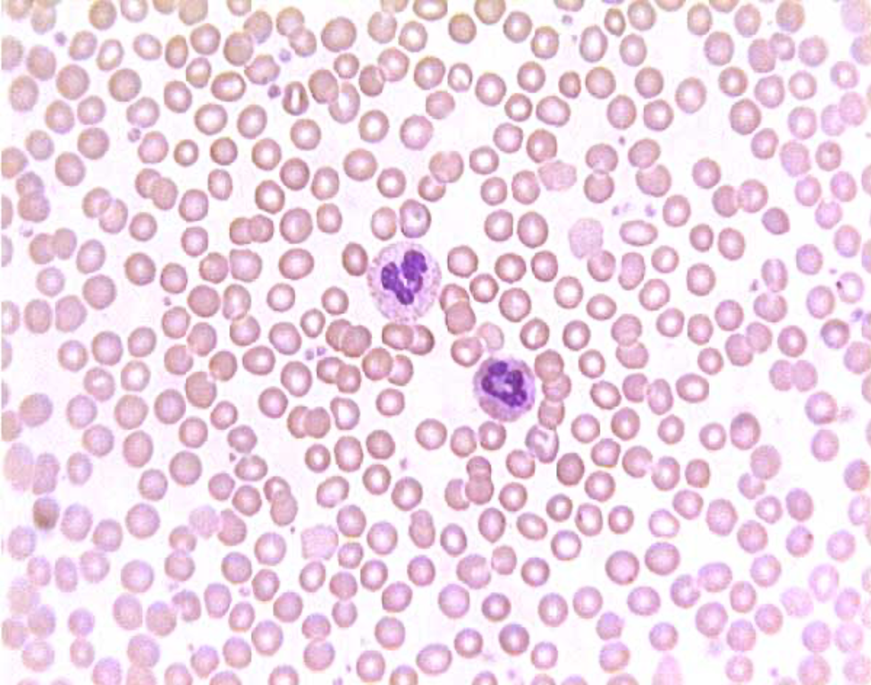 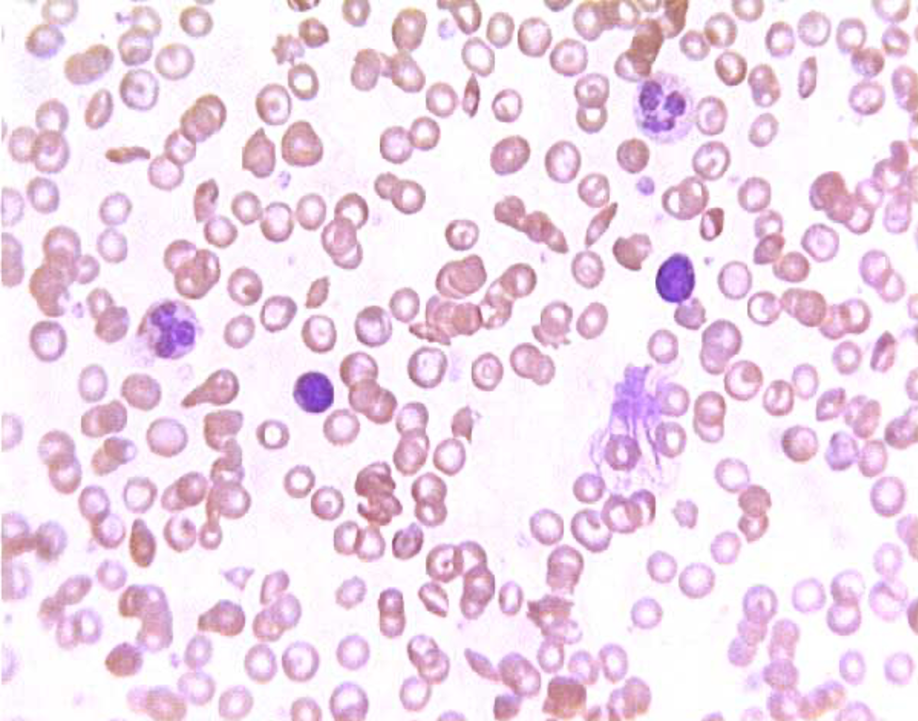

Patient 1 Patient 2

|  |  |  |
| --- | --- | --- |
|  | **Patient 1** | **Patient 2** |
| Hemoglobin (g/dL) | 12.6 | 9.1 |
| White Blood Cells (cells x 109/L) | 5.61 | 10.13 |

Answer the question on the following page.

|  |  |
| --- | --- |
| **Question/Prompt** | **Your Response** |
| 1. After looking at the blood smear and blood analysis of Patients 1 and 2 in addition to the data from Dr. Akinbambi’s study, what diagnosis could you offer Patient 2? | **[Answers are intentionally BLUE]** |