|  |  |  |  |  |  |
| --- | --- | --- | --- | --- | --- |
| Name: | **[insert name]** | Period: | **[insert Period]** | Date: | **[insert date]** |

Lactose Intolerance Gene?

# Background

Based on Maria’s symptoms created by the cow’s milk that she drank at her grandfather’s house, the doctors are confident that Maria is lactose intolerant. To better understand the mechanism of her lack of lactase, the doctors looked at her genes to see if there were mutations for the lactase gene (*LCT)*.

## Looking at LCT

The gene that codes for lactase (*LCT*) is found on the long arm of chromosome 2 indicated with the orange arrow below..

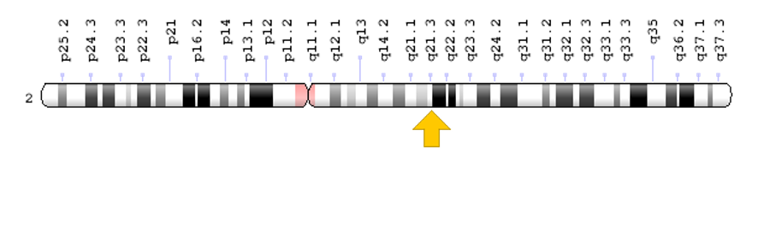

Credit: [Genome Decoration Page/NCBI](https://www.ncbi.nlm.nih.gov/genome/tools/gdp)

There are at least 9 known *LCT* gene mutations. These mutations of the *LCT* gene result in infants that are unable to break down lactose in breast milk or formula. The *LCT* gene mutations change an amino acid, a protein building block, causing a misshapen protein or result in an enzyme sequence that is abnormally short. The mutations interfere with the function of the enzyme leading to undigested lactose.

Maria never had any issue digesting lactose as a kid. Only now does it appear that lactose is giving her issues.

|  |  |
| --- | --- |
| **Question/Prompt** | **Your Response** |
| 1. Based on Maria’s history with lactose tolerance, do you think it is likely that Maria has a mutation in the *LCT* gene? |  |

## Looking at LCT Expression

Maria had her genes tested only to find out that she doesn’t have any mutations in the *LCT* gene. To investigate further, testing was done to see if her body was producing lactase. Doctors took some of her DNA to measure that amount of lactase mRNA was being produced through a process called reverse transcription PCR or RT-PCR. They did the same thing measuring sucrase mRNA as a control.

Look below to see the results of Maria’s RT-PCR test. Maria’s samples are labeled 1 and the control, a patient who is not lactose intolerant, is labeled 2. The *LCT* mRNA results are on the left and the sucrase results are on the right.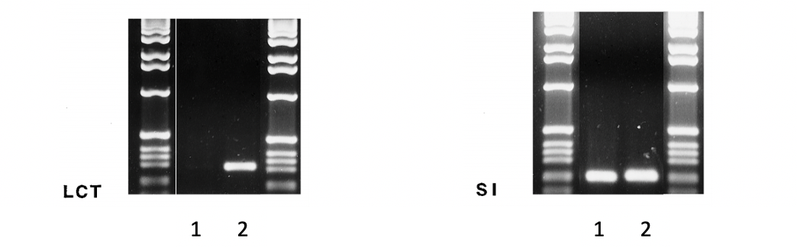

### *Data Analysis*

Using the data above, answer the following questions.

|  |  |
| --- | --- |
| **Question/Prompt** | **Your Response** |
| 1. Is Maria producing any lactase mRNA? Based on her mRNA results, would you expect to see any lactase present in a protein test? |  |
| 1. Considering Maria doesn’t have mutations in *LCT*, what could be a factor in the *LCT* transcription? |  |

Data adapted from Wang, Y., Harvey, C., Hollox, E., Phillips, A., Poulter, M., & Clay, P. et al. (1998). The genetically programmed down-regulation of lactase in children. *Gastroenterology*, *114*(6), 1230-1236. doi: 10.1016/s0016-5085(98)70429-9