|  |  |  |  |  |  |
| --- | --- | --- | --- | --- | --- |
| Name: | **[insert name]** | Period: | **[insert Period]** | Date: | **[insert date]** |

A Closer Look at the Cause of Sickle Cell: References

# Background

Your research has determined that sickle cell hemoglobin differs from normal hemoglobin in the net negative charge on the proteins. This discovery is an important one; it identifies a characteristic that can be used to diagnose sickle cell anemia. However, it does not tell us what causes sickle cell anemia or why the proteins are different. Advances in molecular biology and our understanding of DNA in the past two decades have provided us with more insights into the cause of sickle cell anemia. See if you can use the following data obtained from research in molecular biology to uncover more information about sickle cell anemia.

**Document 1** The DNA base sequences of the first seven amino acids for both normal and sickle cell hemoglobin

**Document 2** A chart of mRNA codons and their corresponding amino acids

**Document 3** The structural formulas for the amino acids and their corresponding charges

## Document 1

The DNA sequence of bases for the first 7 amino acids in normal hemoglobin is:

5' GTGCACCTGACTCCTGAGGAG 3'

3' CACGTGGACTGAGGACTCCTC 5'

The DNA sequence of bases for the first 7 amino acids in sickle cell hemoglobin is:

5' GTGCACCTGACTCCTGTGGAG 3'

3' CACGTGGACTGAGGACACCTC 5'

**REMINDER**:

5'…ATGGCCTGGACTTCA…3' **Sense strand of DNA**

3'…TACCGGACCTGAAGT…5' **Antisense strand of DNA**



Transcription of antisense strand

5'…AUGGCCUGGACUUCA…3' **mRNA**



Translation of mRNA

Met-Ala-Trp-Thr-Ser- **Peptide**

## Document 2

A chart of mRNA codons and their corresponding amino acids.

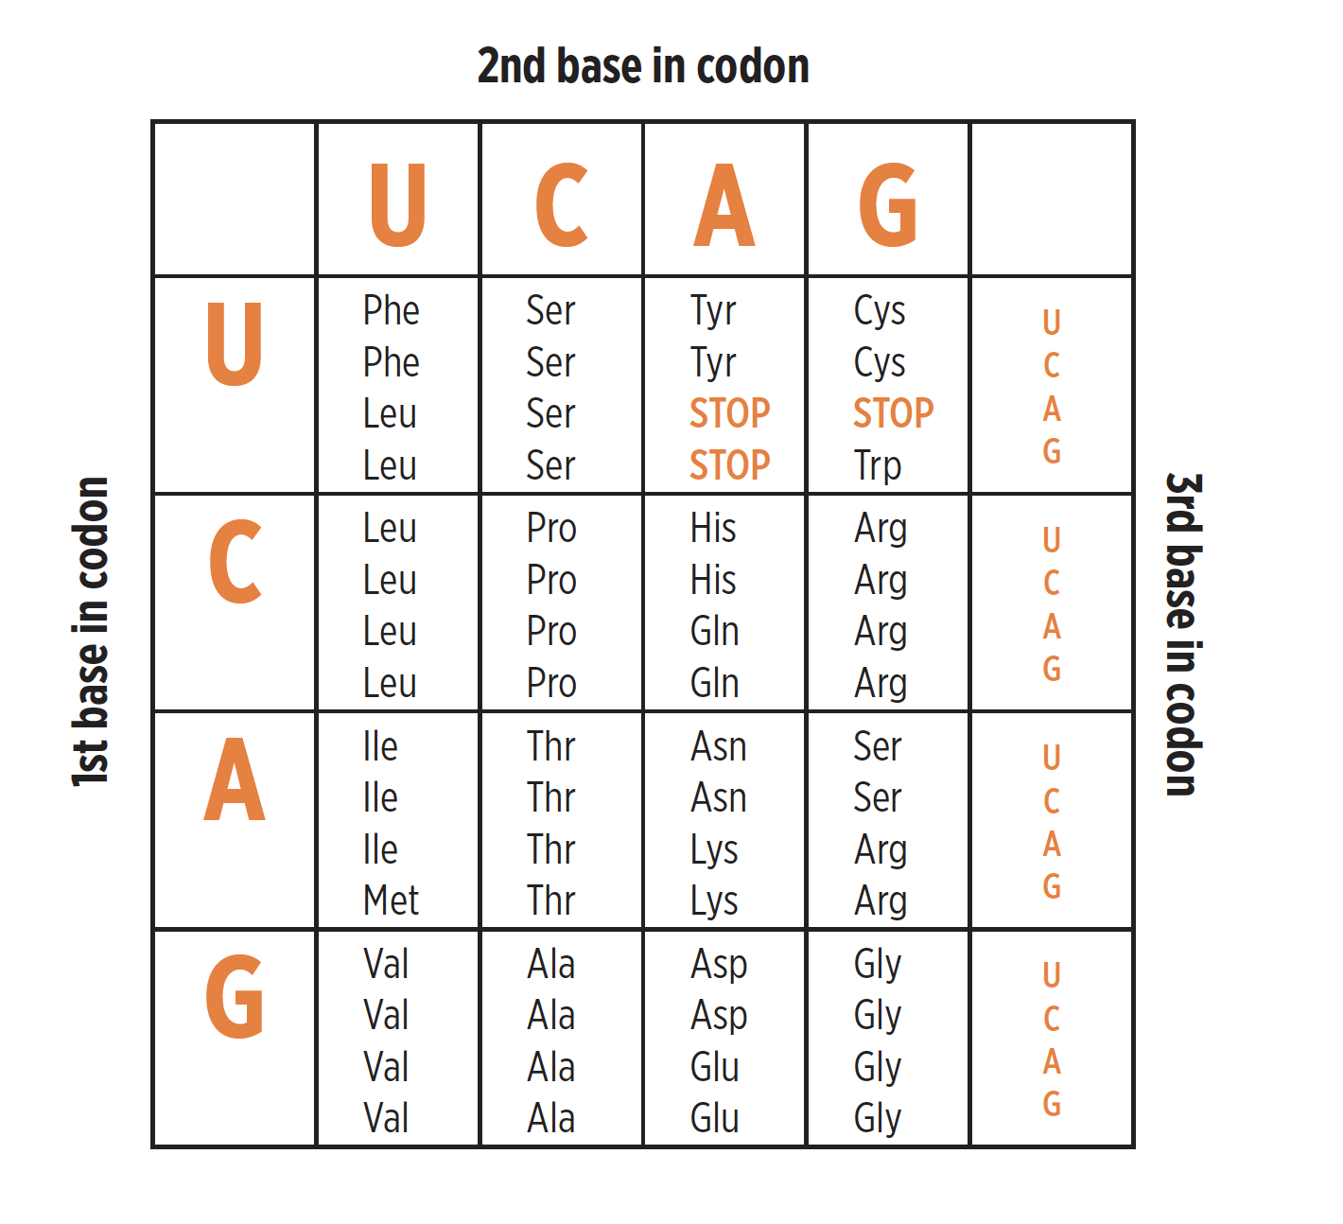

## Document 3

Below are the structural formulas for the amino acids. Note that the backbone of the amino acid contains one positive charge (+H3N) and one negative charge (COO--). Since the side chain of proline connects to the nitrogen of the backbone, it has a +H2N. Sum the charges in the side chain to calculate the charge of the specific amino acid.

**Amino acids with hydrophobic side groups**

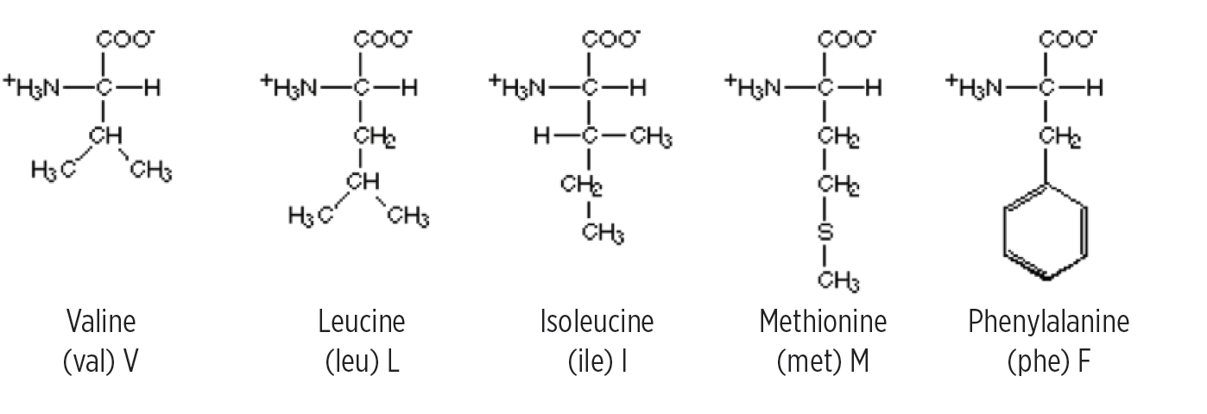

**Amino acids with hydrophilic side groups**

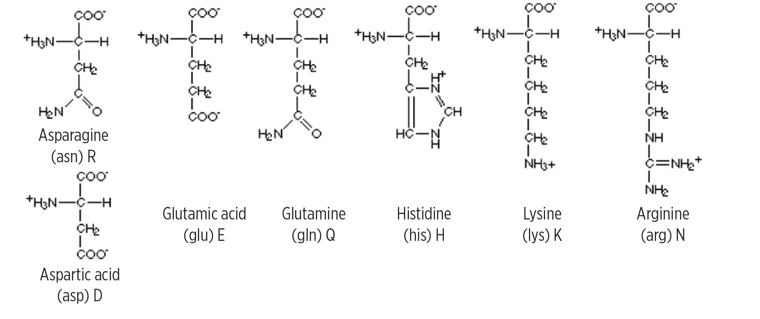

**Aminos acids that are in between**

