Name: | [insert name] | Period: | [insert Period] | Date: | [insert date]

Electrophoresis Analysis

Background
To better understand how sickle cell anemia is caused, scientists have used molecular biology techniques, like gel electrophoresis. This is a technique that uses electricity to cause samples to move and sometimes separate.

Video Questions
Watch the video “Mystery of the Crooked Cell: Investigating the Heredity of a Blood Disorder” and answer the questions below.

Question/Prompt | Your Response
- Why is it important to include normal and sickle hemoglobin in our patient’s test? | [Answers are intentionally BLUE]
- Which end of the electrophoresis chamber will the hemoglobin be attracted to? (Highlight your response.) | - Positive  - Negative  - Neither  - Both
- How will we be able to differentiate between the hemoglobin samples if they are all migrating to the same end of the gel? (Highlight your response.) | - You can’t  - Varying charges  - Size fragments  - Voltage
- What type of hemoglobin do you expect to be more attracted to the positive end of the gel? (Highlight your response.) | - Normal  - Sickle  - They will be attracted equally

Drawing Conclusions
View the following patient result and answer the following question.
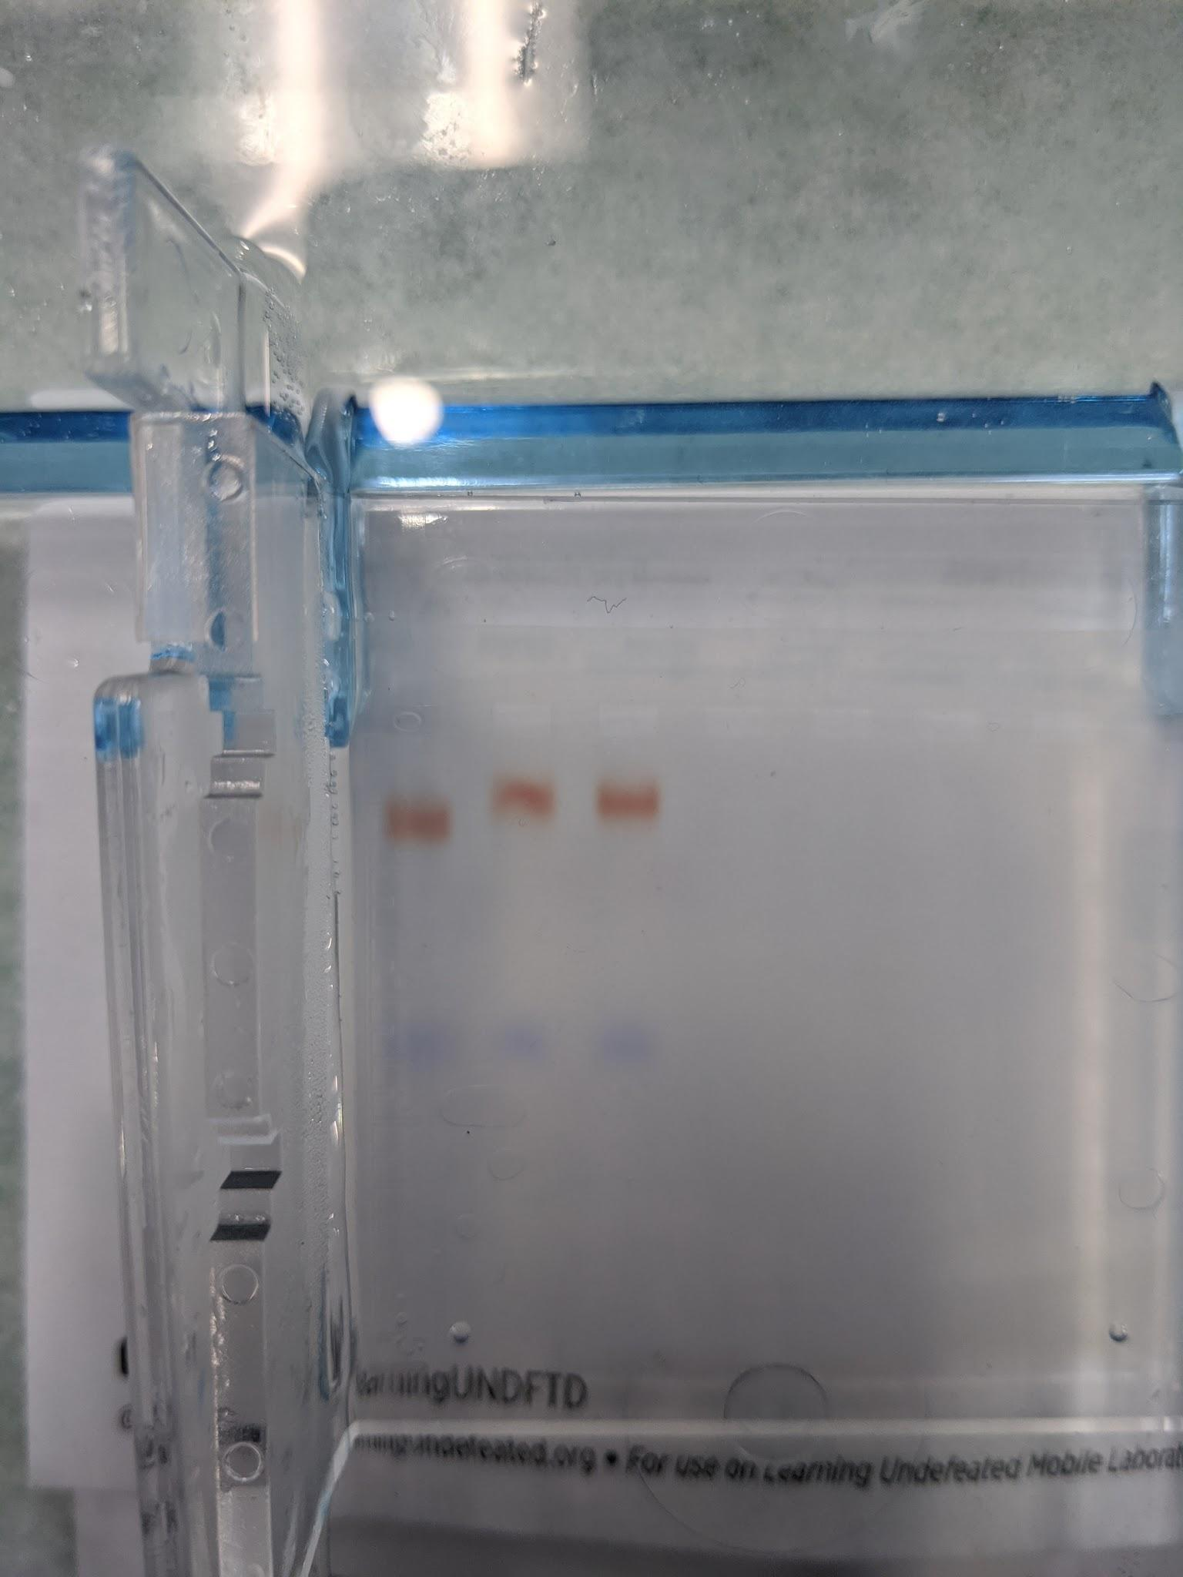

N S P

Question/Prompt | Your Response
- Based on the given result, is the patient sample (in the third well) healthy or sickle cell anemic? How do you know | [Answers are intentionally BLUE]

