|  |  |  |  |  |  |
| --- | --- | --- | --- | --- | --- |
| Name: | **[insert name]** | Period: | **[insert Period]** | Date: | **[insert date]** |

Gene Regulation in Eukaryotes

# Background

The last tests run by doctors showed that Maria did not have a mutation in the lactase gene (*LCT*) and that she did not have any lactase mRNA. This means that the gene was not being transcribed and therefore there was no protein to break down any present lactose.

Maria’s genetic tests did show another mutation that the doctors think might play a role in her lactose intolerance.

## 

## Looking at *MCM6*

Though Maria’s genetic test showed no mutations in the *LCT* gene, it did show a single nucleotide polymorphism (SNP) about 14,000 base pairs upstream of *LCT* in another gene called *MCM6*.The *MCM6* gene provides instructions for making part of the MCM complex, a group of proteins that functions as a helicase. Helicases attach to particular regions of DNA and temporarily unwind the two spiral strands of these molecules for transcription and replication.

13,910 bp before the start of the *LCT* gene and within the *MCM6* gene, Maria was found to have the base cytosine present on both chromosomes. Below shows the lactase activity for people with the same SNP pairing (CC) compared to two other pairings (TC and TT).

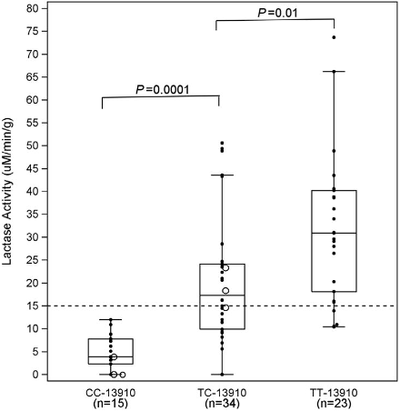

### *Drawing Inferences*

Use the graph above to answer the following question.

|  |  |
| --- | --- |
| **Question/Prompt** | **Your Response** |
| 1. Based on the graph above, do you think Maria’s SNP (CC at 13,910 before *LCT)* plays a role in lactase expression? Why or why not? |  |

## Gathering Information

Watch HeyNowScience’s video “[Eukaryotic Gene Regulation](https://www.youtube.com/watch?v=PTKF1hpmcWQ)” (from 9:01-12:49) and answer the questions below.

|  |  |
| --- | --- |
| **Question/Prompt** | **Your Response** |
| 1. After watching the video, what role do you think the *MCM6* gene plays in *LCT* expression? |  |
| 1. How does Maria’s SNP affect *LCT* expression? |  |

Data from Baffour-Awuah, N. Y., Fleet, S., Montgomery, R. K., Baker, S. S., Butler, J. L., Campbell, C., Tischfield, S., Mitchell, P. D., Moon, J.E., Allende-Richter, S., Fishman, L. Bousvaros, A., Fox, V., Kuokkanen, M., Montgomery, R. K., Grand, R. J., & Hirschhorn, J. N. (2015). Functional Significance of Single Nucleotide Polymorphisms in the Lactase Gene in Diverse US Patients and Evidence for a Novel Lactase Persistence Allele at −13909 in Those of European Ancestry. *Journal of Pediatric Gastroenterology and Nutrition,* *60*(2), 182-191. doi:10.1097/mpg.0000000000000595