|  |  |  |  |  |  |
| --- | --- | --- | --- | --- | --- |
| Name: | **[insert name]** | Period: | **[insert Period]** | Date: | **[insert date]** |

Gene Regulation for Specialized Cells

# Background

Every cell in the human body contains the same DNA, yet somehow they all look very different and have very different functions. This is all due to the way the genes are expressed in each cell.

We know that Maria has a SNP that makes the enhancer for *LCT* less likely to bind to activators, explaining her lack of expression of lactase. Where in her body has the expression for lactase changed?

In this activity, you will use a simulation to determine what temperature and pH lactase prefers in order to determine what part of the body normally expresses lactase.

## 

# Using a Simulation

## Testing for Optimal Temperature

First, we want to know what temperature the enzyme functions best at. We can determine this by measuring the amount of glucose formed over time and calculate the rate of the reaction, the concentration of lactose (in mg/dL) broken down per minute. Vmax, the reaction rate, is recorded on the second tab of the simulation.

1. Open the [Lactase Enzyme Activity with Data Analysis](https://sites.google.com/site/biologydarkow/lactase-enzyme-simulation).
2. Start with the initial lactose at 500 mg/dL and the pH at 7. Do not vary these parameters while testing for temperature, they are environmental controls. The temperature is in degrees Celsius.
3. Vary the temperature by 20℃. Run each experiment 5 times (for reliability in the results).
4. Record the rate of the reaction (Vmax) at 500 mg/dL of lactose in the table below. The rate of the reaction should be in mg/dL of glucose per minute.
   1. Dragging your mouse across the graph will give you the (X,Y) coordinates for each point.
5. After collecting data for 5 trials, calculate the mean and the standard deviation for each temperature tested.

|  |  |  |  |  |  |
| --- | --- | --- | --- | --- | --- |
|  | **0℃** | **20℃** | **40℃** | **60℃** | **80℃** |
| **Trial 1** |  |  |  |  |  |
| **Trial 2** |  |  |  |  |  |
| **Trial 3** |  |  |  |  |  |
| **Trial 4** |  |  |  |  |  |
| **Trial 5** |  |  |  |  |  |
| **Mean** |  |  |  |  |  |
| **Standard Deviation** |  |  |  |  |  |

### *Data Analysis*

1. On the image included in the table below, create an appropriately labeled graph to illustrate the sample means of the five temperatures tested with standard deviation as your error bars.
2. Answer the questions below the graph.

|  |  |
| --- | --- |
| **Your Graph** | |
|  | |
| **Question/ Prompt** | **Your Response** |
| What are the results of the simulation? What is the optimal temperature for lactase? Explain. |  |

## Testing for Optimal pH

Next, we want to know what pH the enzyme functions the best at. We can determine this by measuring the amount of glucose formed over time and calculate the rate of the reaction, the concentration of lactose (in mg/dL) broken down per minute. Vmax, the reaction rate, is recorded on the second tab of the simulation.

1. Open the [Lactase Enzyme Activity with Data Analysis](https://sites.google.com/site/biologydarkow/lactase-enzyme-simulation).
2. Start with the initial lactose at 500 mg/dL and the temperature at 37**℃.** Do not vary these parameters while testing for pH, they are environmental controls.
3. Vary by a pH of 3. Run each experiment 5 times (for reliability of the results).
4. Record the rate of the reaction (Vmax) at 500 mg/dL in the table below. The rate of the reaction should be in mg/dL of glucose per minute.
   1. Dragging your mouse across the graph with give you the (X,Y) coordinates for each point.
5. After collecting data for 5 trials, calculate the mean and the standard deviation for each temperature tested.

|  |  |  |  |  |  |
| --- | --- | --- | --- | --- | --- |
|  | **pH 1** | **pH 4** | **pH 7** | **pH 10** | **pH 13** |
| **Trial 1** |  |  |  |  |  |
| **Trial 2** |  |  |  |  |  |
| **Trial 3** |  |  |  |  |  |
| **Trial 4** |  |  |  |  |  |
| **Trial 5** |  |  |  |  |  |
| **Mean** |  |  |  |  |  |
| **Standard Deviation** |  |  |  |  |  |

### *Data Analysis*

1. On the image included in the table below, create an appropriately labeled graph to illustrate the sample means of the five pH levels tested with standard deviation as your error bars.
2. Answer the questions below the graph.

|  |  |
| --- | --- |
| **Your Graph** | |
|  | |
| **Question/ Prompt** | **Your Response** |
| What are the results of the simulation? What is the optimal pH for lactase? Explain. |  |

# Comparing Data to Accepted Values

Compare your temperature and pH data to these [accepted values](https://drive.google.com/file/d/1oIUyCaLCeALcb8t2hAhoCcrBSgDCsvCv/view?usp=sharing) and answer the question below.

|  |  |
| --- | --- |
| **Question/ Prompt** | **Your Response** |
| Where do you think the lactase enzyme is usually expressed when its regulators allow for expression? Explain |  |

## Deny or Support your Claim?

Look below at the provided image below and answer the following question.

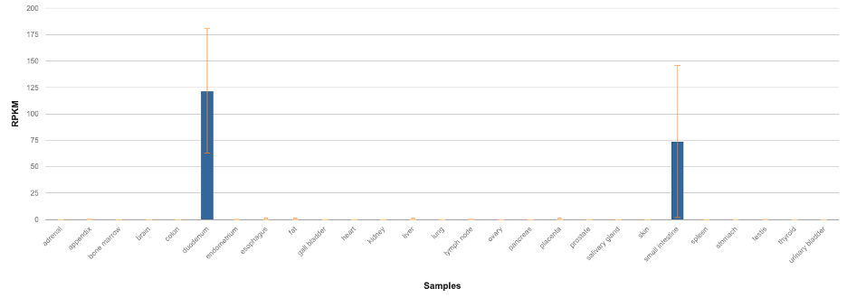

Graph shows the organs that exhibit RNA transcription of *LCT*.

Data from Fagerberg, L., Hallström, B. M., Oksvold, P., Kampf, C., Djureinovic, D., Odeberg, J., Habuka, M., Tahmasebpoor, S., Danielsson, A., Edlund, K., Asplund, A., Sjöstedt, E., Lundberg, E., Szigyarto, C. A.-K., Skogs, M., Takanen, J. O., Berling, H., Tegel, H., Mulder, J., … Uhlén, M. (2013). Analysis of the Human Tissue-specific Expression by Genome-wide Integration of Transcriptomics and Antibody-based Proteomics. Molecular & Cellular Proteomics, 13(2), 397–406. https://doi.org/10.1074/mcp.m113.035600

|  |  |
| --- | --- |
| **Question/ Prompt** | **Your Response** |
| Does this data support your claim for the previous question? Why or why not? |  |