|  |  |  |  |  |  |
| --- | --- | --- | --- | --- | --- |
| Name: | **[insert name]** | Period: | **[insert Period]** | Date: | **[insert date]** |

Temperature and pH Accepted Values

# Background

Because every part of our body has a different function, it has ideal temperature and pH levels. Use the provided information to determine where the lactase enzyme works best.

## Temperature Data

Normal human body temperature is typically stated as 36.5-37.5 °C (97.7-99.5°F). Use the image below to see how the body temperature differs throughout the body.

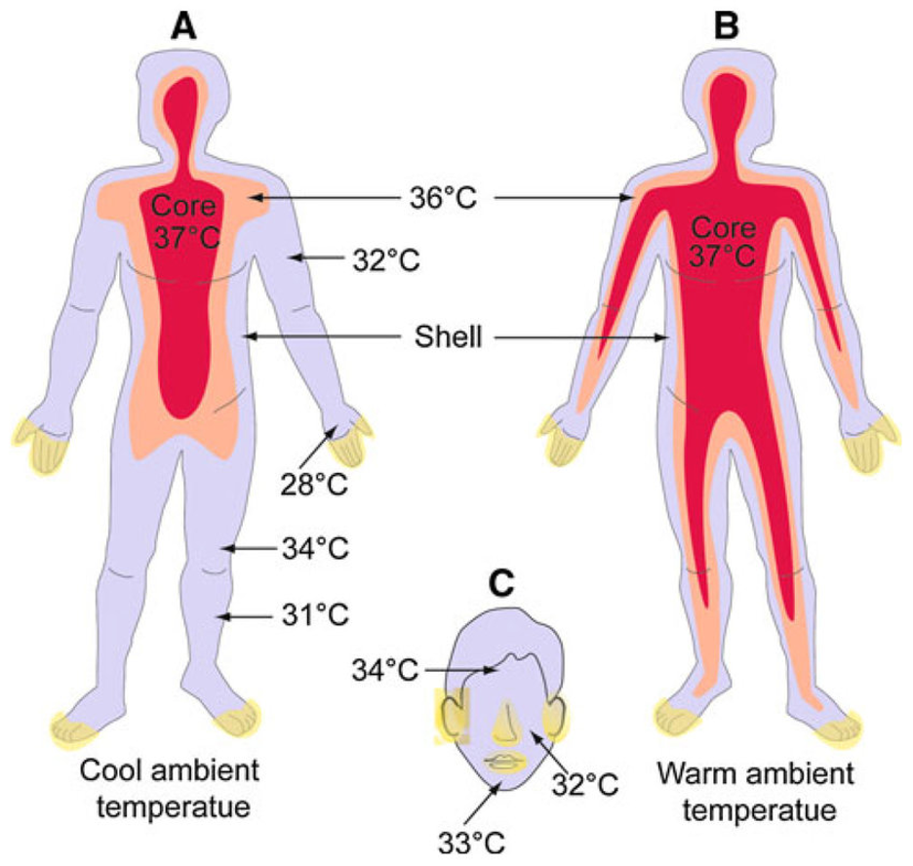

Illustration of body temperature in the human body. a) In cold environments, the area preserved at 37°C contracts and the shell area expands. b) The body volume preserved at 37°C expands. The concepts presented here are generalizations; a number of variables, such as gender, age, and individual difference can affect the temperature distribution.

Data from White, M. D., Bosio, C. M., Duplantis, B. N., & Nano, F. E. (2011). Human body temperature and new approaches to constructing temperature-sensitive bacterial vaccines. Cellular and Molecular Life Sciences, 68(18), 3019–3031. https://doi.org/10.1007/s00018-011-0734-2

## pH Data

The pH of the digestive system varies greatly. Below shows the average pH through different gastrointestinal organs/regions.

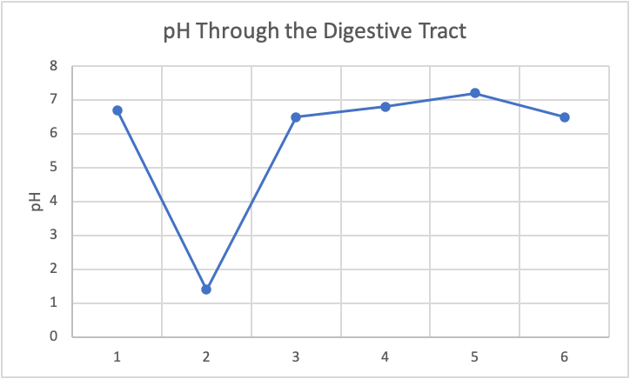

*Average pH through different gastrointestinal organs. Numbers each represent a different organ or organ part. (1) mouth, (2) stomach, (3) proximal small intestine, (4) mid small intestine, (5) distal small intestine, (6) colon.*

*Data adapted from the following:*

Ibekwe, V. C., Fadda, H. M., McConnell, E. L., Khela, M. K., Evans, D. F., & Basit, A. W. (2008). Interplay Between Intestinal pH, Transit Time and Feed Status on the In Vivo Performance of pH Responsive Ileo-Colonic Release Systems. Pharmaceutical Research, 25(8), 1828–1835. <https://doi.org/10.1007/s11095-008-9580-9>

Bibby, B. G., Mundorff, S. A., Zero, D. T., & Almekinder, K. J. (1986). Oral food clearance and the pH of plaque and saliva. The Journal of the American Dental Association, 112(3), 333–337. <https://doi.org/10.1016/s0002-8177(86)23012-3>