**STUDENT NAME:**

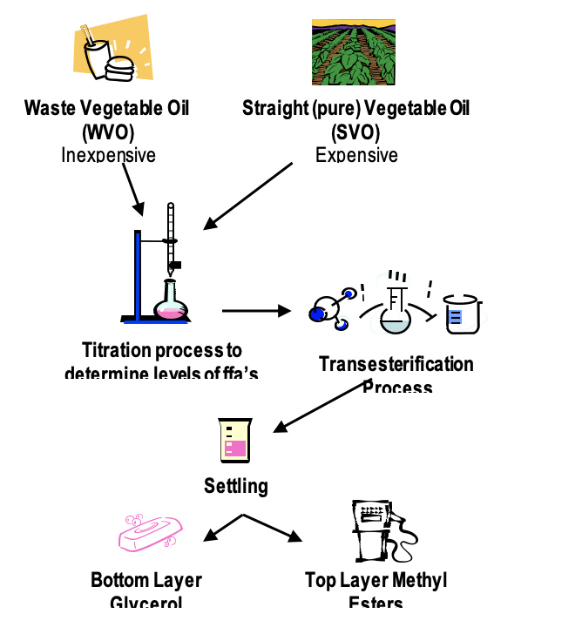

Learning Undefeated has purchased new generators for its mobile labs that can run on biodiesel fuel. Biodiesel is a renewable form of energy that is manufactured from the natural oils found in vegetables. It is used in diesel engines and provides a cleaner burning alternative to petroleum-based diesels.

Biodiesel is created from vegetable oil through a chemical process called **transesterification**. This process uses sodium hydroxide, a very strong base, to convert the vegetable oil into a combustible liquid. The transesterification process separates the oil into two products, methyl esters (biodiesel fuel) and glycerol (a valuable by-product used to make soap and other skin care products).

Unfortunately, the transesterification reaction is sensitive to the presence of free fatty acids, which occur more prevalently in waste vegetable oil that has degraded over time. Luckily, the same chemical that is used to catalyze the reaction which produces biodiesel, sodium hydroxide, can also be used to eliminate or “neutralize” these acids.

The levels of free fatty acids can be determined through a process called acid/base **titration**. A titration is a way of determining the concentration of a substance by adding a known concentration of a reagent to it until we see an effect. In our case, we will add a known concentration of sodium hydroxide to the free fatty acids contained in vegetable oil until we see a color change (this color change is due to a change in pH which we can observe by adding a pH indicator). When the mixture’s color has been changed (from yellow to bright pink), then it has reached its **equivalence point** and the free fatty acids have been neutralized.

2NaOH + [free fatty acid] à Na2[neutralized free fatty acid] + 2H2O

We need your help to determine the molarity of free fatty acids in the waste vegetable oil. To do so you will need to find the equivalence point for the waste vegetable oil.

**Part I: Introduction**

1. What is biodiesel?

1. Why is making biodiesel important?

1. Why is biodiesel not readily available at most gas stations?

**Part II: Titrating Straight Vegetable Oil**

1. What is molarity?
2. Which oil, straight vegetable oil or waste vegetable oil, do you think has more free fatty acids (FFAs)?

1. The titration with straight vegetable oil (SVO) is conducted. Be sure to calculate how much NaOH (sodium hydroxide) was used to neutralize the oil.

|  |  |
| --- | --- |
| **Table 1 – Amount of 0.01M NaOH added to the straight vegetable oil (SVO)** | |
| **Final** reading of 0.01 M NaOH solution in burette | _______**mL** |
| **Initial** reading of 0.01 M NaOH solution in burette | _______**mL** |
| **Total** amount of 0.01 M NaOH added to the beaker | _______**mL** |

1. Use the example titration curve below and your knowledge of acids and bases to answer the following questions.

**Figure 1: Example Titration Curve**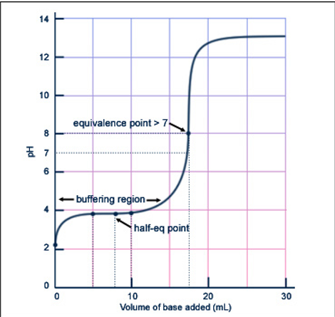

* 1. When does the equivalence point occur?

* 1. Why does the equivalence point for this titration occur at a pH > 7?

**Part III: Titrating Waste Vegetable Oil**

1. Which oil, straight vegetable oil or waste vegetable oil, will require more NaOH to neutralize the FFAs?
2. The titration with 1000 μL **(Vacid)** waste vegetable oil (WVO) is conducted. Be sure to calculate how much NaOH (sodium hydroxide) was used to neutralize the oil.

|  |  |
| --- | --- |
| **Table 2 – Amount of 0.01 M NaOH added to Waste Vegetable Oil (WVO)** | |
| **Final** reading of 0.01 M NaOH solution in burette | ________**mL** |
| **Initial** reading of 0.01 M NaOH solution in burette | ________**mL** |
| **Total** amount of 0.01 M **(Mbase)** NaOH added to the beaker | ________**mL (Vbase)** |

**Part IV: Determine the ratio of acid to base**

2NaOH + [free fatty acid] à Na2 [neutralized free fatty acid] + 2H2O

1. Based upon the above reaction, what is the mol ratio of acid to base (i.e. how many mols of free fatty acid can be “neutralized” by only 1 mol of NaOH) ?

_______ (**C**)

**Part V: Determine the molarity of free fatty acids**

Because the equivalence point occurs when the amount of acid is equal to the amount of base, we can derive the following equation, which can be used to determine the molarity of free fatty acids in the WVO:

Macid = (Mbase x Vbase x C) / Vacid

1. Calculate Macid (the molarity of free fatty acids in the waste vegetable oil) by plugging in the numbers for our variable. (*Hint: they are labeled after each value in bold on this page).*

**Part VI: Scaling measurements**

1. We tested 1000 μL of our waste vegetable oil which comes from a barrel that contains 160 L of our waste vegetable oil. How much 0.01M NaOH should be added to neutralize all of the free fatty acids?