**STUDENT NAME:**

Chemistry of Explosions

Identifying Chemical and Physical Changes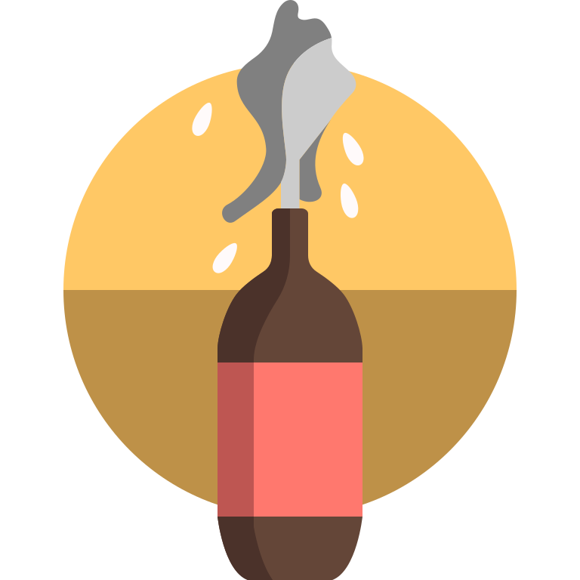

**BOOM! POW!** There’s been an explosion! An explosion is a rapid increase in volume and release of energy in an extreme manner, usually with the generation of high temperatures and the release of gases. Explosions can be very dangerous (like a bomb or a volcano), but they can also be really cool (like fireworks and rockets).

Explosions can occur due to chemical changes and physical changes. Remember physical changes affect the form of a substance but not its chemical composition. We can identify a physical change by noticing a change in state, shape, or texture. A physical explosion is usually caused by pressurized gas or a sudden change from liquid to vapor. Chemical changes are different because they change the substance’s chemical composition. Our reactants change composition to create new products. We can spot chemical changes if we feel a temperature change, see a change in color, notice a new smell, or see the formation of bubbles. A chemical explosion is caused by the interaction of two chemicals or the introduction of heat that decomposes and rearranges very rapidly, creating a lot of gas and heat.

Today, we will explore some small explosions and try to identify what kind of change occurred.

**PART I - Introduction**

1. Can you think of ways that an explosion might occur due to only a physical change?

1. Can you think of ways that an explosion might occur due to only a chemical change?
2. Can you think of an example of an explosion that includes both chemical and physical changes?

**PART II - Hydrogen Peroxide and Yeast**

1. Do you think this will create a physical or a chemical change? Why?
2. Now that you’ve seen the explosion, what observations did we note?
3. Now that we’ve made our observations, do you think this was a physical or chemical change? Why?
4. Keeping in mind the law of conservation of mass, if I use less yeast, how do you think that will affect our explosion? Why?

**PART III - Mentos and Diet Coke**

1. Do you think this will create a physical or chemical change explosion? Why?
2. Now that you’ve seen the explosion, what observations did we note?
3. Now that we’ve made our observations, do you think this was a physical or chemical change? Why?
4. If I were to add more Mentos to my reaction, how would that affect our explosion?

**PART IV - Conclusions**

1. How can you distinguish an explosion caused by chemical change from one caused by a physical change?