Hydrogen Peroxide and Yeast

**Background Information**

Hydrogen peroxide is often used to disinfect cuts, but you may not know that your body actually makes hydrogen peroxide to fight off infections all the time. Hydrogen peroxide, H2O2 has a chemical formula very similar to another molecule. Can you think of it? Congratulations if you realized that H2O2 looks very similar to the chemical formula for water, H2O.

Hydrogen peroxide is **unstable**, because it spontaneously breaks down into water, H2O, and oxygen gas, O2. Now that you know this, what do you think is in the bubbles when you put hydrogen peroxide on a cut? Oxygen gas!

If hydrogen peroxide is unstable, why doesn’t it break down into water and oxygen in the bottle? Well, as it turns out, it does, but this reaction happens very slowly. Why? Chemical reactions require energy to get started. We call this the reaction’s **activation energy**. Think about starting a fire. Even though the fire is self-sustaining once it is lit, you still need to use a match or a lighter and provide it with a spark to start the reaction. This spark provides the reaction’s activation energy, and allows it to get started.

Most living things make a kind of protein called **enzymes**. Enzymes lower the activation energy of chemical reactions. This means that enzymes allow reactions to get started with less energy. Because the reaction requires less energy, it will also occur more quickly. These enzymes are called **catalysts** because they are not changed in the chemical reaction and can be used over and over. Today we will test the ability of yeast to speed up the breakdown of hydrogen peroxide, H2O2, into water, H2O, and oxygen gas, O2. In chemistry, we write this reaction like this:

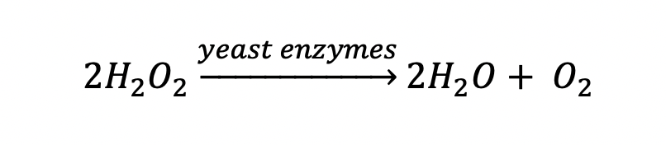

|  |  |
| --- | --- |
| **Materials** | **Procedure** |
| * empty 16.9 fl. oz. water bottle * funnel * 2 tbsp warm tap water * 2 tsp active dry yeast * dish detergent * 1 cup 3% hydrogen peroxide * small bowl * food coloring (if desired) | 1. In the small bowl, combine the warm water and yeast to activate. 2. With a sharp pencil or pen, poke a hole through the cap of the water bottle 3. Using the funnel, add 1 cup hydrogen peroxide to the water bottle 4. Add 10 drop of dish detergent to the water bottle    1. If you’d like, you can also add 5-10 drops of food coloring to the water bottle 5. Swirl bottle to mix 6. Bring your water bottle, yeast, and funnel outside. 7. Add yeast mixture to water bottle, using funnel if necessary 8. Quickly cap the water bottle and set back to watch! |