**STUDENT NAME:**

Enzyme Fact Sheet

What are enzymes?

**Enzymes** are biological **catalysts**, meaning that they make a reaction go faster. Enzymes are proteins that have the ability to bind a **substrate** in their **active site** and then chemically modify the substrate, converting it to a different molecule — the ***product*** of the reaction. When substrates bind to enzymes, they undergo an enzyme-induced chemical change, and are converted to products. Enzymes themselves are not altered by the overall reaction.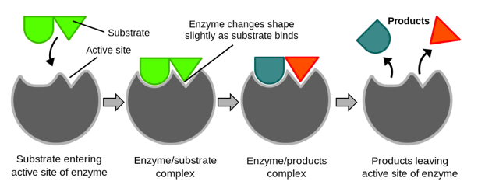

Many enzyme names end with –*ase*. For example, the enzyme lactase is used to break down the sugar lactose, found in mammalian milk. Other enzymes are known by a common name, such as pepsin, which is an enzyme that aids in the digestion of proteins in your stomach by breaking the peptide bonds in the proteins.

Fig 1 An enzyme combines with a substrate to form a product(s)

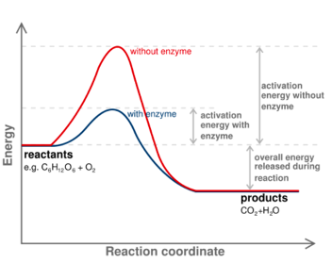

How do enzymes work?

In any chemical reaction, there is an initial input of energy that is required. If the initial energy or activation energy is low, a reaction will go forward. If it is too high, this can prevent a reaction from going forward. An enzyme reduces the activation energy required for a reaction to occur. This can speed up reaction up to 10 billion times.

Fig 2 An enzyme reduces the energy

needed to start a reaction.

What affects enzyme function?

Enzymes are very specific for different substrates. The specificity of enzymes relies on their protein structure or shape. This allows the active site to create and break chemical bonds with the substrate allowing the chemical 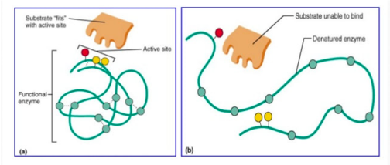reaction to occur.

When environmental conditions change it can affect enzyme function. Conditions such as a change in temperature or a change in pH can alter the structure of the enzyme protein. This can reduce the ability for the active site to bind the substrate.

Fig 3 Changes in pH or temperature cause enzyme structure

to change affecting the binding of the substrate to the active site