## 

**STUDENT NAME:**

Lactose Intolerance and Lactase Persistence

## **Practice Makes Perfect**

1. Using the graph, write a brief paragraph comparing the similarities and differences in the three populations in terms of normal lactose tolerance.

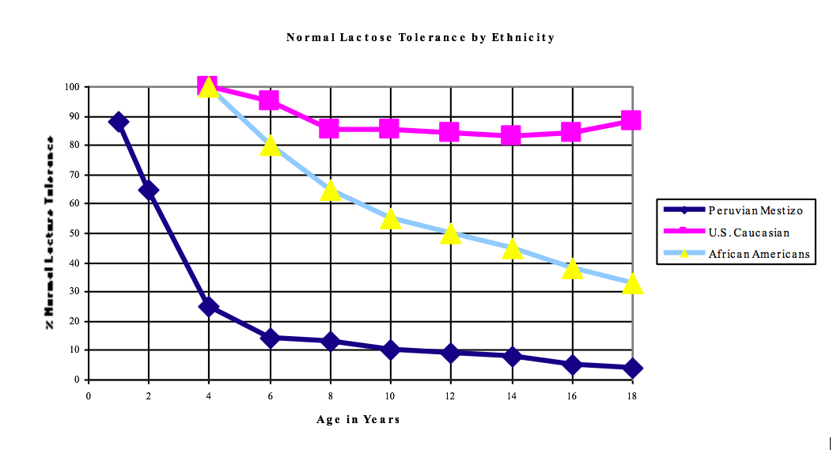

1. Using the data in the chart, construct a graph. Be sure to follow customary rules for graphing, including an appropriate title and labeled axes. Put the independent variable on the x-axis and the dependent variable on the y-axis. Then write a paragraph comparing the similarities and differences in the three populations in terms of normal lactose tolerance.

Normal Lactose Tolerance in U.S. Caucasian and African American Children and Peruvian Mestizo Children (in %)

|  |  |  |  |
| --- | --- | --- | --- |
| Age in Years | Caucasian | African American | Peruvian |
| 2 | No data | No data | 65 |
| 4 | 100 | 100 | 25 |
| 6 | 95 | 80 | 14 |
| 8 | 85 | 65 | 13 |
| 10 | 85 | 55 | 10 |
| 12 | 84 | 50 | 9 |
| 14 | 83 | 45 | 8 |
| 16 | 84 | 38 | 5 |
| 18 | 88 | 33 | 4 |



1. Propose a solution to the problem of school-age children in Baltimore City needing calcium and not making use of the milk provided with school lunches (due to their symptoms of lactose intolerance). Write this up in the form of a letter to the principal.

## **What the Hay!**

1. While on a field trip with your biology class to visit a local farm, you accidentally become separated from your classmates and miss lunch. After a while, you get so hungry that you pull up some grass and eat it. Shortly afterward, you were reunited with your classmates. On the bus ride home a few hours later, you developed terrible cramps and gas and nobody wanted to sit near you. You don’t understand what happened. You see the cows, sheep, and goats eating grass, and they are mammals just like you. You asked your teacher about it, and she said that many herbivorous animals have compartmentalized stomachs that contain certain bacteria and protozoa. She also mentioned that humans don’t have the ability to digest cellulose, a carbohydrate found in the cell walls of plants.
   1. In terms of enzymes, explain why eating the grass caused you to have digestive problems.
   2. Explain the role of bacteria and the protozoa in the stomachs of herbivorous mammals such as cows, sheep, and goats. What do you think would happen to these animals if they did not have this symbiotic relationship with the bacteria and the protozoa?

1. Discuss in terms of evolution why the ability to produce lactase seems to be universal among humans for the first two years of life and diminishes for many groups of people after that.