**STUDENT NAME:**

Looking into Lactase

Understanding Enzyme Specificity and Activity

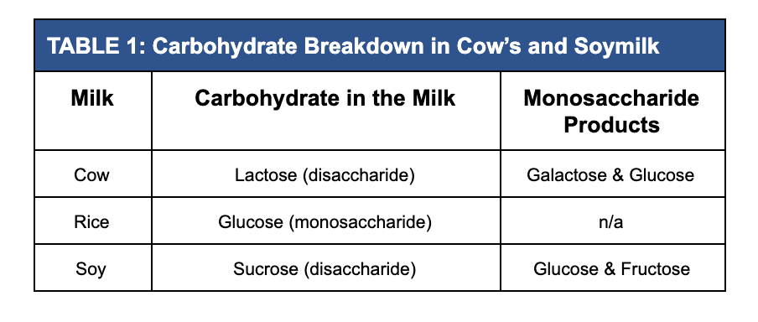

Enzymes are proteins that catalyze chemical reactions by lowering the reaction’s activation energy. Every enzyme has an active site that binds to another molecule called the substrate. Once bound to the substrate, an enzyme can catalyze a reaction up to 10 billion times faster than the comparable, non-catalyzed reaction. In other words, a reaction that only occurs once every ten billion seconds (316 years) will occur once every second if catalyzed by an enzyme. Enzymes are not consumed in the reaction and can bind to an infinite amount of substrates.

You are working in the quality control department of a local bioscience company that produces a lactase enzyme product used to treat lactose intolerance. It is your job to determine the optimal pH of the lactase product by testing the enzyme’s activity in cow’s milk at different pH levels. Unfortunately, due to a mistake in shipping, the labels were removed from the research lab’s milk supply. You know that the lab carries cow, rice, and soymilk, but you don’t know which is which. Before you can test the lactase activity at different pH levels, you must first identify which sample is cow’s milk. To do this, you will use a special property of enzymes called “specificity.” Lactase specificity describes the fact that the lactase enzyme will break down lactose but no other disaccharide substrate.

You know that each type of milk contains a unique carbohydrate. Cow’s milk and soymilk both contain disaccharides which have glucose as one of their monosaccharide products (table 1). Rice milk, on the other hand, simply contains the monosaccharide glucose. You will determine which of the unidentified samples is cow’s milk by testing the milk samples for glucose both prior to and following the addition of the lactase enzyme. After you identify which sample is cow’s milk, you can determine the optimal pH of the lactase enzyme product.

**Introduction**

**1.** What is lactase?

**2.** What is lactose intolerance?

**3.** If you are lactose intolerant, what are some ways that you can still enjoy dairy day to day? Like having milk in your cereal?

**Part I - Identify the cow milk**

1. Three test tubes contain unidentified milk samples. Predict which milk is in each tube using qualitative observations.

|  |  |
| --- | --- |
| **TABLE 2: Qualitative Milk Analysis** | |
| **A** |  |
| **B** |  |
| **C** |  |

1. A glucose strip is dipped into each corresponding test tube. In the table below, record any color change and the relative amount of glucose present.

|  |  |  |
| --- | --- | --- |
| **TABLE 3: Quantitative Milk Analysis** | | |
|  | **Test strip color** | **Relative amount of Glucose (mg/dl)** |
| **A** |  |  |
| **B** |  |  |
| **C** |  |  |

1. Based on these results can we identify one of the milks?

1. Lactase is added to each test tube. **Predict which type(s) of milk will test positive for glucose after adding the enzyme.**
2. Three new glucose strips are dipped into each milk + lactase sample. Record any color change, the relative amount of glucose present, and whether or not the enzyme was active in the sample.

|  |  |  |  |
| --- | --- | --- | --- |
| **TABLE 4: Quantitative Milk Analysis – Enzyme Activity** | | | |
|  | | **Post-Lactase Glucose Test Strip** | |
|  | **Test strip color** | **Relative amount of Glucose (mg/dl)** | **Enzyme Activity** |
| **A** |  |  | **🗆** |
| **B** |  |  | **🗆** |
| **C** |  |  | **🗆** |

1. Identify the milk types. Based upon your analysis what type(s) of milk did the enzyme effect and why is it used to treat lactose intolerance?

**PART II - Determine the optimal pH for the enzyme lactase**

1. Label each section of the digestive tract with its specific pH.

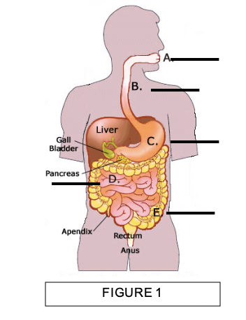

1. Lactase is added to cow’s milk at different pHs. Glucose strips are dipped into each sample. Record your observations in Table 5.

|  |  |  |
| --- | --- | --- |
| **TABLE 5: Enzyme Activity at Different pH Levels** | | |
|  | **Color of Test Strip** | **Relative amount of Glucose (mg/dl) after adding lactase** |
| **pH 2** |  |  |
| **pH 4** |  |  |
| **pH 7** |  |  |
| **pH 10** |  |  |
| **pH 12** |  |  |

1. What does this result tell us?

**PART III - Data Analysis**

1. Graph the relative amount of glucose to the corresponding pH on the graph. Be sure to give your graph a title and label the axes.

What is the independent variable?_______________

What is the dependent variable? ________________

1. What effect (if any) does pH have on lactase activity?

**PART IV - Conclusion**

1. Compare the results found in PART III to the pH’s found in the digestive tract. Does the enzyme function in the organ where it needs to?

