**STUDENT NAME:**

Neutralizing Acids and Bases

Have you ever used a measuring cup to measure certain ingredients like milk, flour, or sugar to bake your favorite homemade cookies or cakes with your family or friends? You’re able to follow a recipe to know exactly how much of that ingredient to include into your delicious dessert. An interesting challenge would be to purchase your favorite cookie and try to alter the ingredients that you use to taste similar to the cookie you purchased.

In many chemical, medical, and food laboratories, very similar processes occur so that pharmacists know the concentration of anesthesia to give each patient before a major surgery or food manufacturers can measure the amount of salt in a bag of chips. These processes are called titrations, or a method used to determine the concentration of a solution. These processes are done precisely and are extremely important in the consideration of product quality.

Today, you will perform a titration experiment to determine how much acetic acid is inside of vinegar. We will be using a baking soda (sodium carbonate) as our titrant. It will be your job to stop the reaction at it’s equivalence point which occurs at pH6. Keep in mind that if you go past the equivalence point, your acetic acid will still be neutralized, but there will be an excess of sodium carbonate in solution. After your titration you will calculate the percent composition of acetic acid in vinegar. Most commercial vinegars contain approximately 5% acetic acid. You will compare your result to this value.

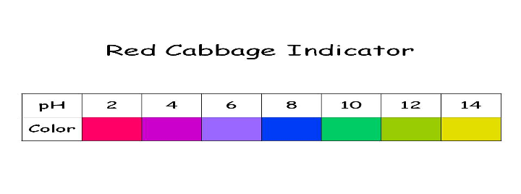

**MATERIALS**

**● Vinegar**

**● Baking Soda**

**● Water**

**● Red Cabbage Indicator Liquid**

**● 5 clear plastic cups**

**● ⅛ or ¼ teaspoon measure**

**● 1 tsp measure**

**● ¼ cup measure**

**PREPARATION**

This lab activity will be done by running three trials of adding the vinegar into the baking soda solution until students see a violet color, indicating a neutral pH of 7.

1. Carefully prepare the three clear plastic cups #1, #2, #3, #4, and #5 by:

● Adding 2 tsp (9.86mL) of vinegar, 1 tsp red cabbage indicator to Cup #1, #2, and #3

● Adding 1 tsp vinegar and ½ tsp red cabbage indicator to Cup #4,

● Adding 1 tsp water with ½ tsp red cabbage indicator to Cup #5.

2. Carefully prepare your standard sodium bicarbonate (baking soda) solution.

* Mix 4¾ level teaspoons of baking soda with 1¼ cup of water in a small container and set it aside. This will give you a solution with a concentration of 1.14 M.

**PROCEDURE**

1. Using the smallest fraction of a teaspoon measuring tool available, add the standard sodium bicarbonate solution to the vinegar in Cup #1. Use gentle swirling when adding increments of sodium bicarbonate.
2. Continue to add sodium bicarbonate until a permanent light purple color change is apparent. At this point, the end point has been reached.
3. If the solution starts turning blue you have gone too far. Use the images below as a reference for the endpoint.
4. 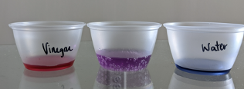
5. 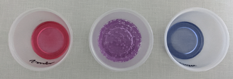

3. Record the total number of teaspoons of the sodium bicarbonate solution you added to the vinegar in the Data Table on the next page

4. Repeat step 1-3 with cups #2 and #3.

5. Use the table below to convert your measurements in teaspoons to milliliters.



|  |  |
| --- | --- |
| mL | tsp |
| 4.93 | 1 |
| 2.46 | 1/2 |
| 1.64 | 1/3 |
| 1.23 | 1/4 |
| 0.62 | 1/8 |

6. Calculate the average number of teaspoons of sodium bicarbonate used to cause the reaction to reach an endpoint for your final calculations.

7. Complete the calculations in the Analysis section to determine the % acetic acid in vinegar and the percent error.

**TEST/COLLECT DATA**

Record the data you collect in the table below.

|  |  |  |  |  |
| --- | --- | --- | --- | --- |
| **TRIALS** | **Tsp of sodium bicarbonate added to reach equivalence point** | **Volume of sodium bicarbonate added at equivalence point (mL)** | **Volume of Vinegar (mL)** | **Molarity of Baking Soda Solution** |
| **CUP 1** |  |  | **9.86 mL** | **1.14 M** |
| **CUP 2** |  |  | **9.86 mL** | **1.14 M** |
| **CUP 3** |  |  | **9.86 mL** | **1.14 M** |
| **AVERAGE** |  |  | **9.86 mL** | **1.14 M** |

**ANALYSIS**

1. Convert our volumes used from mL to liters.

9.86 mL vinegar x 1 L = 0.00986 L vinegar

1000 mL

____________ mL sodium x 1 L = _____________ L sodium

bicarbonate 1000 mL bicarbonate

1. Calculate the number of moles of sodium bicarbonate that were required to neutralize the acetic acid in the vinegar.

_____ L sodium x 1.14 moles = _____________ mol sodium

bicarbonate 1 L bicarbonate

1. Using the chemical equation below, calculate the number of moles of acetic acid were present.

CH3COOH (acetic acid) + NaHCO3 (sodium bicarbonate) --> CH3COONa + CO2 + H2O

1. Calculate the molarity of the acetic acid in the vinegar.

______________ moles acetic acid. = _______________ M acetic acid

L vinegar used

1. Calculate the number of grams of acetic acid in the vinegar.

________ mol acetic acid x __60 g acetic acid x _________L vinegar = _____g

1 L vinegar 1 mol acetic acid acetic acid

1. Convert the volume of vinegar to grams using it’s density (1.002 g/mL).

9.86 mL vinegar x 1.002 g = _____________ g vinegar

1 mL

1. Calculate the percent of acetic acid in the vinegar.

____________ g acetic acid x 100 = ________________% acetic acid

g vinegar

1. Typically, vinegar has about 5% acetic acid . Find the percent error by using the formula below.

Percent error is a calculation used to determine the precision of your measurements and calculations based on the known percent composition of vinegar. In this lab, the standard accepted error is 10%.

**% Error = (Calculated % acetic acid– Expected % acetic acid) x 100**

**Expected % acetic acid**

**THINK IT OUT**

After calculating the percentage of acetic acid in your vinegar and comparing your calculation to the percentage of acetic acid in commercial vinegar, was excess sodium bicarbonate or acetic acid present when you completed your titration?

|  |  |  |
| --- | --- | --- |
| **CLAIM** | **EVIDENCE** | **REASONING** |
| Use the above question to formulate a complete answer. Your answer to the question is your claim. It is like a thesis statement, or something you’re trying to prove.  The titration contained … | **Evidence:** List 2-3 pieces of information that support your claim. Each should be specific observations or calculations taken directly from the activities in this lab.  1.    2.    3.    Now that we have our three pieces of information. We need to make an evidence statement.    *From the demonstration, I know…* | **Reasoning:** This part of your answer is very important. It gives the explanation for your claim, and it explains how your evidence supports your claim. Describe and show how your pieces of evidence support your claim. You also want to describe any connections you can make between your claim/evidence and other scientific principles you already know. Use relevant facts and general concepts from your scientific knowledge in this section to expand on your evidence and support your claim.    *The evidence shows…*    *I know that…*    *Therefore, I can conclude that…* |