**STUDENT NAME:**

The Edible pH Indicator

**Activity Overview:**

You may be familiar with the sour taste of a lemon but have you thought about why it’s tangy flavor packs such a sour punch? Lemons are sour because they contain citric acid which is a weak organic acid found in many citrus fruits like oranges, lemons and limes.

Have you ever tasted baking soda? Baking soda is a base and may taste bitter to you. Bases may also feel slippery and soapy.

In this experiment, you will use red cabbage juice as a pH indicator to determine whether certain liquids are an acid or a base. Red cabbage juice is usually a deep dark purple color but it turns red when added to an acid or green when added to a base. pH is a scale that we use to measure acidity, 1-14. The lower the number the more acidic the solution and the higher the number, the more basic the solution.

Red cabbage juices is the best known edible pH indicator in your kitchen but there are many safe fruits, vegetables and flowers that change color in response to acids and bases such as eggplant, beets, blueberries, cherries, onion, raspberry, grape juice, turmeric, and even tomatoes! Use this protocol to text some common household solutions to determine if they are an acid or a base.

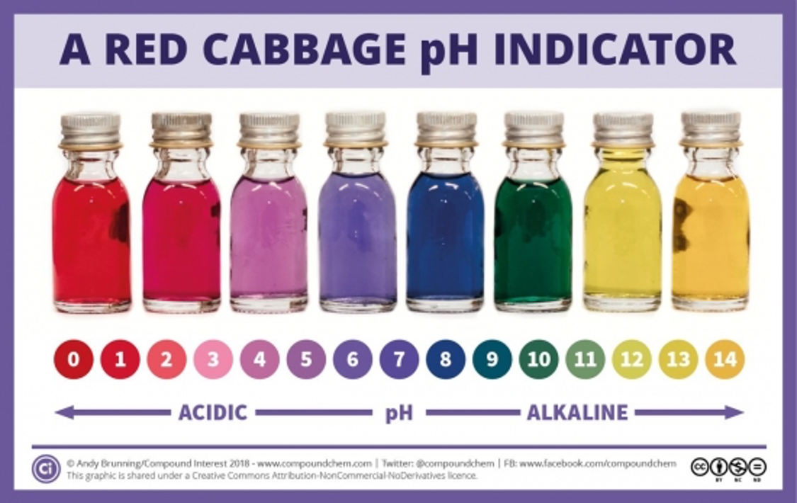

**Red Cabbage Indicator Protocol**

|  |  |  |
| --- | --- | --- |
| **Materials:** | | |
| * Red cabbage juice * Water * Baking soda * Lemon juice | * Egg whites * Sugar * Vinegar, clear * Six clear glasses | * Colander, strainer, or slotted spoon * Paper and pencil * Pitcher to hold red cabbage juice |

**PART ONE: Make your red cabbage juice**

1. Cut a small red cabbage into chunks and cover with water in a large pan.

How much water? You will need at least three cups of red cabbage juice.

Is the color really pale or light? To concentrate the color, boil the water to reduce the volume.

2. Boil the cabbage until the cabbage is soft

3. Strain the pieces from the water using a slotted spoon or strainer.

4. Allow to cool before using. Store in refrigerator until ready for use

**PART TWO: Prepare your test solutions**

5. Place six (6) clear glasses in a row. Label each solution with a piece of paper in front of the glass.

6. Prepare your test solutions:

**Lemon juice** – add ¼ cup of lemon juice to a clear glass

**Baking soda** – dissolve 2 tablespoons of baking soda in ¼ cup of water in a clear glass

**Water**- add ¼ cup of water to a clear glass

**Vinegar** – add ¼ cup of white vinegar to a clear glass

**Sugar solution** – dissolve 2 tablespoons of sugar in ¼ cup of water in a clear glass

**Egg White** – add the whites of 1-2 eggs to a clear glass

**PART THREE: test your solutions**

7. Add red cabbage juice to each of your solutions to determine if they are an acid or a base

Example: Add 2 tablespoons of red cabbage juice to the glass with the lemon juice and observe the changes. What did you observe? What does that mean about lemon juice?

**Fill in this observation chart as you go through Part Three.**

|  |  |  |
| --- | --- | --- |
| **Substance** | **Observation** | **Acid/Base** |
| Lemon Juice |  |  |
| Baking Soda |  |  |
| Water |  |  |
| Vinegar |  |  |
| Sugar Solution |  |  |
| Egg Whites |  |  |

**Answer the following questions when you complete the protocol.**

What is a pH scale used for?

How were you able to determine whether the solution was an acid or base?

What is a pH indicator? List some examples.

What other solutions in the kitchen could you test?