STUDENT NAME:
“Spaghetti Quake”: Understanding Earthquake Magnitude
Earthquakes are measured on the moment magnitude scale. Magnitude 2 and smaller earthquakes occur several hundred times a day worldwide. Major earthquakes, greater than magnitude 7, happen more than once per month. “Great earthquakes”, magnitude 8 and higher, occur about once a year. But what do these differences in magnitude mean?
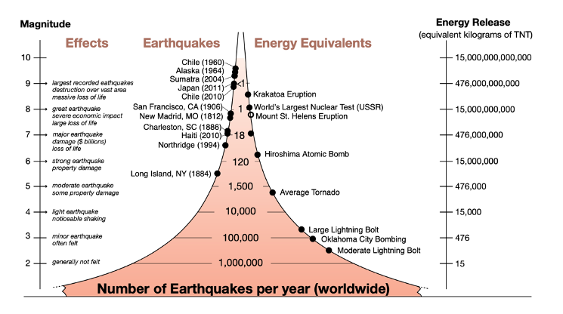
Notice on the right side of the diagram above that the energy released from an earthquake increases approximately 32x as it increases in magnitude. For example, a magnitude 2 (M2) earthquake releases the energy equivalent of 15 kg of TNT but a magnitude 3 (M3) earthquake releases energy equivalent of 476kg. The strongest recorded earthquake occurred in Chile and was between an M9 and M10. This means it released the energy equivalent of 476,000,000,000 kg of TNT!

Today we will use a model to understand the energy release at different magnitudes. We will break strands of spaghetti at different magnitudes and make observations of the differences.

Materials Needed:
- 2 boxes or spaghetti or angel hair pasta, any long noodle pasta or long thin sticks will work
- Rubber bands

Procedure:
- Get one piece of spaghetti. Bend the piece between your hands until it breaks. Notice the work it takes to break the spaghetti. This is a 5 on the Moment Magnitude scale (M5).

- Now we will test an earthquake of magnitude 6 (M6). To do this you will have to calculate the number of pieces of spaghetti you will need. Since there is a 32x increase between levels, you need to multiply the number of spaghetti by 32.

1 piece x 32 = _____ pieces of spaghetti
(M5) (M6)

Now try to break apart those pieces of spaghetti. Notice the work it takes to break the bundle.

- Did this take more or less work?

3. Now we want to create an earthquake of magnitude 7 (M7) and try to break it. Calculate the number of pieces of spaghetti you will need to model an M7 earthquake.

_____ pieces x 32 = _____ pieces of spaghetti
(M6) (M7)

- How many strands of spaghetti do you need?

4. The average box of spaghetti has around 550 pieces of spaghetti. To mimic an M7 earthquake we will estimate it to be 2 boxes. Take approximately two boxes of spaghetti in your hands and try to break them.

- Did this take more or less work?

5. The amount of work it takes to break the spaghetti represents the energy that an earthquake releases on different levels of the moment magnitude scale. Now let’s scale up and down on the scale. Use the table below to fill in how many pieces of spaghetti represent each magnitude.
Spaghetti Magnitude Scale | # of spaghetti pieces broken
4
5 | 1
6 | 32
7 | 1024
8
9

6. Below is a list of recorded earthquakes. Number them in order of energy released with (1) representing the lowest release of energy and (7) representing the energy to highest.
Year | Location | Magnitude | Order of Energy Release
1811 | New Madrid (Midwestern US) | 8.1
1906 | San Francisco, California | 7.7
1960 | Arauco, Chile | 9.5
1964 | Anchorage, Alaska | 9.2
1971 | San Fernando, California | 6.7
1989 | San Francisco, California | 7.0
1995 | Kobe, Japan | 6.9

7. Which earthquake released about 32 times more energy than the New Madrid quake of 1811?

