|  |  |  |  |  |  |
| --- | --- | --- | --- | --- | --- |
| Name: | **[insert name]** | Period: | **[insert Period]** | Date: | **[insert date]** |

Moon Model

# Background

Now that we know the moon goes through changes every month, we need to understand why. We want to see how the Sun, Earth, and moon all need to be in alignment for the moon to look the ways we have seen it.

We’ll be using a model to help us understand this. Through the unit we will come back to this model, to update it and add details!

# Making our Model

## Materials

* A light source (lamp, flashlight)
* Dark room
* Styrofoam ball, orange, or other soft circular object
* Sharpened pencil or wooden skewer

## Set Up

1. Place the light source in the dark room.
2. Carefully push the pencil/ skewer through the center of your circular object. You want to make sure to push deep enough so that the round object is stable if you only hold the skewer.
3. Turn on the lamp and darken the room. Be careful not to look directly at the lit bulb as this can hurt your eyes.
4. Use the next few pages, to help guide you through the model.

# Using the model

Please follow the directions below and fill in the image on the next page when instructed.

Looking for help [setting up the model](https://vimeo.com/502766104)? [Using the model](https://vimeo.com/502766104#t=110s)?

1. Stand three to four feet away from your light source. Face the light source directly (toes pointing toward the light source).
   1. The light source is going to model our sun, your head is going to model the moon, and the skewered ball is going to model the Earth’s moon.
2. Hold the moon at arm’s length in front of you.
   1. What does the surface of the moon look like? Drag the image that best matches what you see to the circle labeled 1 on the next page.
3. With your arm still outstretched in front of you, slowly turn your body to the left. Stop when the Moon is to the left of the Sun, but before you have made a quarter turn.
   1. What does the surface of the moon look like? Drag the image that best matches what you see to the circle labeled 2 on the next page.
4. Continue turning left until the light source is on the right side of your body.
   1. What does the surface of the moon look like? Drag the image that best matches what you see to the circle labeled 3 on the next page.
5. Continue turning left until you almost have your back to the sun but not quite.
   1. What does the surface of the moon look like? Drag the image that best matches what you see to the circle labeled 4 on the next page.
6. Continue turning left until the sun is directly behind you.
   1. What does the surface of the moon look like? Drag the image that best matches what you see to the circle labeled 5 on the next page.
7. Continue turning left but stop before the sun is directly to your left.
   1. What does the surface of the moon look like? Drag the image that best matches what you see to the circle labeled 6 on the next page.
8. Continue turning left until the sun is directly on your left.
   1. What does the surface of the moon look like? Drag the image that best matches what you see to the circle labeled 7 on the next page.
9. Continue turning left until you have almost returned to where you started.
   1. What does the surface of the moon look like? Drag the image that best matches what you see to the circle labeled 8 on the next page.

## Drawing with our Model

|  |
| --- |
| **Use the image below to depict what you saw with your model.**  *Adjust the zoom to 50% to see the provided moon images in the “Moon Bank”.* |
|  |

## Labeling our Model

The moon’s different shapes that occur over the course of a month are called phases. The eight phases you identified all have different names.

Watch [SciShow Kids’ “Why Does the Moon Change?”](https://www.youtube.com/watch?v=yXe0yxzYkjo) to learn the names of the phases of the moon. After watching the video, update the image below so each phase is appropriately labeled with its phase name.

Keep in mind that the waxing phases of the moon occur when the moon is getting more lit each night. In these phases you’ll see the lit side of the moon on the right side. This is the opposite of the waning phases of the moon where the moon is getting darker each night. In waning phases you’ll see the lit side of the moon on the left side.

|  |
| --- |
| **Labeled Moon Phases** |
|  |

# Thinking about the Phenomena

Think back to the photos that the scientists in Chile and Idaho took leading up to and after that weird event. The moon images from Idaho are shown below. Use the photo and your new knowledge of moon phases to answer the questions below.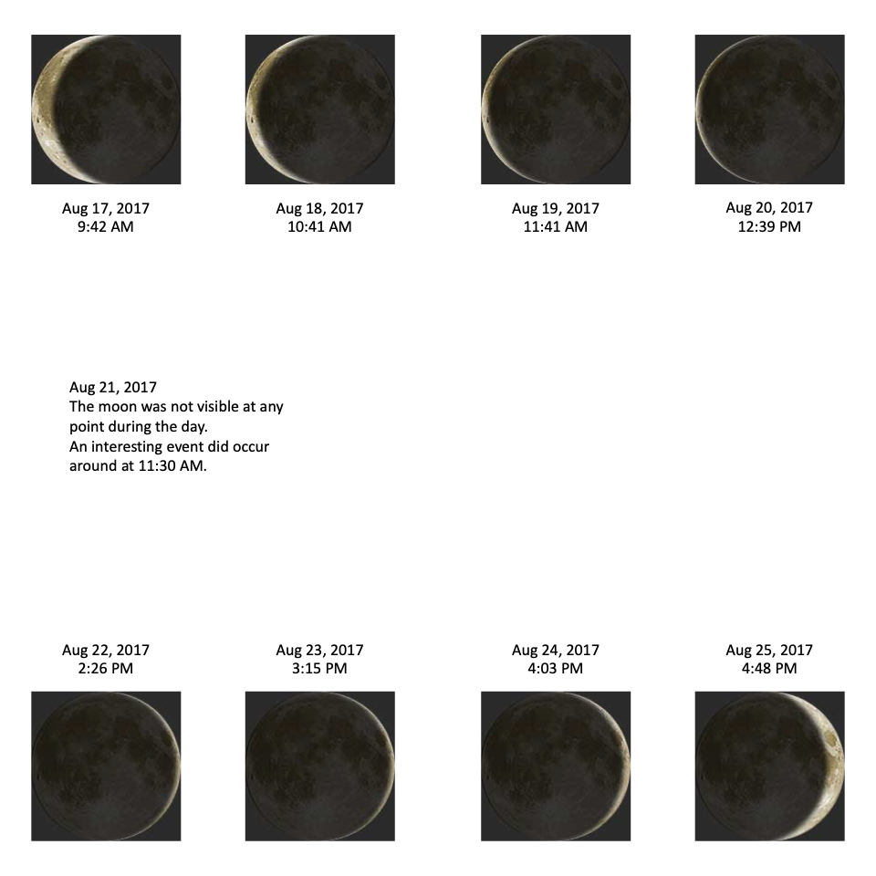



|  |  |
| --- | --- |
| **Question/ Prompt** | **Your Response** |
| What phase was the moon on August 17th? How can you tell? |  |
| What phase was the moon on August 25th? How can you tell? |  |
| Why was the moon not visible on August 21st? What phase was the moon that day? |  |