Name: | [insert name] | Period: | [insert Period] | Date: | [insert date]

Introduction to Plate Tectonics

Background
In the early 1900s, most geologists thought that Earth's appearance, including the arrangement of the continents, had changed little since its formation. But throughout the twentieth century, geologists have learned more about the Earth’s surface, how it changes, and how it created the features we know today.

Gathering Information
- Watch the video “Plate Tectonics: An Introduction” from PBS Learning Media.
- Answer the questions below.

Question/Prompt | Your Response
- What is the theory of plate tectonics?
- How were the Himalayan Mountains formed?

Thinking About the Phenomena
Below is an image of the major plate boundaries on or near New Zealand, where our phenomena was observed. Use your understanding of plate tectonics and the map below to answer the prompt below.

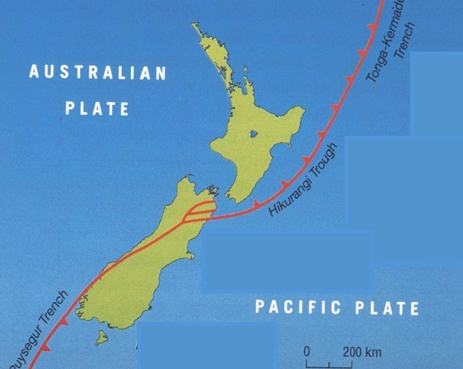

Question/Prompt | Your Response
What questions would you ask to help determine if the observed land rising in New Zealand was the start of a mountain formation?

