Name: | [insert name] | Period: | [insert Period] | Date: | [insert date]

Mountain Maker Interactive

Background
Plate tectonics can help explain instances of mountains, volcanoes, and earthquakes. Overall, the motion of the Earth’s plates create the structures we see around the world.

Gathering Information
- View PBS Learning Media’s Mountain Maker, Earth Shaker Interactive.
- Click and drag on the arrows in the interactive to read about what is happening at that plate boundary. You can also view the Earth’s map where red lines will show where each type of activity takes place on Earth.
- As you use this interactive, answer the questions below.

Question/Prompt | Your Response
- What are the names of the three different types of plate boundaries?
- How does new ocean floor get created? Where on the Earth’s surface does this actively occur?
- Why does subduction only occur between continental plates and oceanic plates?
- Does most of the change due to the movement of plates occur at a slow or quick pace?

Thinking About the Phenomena
Below is an image of the major plate boundaries on or near New Zealand now with the direction and speed of motion of the Pacific Plate. The purple star shows the location of Kaikoura. Use your understanding of plate tectonics and the map below to answer the question below.

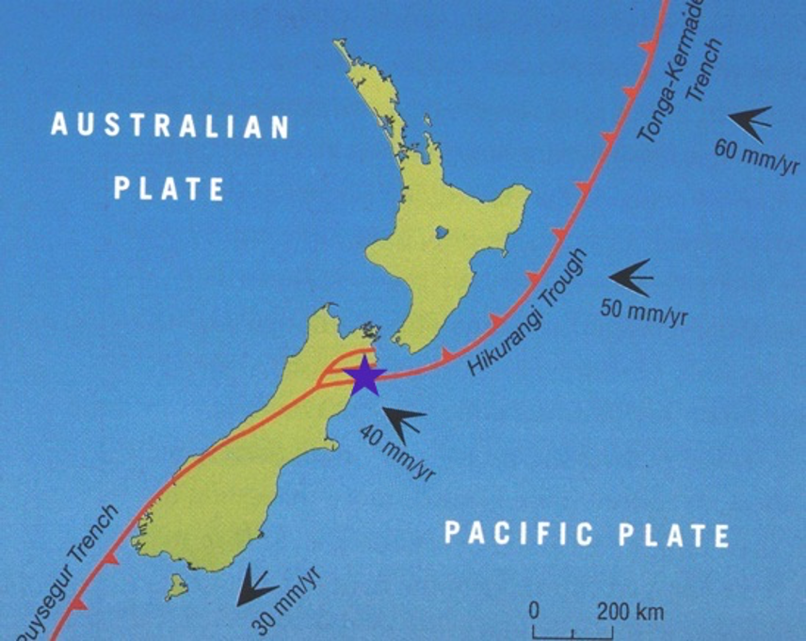

Question/Prompt | Your Response
As the Pacific Plate moves toward the Australian Plate in Kaikoura, what type of boundary is most likely created?
Which plate is more dense and therefore more likely to subduct at the location of the purple star, the Pacific Plate or the Australian Plate?

