Name: | [insert name] | Period: | [insert Period] | Date: | [insert date]

The Start of a Mountain?

Background
The Earth’s surface is made of large slabs, called tectonic plates. These plates move around the Earth’s surface, slowly forming the features we recognize as volcanoes, mountains, and rifts.
We know that the Australian and Pacific plates are colliding just over the country of New Zealand. Based on the image below and the knowledge of plate densities, we assumed that the Pacific plate was subducting under the less dense Australian plate.
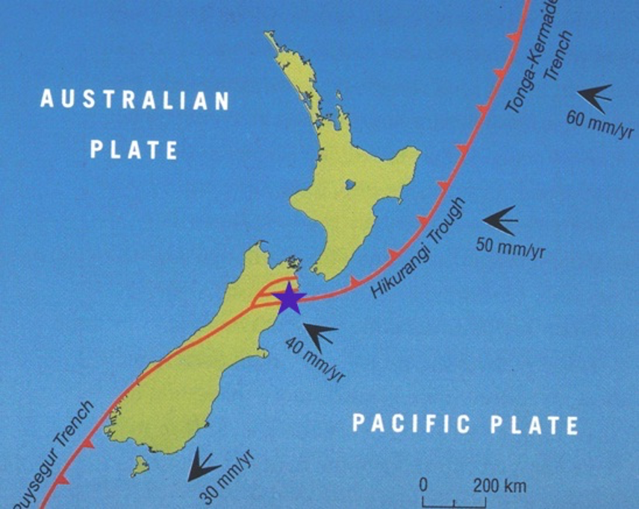
So our question is: can subduction at a plate boundary lead to mountain formations? This will help us understand if the 7 foot lift of the coast of New Zealand between 2010 and 2016 is evidence of the start of a new mountain.

Using a Model
- Follow the link to the Concord Consortium’s Tectonic Explorer.
- Select “2 Plates”.
- Click and drag to draw a small continent on the left plate like in the image below. Then select “Next”.
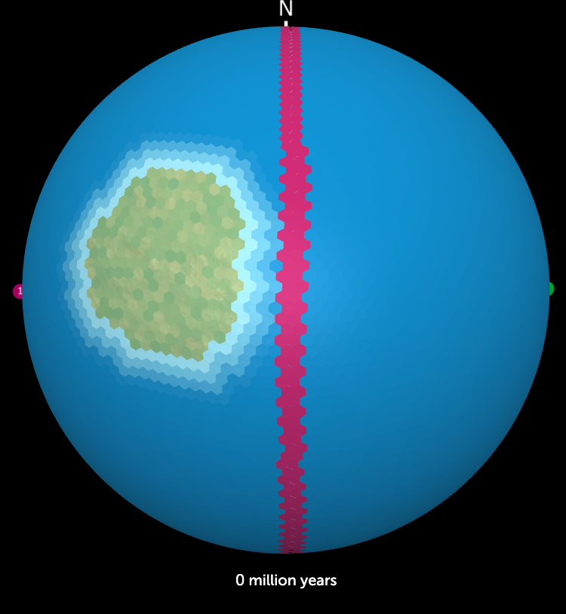
- Click and drag to draw the force vectors toward the plate boundary then select “Next”. This will tell the plates the direction to move in. Use the image below for guidance if necessary.
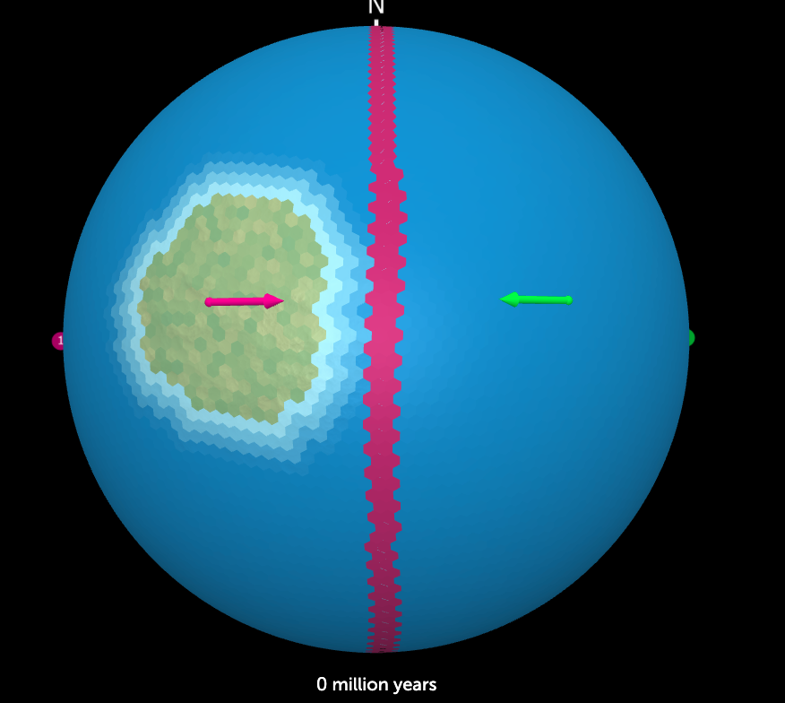
- Make sure that Plate 1 is listed above Plate 2. This indicates that Plate 1 is less dense than Plate 2. Then select “Finish”.
- The model will start automatically. Use the tools described below to interact with the model, then answer the questions below.
  - Mountain formations are marked by brown then gray colors.
  - You can pause the model, restart, step forward or backward using the buttons at the bottom of the screen.
  - You can also draw a cross section to see the interaction of the plates by selecting “Draw Cross-section” and then drawing the rectangle of space you would like to look at. An example of a cross section can be seen below.
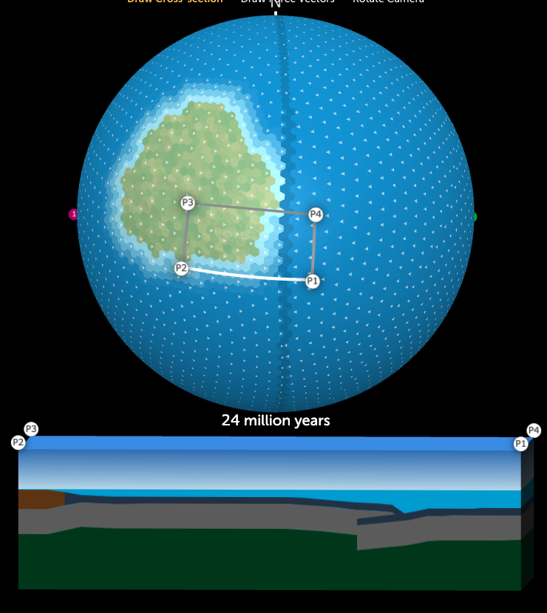

Making Observations
Question/Prompt | Your Response
As the plates collide, do mountains form? How many years does it take to become the highest elevation (gray color)?
Take a cross section of the subduction zone when mountains form and include a screenshot of the image in the box to the right.
In your screenshot, do you see any red spurts coming up from the mantle? What is that substance? What geological feature is created?

Is it possible?
Think about the model you used and how many years it takes for mountains to form. Use the information you’ve acquired to answer the questions below.

Question/Prompt | Your Response
When mountains formed in the model, it indicated a height of 8,000 meters above sea level. How many meters per year did it take to reach this height?

(Hint: 8,000m ÷(number of years)= meters/year)
In Kaikoura, New Zealand, the land was uplifted 7 feet (approximately 2 meters) between 2010 and 2016. Does this match the length of time needed for mountain formation?

