|  |  |  |  |  |  |
| --- | --- | --- | --- | --- | --- |
| Name: | **[insert name]** | Period: | **[insert Period]** | Date: | **[insert date]** |

A Solar Eclipse Every Month?

# Background

We know that solar eclipses occur when a new moon briefly crosses in front of the sun, blocking its light. We know that new moons occur every month as part of the lunar phase cycle, but why don’t we see a solar eclipse every month?

Learn about the moon’s orbit to explain why eclipses are a more rare event!

## Making a Hypothesis

|  |  |
| --- | --- |
| **Question/ Prompt** | **Your Response** |
| Make a hypothesis about why eclipses don’t happen every month during a new moon. Be sure to use an “If...then…” statement. |  |

# 

# Using a Model

The moon does not orbit directly over the earth’s equator, instead its orbit is on a slight angle, 5° to be more precise. Let’s use our physical model to help understand this.

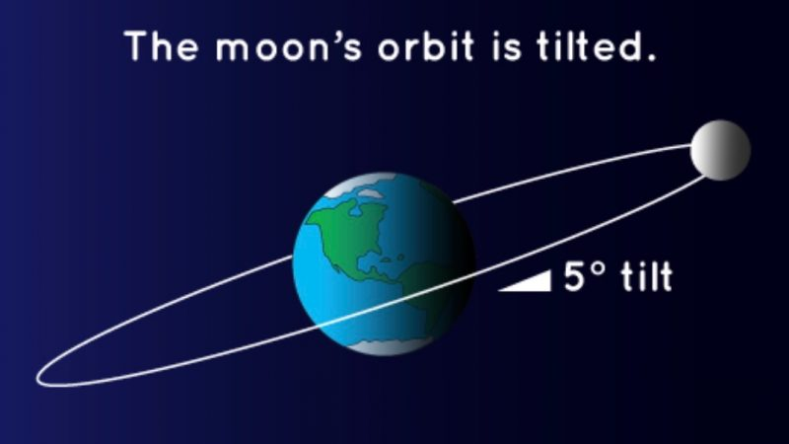

## Materials

* A light source (lamp, flashlight)
* Dark room
* Styrofoam ball, orange, or other soft circular object
* Sharpened pencil or wooden skewer

## Set Up

1. Place the light source in the dark room.
2. Carefully push the pencil/ skewer through the center of your circular object. You want to make sure to push deep enough so that the round object is stable if you only hold the skewer.
3. Turn on the lamp and darken the room. Be careful not to look directly at the lit bulb as this can hurt your eyes.
4. Use the next few pages, to help guide you through the model.

## Model Instructions

Please follow the directions below and answer the questions in the table below.

Looking for help [setting up the model](https://vimeo.com/502766104)? [Using the model](https://vimeo.com/502766104#t=436s)?

1. Stand three to four feet away from your light source. Face the light source directly (toes pointing toward the light source).
   1. The light source is going to model our sun, your head is going to model the moon, and the skewered ball is going to model the Earth’s moon.
2. Hold the moon in position for you to see the “New Moon” phase. The sun should be directly in front of you, your moon should be outstretched in front of you, placing it between the sun and the Earth. Now to account for the 5° tilt, lower the moon to shoulder height.
3. With the model in this set up, answer question 1 in the table below.
4. Then hold the moon in “Full Moon”, but make sure the moon is lifted slightly above your head.
5. With the model in this set up, answer question 2 in the table below.

|  |  |
| --- | --- |
| **Question/ Prompt** | **Your Response** |
| 1. By lowering the moon, does that change what we see from earth with regards to the moon’s phases? |  |
| 1. If the Earth’s shadow covered the moon, what do you think we would call that event? |  |

# 

# Modifying our Model

Our model is used as we stand in one direction with regard to the light source. But now we want to account for the fact that the Earth revolves around the sun over the course of a year to help see when these solar eclipses happen.

To do this, you’ll need to make sure that you can put your light source in a central location so you can walk around it. Once you have set up your light source in the center of the room, you can move onto the directions below.

1. We will have four stopping points in our model: one directly in front of the light source, one directly behind the light source, and one on it’s left and right sides. Feel free to mark these with a piece of paper (labeled 1-4) and place them counterclockwise around your light source. Use the image below to help guide you.



1. Stand at stopping point 1 facing the light source. To keep the moon’s orbit consistent as the earth revolves, place an object beyond your place maker for 3: this will help you orient yourself (This is depicted as a plant in the image below). If the object is in front of you, the orbit will be slightly lower than your head and if the object is behind you the orbit will be slightly higher than your head. See the image below to help.



1. While facing the light source, hold the moon in the new moon position (slightly below your head). Look at the moon surface and then answer question 1 in the table below.
2. Now move to stopping point 2 (to the right of the light source) and face your orienting object. The light source should be over your left shoulder.
3. Start with the moon in front of you in the three quarter moon phase. Remember to keep the moon slightly below your head when you’re facing your orienting object
4. Now move only the moon to the new moon position. Remember if the moon will rise above your head when it’s behind you, half way should be directly in front of your head.
5. Look at the moon surface and then answer question 2 in the table below.
6. Now move to stopping point 3 (behind the light source) and face your orienting object. The light source should be behind you.
7. Start with the moon in front of you in the full moon phase. Remember to keep the moon slightly below your head.
8. Now move only the moon to the new moon position. Remember if the moon will rise above your head when it’s behind you.
9. Look at the moon surface and then answer question 3 in the table below.
10. Finally, move to stopping point 4 (to the left of the light source) and face your orienting object The light source should be over your right shoulder.
11. Start with the moon in front of you in the quarter moon phase. Remember to keep the moon slightly below your head.
12. Now move only the moon to the new moon position. Remember if the full moon will rise above your head when it’s behind you, half way should be directly in front of your head.
13. Look at the moon surface and then answer question 4 in the table below.

|  |  |
| --- | --- |
| **Question/ Prompt** | **Your Response** |
| 1. At stopping point one, are the sun, moon, and earth aligned for an eclipse? Explain. |  |
| 1. At stopping point two, are the sun, moon, and earth aligned for an eclipse? Explain. |  |
| 1. At stopping point 3, are the sun, moon, and earth aligned for an eclipse? Explain. |  |
| 1. At stopping point 4, are the sun, moon, and earth aligned for an eclipse? Explain. |  |

# 

# 

# Using a Computer Model

1. Follow the link to Interactive Earth’s [Sun, Earth and Moon Visualization](https://www.interactive-earth.com/earth/solar-system.html).
2. You can close the dialog box on the left, but keep the right on open.
3. You can click and drag the model to change your view of the model. You can also pause the model by setting the Earth Orbital Velocity to 0. Some things to note:
   1. The large white sphere in the center is the sun and the small white sphere closer to earth is the moon.
   2. The grid that is shown shows the plane that the Earth orbits on. Notice that the earth goes straight through the grid lines, but the moon rises up above and also goes below these lines.
4. Explore the model and answer the questions below.

|  |  |
| --- | --- |
| **Question/ Prompt** | **Your Response** |
| How many times does a solar eclipse happen within a year (one revolution of the Earth around the sun)? |  |
| Does the moon’s orbit ever change? |  |

# 