Name: | [insert name] | Period: | [insert Period] | Date: | [insert date]

Earthquakes and their Faults

Background
Fault is a term used to describe the fracture or zone of fractures between two blocks of rock. This is usually synonymous with the plate boundaries, but there are sometimes breaks in the crust within tectonic plates.
Faults and the way they most can create interesting changes to the earth’s surface in very short amounts of time.
In this activity, you will learn about the types of earthquake faults and draw conclusions as to which fault is most likely found in Kaikoura, New Zealand.

Fault Types
- Follow the link to watch IRIS Earthquake Science’s Earthquake Faults.
- Answer the following questions.

Question/Prompt | Your Response
What type of boundary would you expect to find at a normal fault line?
What type of boundary would you expect to find at a reverse fault line?
Why type of boundary would you expect to find at a strike slip fault line?
Which type of fault would most likely result in uplifted land?

Megathrust Faults

- Follow the link to UUGeosciences Earthquake Cycle at Subduction Zones and watch until 2:04.
- Answer the following questions.

Question/Prompt | Your Response
How long can the plates remain locked before an earthquake occurs?
Where does uplift occur in these earthquakes?
Which fault type best describes a megathrust earthquake?

Plates on the Move
The movements of the tectonic plates lead to earthquakes depending on whether the plates are colliding, separating, moving underneath, or sliding by each other. This can affect the types and intensity of earthquakes in a location. The motion of the plates will affect the types of geological formations that are created such as volcanoes, mountains, or the growth of the oceanic plates. Additionally, the types of interaction can determine the type of damage that can be done when an earthquake occurs.

- Visit the American Museum of Natural History’s Plates on the Move Game.
- Click on the plus signs to learn about the different events that happen at the earth’s plate boundaries.
- After exploring the game, answer the following questions.

Question/Prompt | Your Response
What kind of plate interaction leads to the strongest earthquakes? What kind of fault is this?
Provide two examples of plate interactions that led to both earthquake events and volcanoes formation/volcanic eruptions.

Thinking About the Phenomena
Use the information you know about the faults that cause earthquakes and the image of the plate boundaries in New Zealand below to answer the following questions.
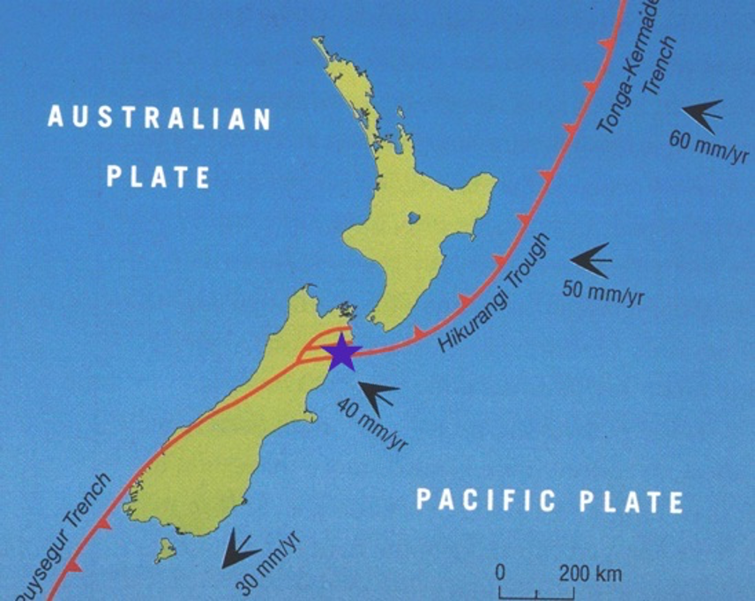

Question/Prompt | Your Response
What type of plate boundary most likely exists at the purple star?
Is there likely to be subduction at the site of the purple star? Why or why not?
What type of fault would you expect to find at the site of the purple star?
Could this fault type create land uplift?
How long would it take for uplift to occur?

