Name: | [insert name] | Period: | [insert Period] | Date: | [insert date]

Food Web Simulation

Background
Ecosystems are a complex and delicate balancing game. The addition or removal of one species affects many other species with which it might compete for, or provide food.

In this lab, you will get the change to “build your own” ecosystem, and explore the effects of these interrelationships.

Understanding the Model
The simulation we will implement uses land species. See the image below, to see the trophic levels (predator, herbivore, etc.) and animals included.

- Edit the drawing below to show how this simulation relates to the marine ecosystems that include sharks.
  - Click on the image below and select “edit”. Then drag the marine species at the bottom over the appropriate trophic level. For example, a fish that eats only plants can be placed over the herbivores (the rabbit, snail, or deer)
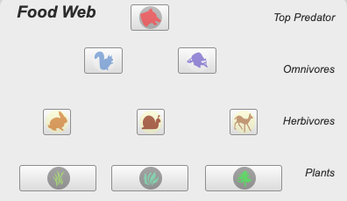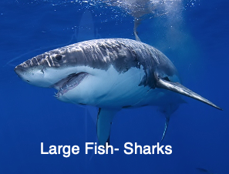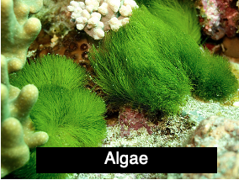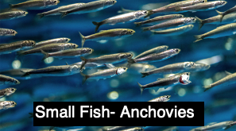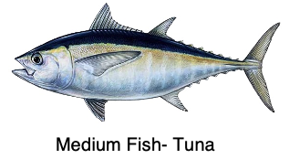

Using the Simulation

Part 1
The goal of this lab is to see how big you can make a food web and still have all of the species survive to the end of the simulation run. Our first part will focus on a simple food chain.

- Follow the link to Annenberg Learner’s Ecology Lab Simulation.
- This simulation shows the food web in the top left corner. We want to create a single food chain (from plant to top predator). The chain has already been started, but we need to create a line from the top predator to the omnivore. Do this by clicking on the top predator, then selecting “eats Omnivore A”.
- Make a prediction below as to whether each species will survive and whether it will increase or decrease in number. Indicate extinction with an “X”, population increase with a “↑”, and a population decrease with a “↓”.
- Select “Run” to advance the simulation 100 days. You can do this manually stepwise by selecting “Step”.
- Record the population at 0 and 100 days in the table below. Hold your cursor over the line colored line for each species to see the coordinate points (days since start, # of species).
- Indicate the overall change for the species in the table below.

Part 1:  Food Chain | Prediction  (X, ↑, ↓) | Population at 0 days | Population at 100 days | Overall change  (X, ↑, ↓)
Plant A | [Answers are intentionally BLUE]
Herbivore A
Omnivore A
Top Predator

Data Analysis
Answer the questions below regarding Simulation Part 1.

Question/Prompt | Your Response
- Did any of the species increase in number? What could account for this increase? | [Answers are intentionally BLUE]
- Which species decreased in number and what might account for this decrease?

Part 2
Now that we see the interactions of populations in a simple food chain, we are going to try a more realistic scenario. This setup will allow us to experiment with what might happen in an ecosystem that is more like a web.
- Follow the link to Annenberg Learner’s Ecology Lab Simulation.
- Click the “All on” button.
  - This model will show each organism eating everything below it that satisfies its diet. For example, the top predator will eat all omnivores and herbivores and the omnivores will eat all omnivores, herbivores, and plants.
- Make a prediction below as to whether each species will survive and whether it will increase or decrease in number. Indicate extinction with an “X”, population increase with a “↑”, and a population decrease with a “↓”.
- Select “Run” to advance the simulation 100 days. You can do this manually stepwise by selecting “Step”.
- Record the population at 0 and 100 days in the table below. Hold your cursor over the line colored line for each species to see the coordinate points (days since start, # of species).
- Indicate the overall change for the species in the table below.

Part 2:  Food Web | Prediction  (X, ↑, ↓) | Population at 0 days | Population at 100 days | Overall change  (X, ↑, ↓)
Plant A | [Answers are intentionally BLUE]
Plant B
Plant C
Herbivore A
Herbivore B
Herbivore C
Omnivore A
Omnivore B
Top Predator

Data Analysis
Answer the questions below regarding Simulation Part 2.
Question/Prompt | Your Response
- What differences were there between your prediction and the simulatoin? | [Answers are intentionally BLUE]

Part 3
- Select “Reset” and remove the top predator from the food chain. Do this by selecting the top predator, and unselecting all of the options. There should be no lines coming from the top predator to another species in the web.
- Again, “run” the simulation for 100 days.
- Record the population at 0 and 100 days in the table below. Hold your cursor over the line colored line for each species to see the coordinate points (days since start, # of species).
- Indicate the overall change for the species in the table below.

Part 3:  Food Web- no top predator | Prediction  (X, ↑, ↓) | Population at 0 days | Population at 100 days | Overall change  (X, ↑, ↓)
Plant A | [Answers are intentionally BLUE]
Plant B
Plant C
Herbivore A
Herbivore B
Herbivore C
Omnivore A
Omnivore B
Top Predator

Data Analysis
Answer the questions below regarding Simulation Part 3.
Question/Prompt | Your Response
- What effect does the removal of a top predator have on the simulation’s ecosystem? | [Answers are intentionally BLUE]
- How does this data compare with the information provided about the effects of shark finning?

Part 4
Now that you have seen the food chain play out in the simulation, you are going to try to modify who eats whom in order to ensure the survival of all species.
- Make modifications to the food web, by changing who eats whom.
- Take a screenshot of your new food web and past it below, or note the changes that were made from “all on”.
- Run the simulation and record your results below.

Part 4: Modifying the Food Web
Modifications Made | [Answers are intentionally BLUE]
 | Population at 0 days | Population at 100 days | Overall change  (X, ↑, ↓)
Plant A
Plant B
Plant C
Herbivore A
Herbivore B
Herbivore C
Omnivore A
Omnivore B
Top Predator

Data Analysis
Answer the questions below regarding Simulation Part 3.
Question/Prompt | Your Response
- Were you able to modify the parameters so that each species survived? Explain how you decided what changes to make. | [Answers are intentionally BLUE]

