Name: | [insert name] | Period: | [insert Period] | Date: | [insert date]

Realistic Effects of Shark Finning

Background
An important part of conservation is understanding how different species interact with one another. Sharks are very important in balancing different species of ocean creatures and plants.

In this activity, you will use real scientific research to describe the relationship between sharks, seagrass, and sea turtles.

Real-World Research
Michael Heithaus and his team of researchers work at the Florida International University and study predator-prey interactions. In one study, Heithaus and his team have found that work done to improve sea turtle populations has helped to keep seagrass from over growing and restricting oxygen levels in the ocean sediment. They also found that in regions where there is overfishing of sharks, the populations of sea turtles could grow beyond historical sizes and have the possibility to trigger detrimental ecosystem changes.

In this specific study, the researchers compared seagrass heights in Western Australia and Lakshadweep, India. Western Australia has stable turtle populations (not rapidly growing or declining) and also high shark populations. Meanwhile, India has high and rapidly increasing turtle populations and the shark populations are reduced. See the graph below to see how the locations compare. Make note that for both sites the control group is the ungrazed land that was covered to prevent turtles from eating it. This shows us how tall the grass grows without turtles present. See the data below to see how the locations compare then answer the questions on the next page.

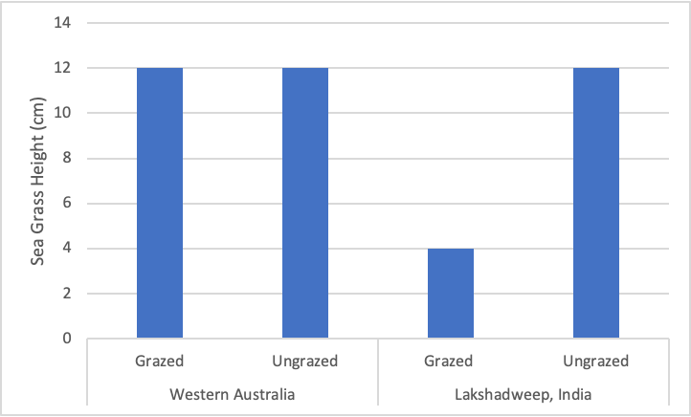

Data Analysis
Using the provided information and data, answer the following questions.

Question/Prompt | Your Response
- Explain the relationship between sharks, sea turtles, and seagrass. | [Answers are intentionally BLUE]
- Explain how the grazed and ungrazed seagrass in Australia can have the same height.
- How does the shark population affect the growth of seagrass in India?

Data adapted from Heithaus, M., Alcoverro, T., Arthur, R., Burkholder, D., Coates, K., & Christianen, M. et al. (2014). Seagrasses in the age of sea turtle conservation and shark overfishing. Frontiers In Marine Science, 1. doi: 10.3389/fmars.2014.00028

