Name: | [insert name] | Period: | [insert Period] | Date: | [insert date]

What’s going on?

Background
New Zealand is an island country south east from Australia. Satellite imagery shows the tourist town of Kaikoura. Kaikoura is a coastal town known for its abundant wildlife. The images below show the satellite view of the town in 2010 and again in 2016. These images were taken from satellites orbiting the Earth. Around the coast of the peninsula in 2016, more white can be seen. This is exposed land that had previously been underwater. The white color comes from the calcification of underwater organisms like sea snails and crayfish that were stranded well above the high tide level. Sometime between the two photos, the land had been lifted up to 7 feet.

Satellite Images

Kaikoura 2010
Kaikoura 2016

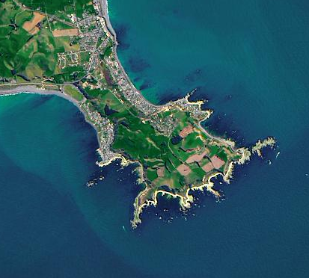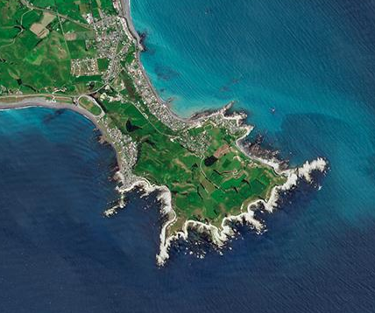

Asking Questions
Discuss with your class the questions you have about the land being lifted in Kaikoura.

