Name: | [insert name] | Period: | [insert Period] | Date: | [insert date]

What’s going on?

Background
Astronomers around the world regularly take pictures of the night sky to help us understand where the Earth is in relation to other stars, planets, and planetary objects. Generally, these pictures are taken at night, when we have the best view of the stars and planets but sometimes can be taken during the day as well.

Two scientists, one from South America’s Chile and one from Idaho, USA, have the job of taking photos of the moon everyday when it is at its highest in the sky. They both noticed an interesting trend in the behavior of the moon where it seemed to disappear and then come back. On the day that the moon seemed to have vanished completely, they also noticed a very weird event in the middle of the day that caused the sky to get dark. It happened about mid-day and they noticed that it started to get dark like it does in the evening even though it was still early afternoon. Then the sun turned dark and caused the whole area to go into what seemed like a night time darkness. Then within minutes the sun was back again. The next day, the moon started to come back as if nothing had happened.

See the next following pages for the images they took, and the timeline of events. There is a short gif of the weird event in both locations. Be sure to watch both all the way through.

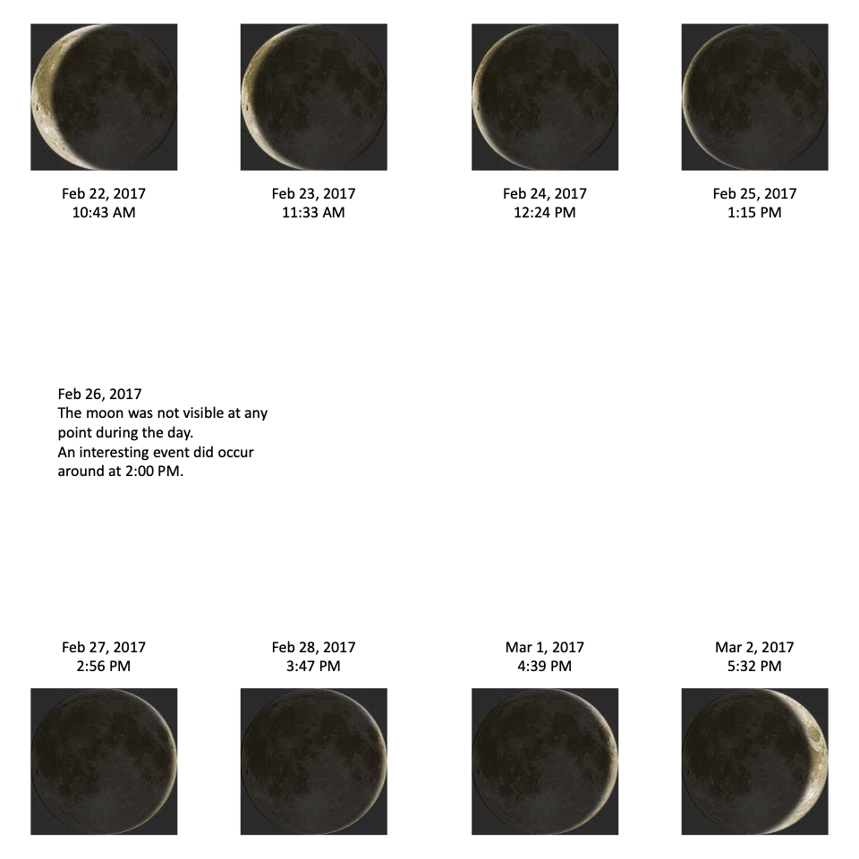
Chile- February 2017

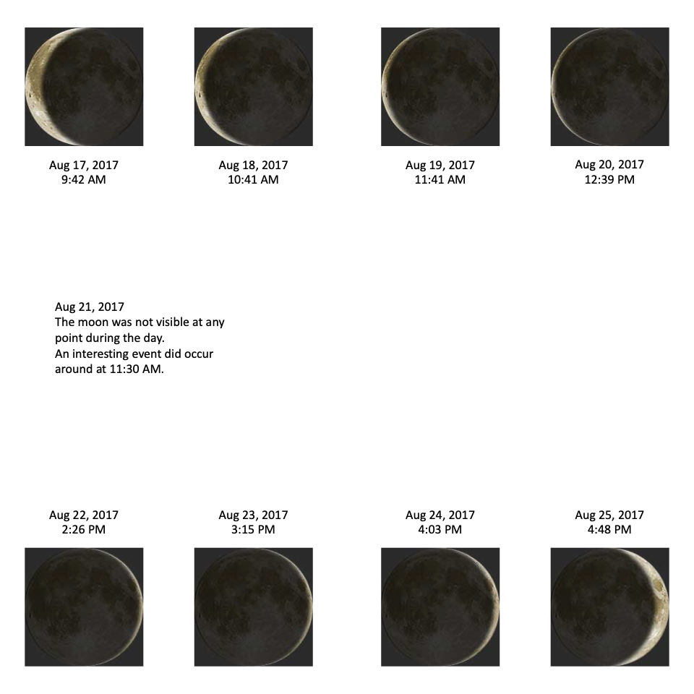
Idaho- August 2017

Asking Questions
Discuss with your class, the questions you have about what happened to Chile and Idaho in 2017.

