Background
The LacZ gene is one of the most studied and useful gene in molecular biology. It played a central role in the development of the model for regulation of gene expression and is one of the fundamental tools in biology to understand when and how genes are turned on.
The LacZ gene codes for the enzyme β-Galactosidase and serves a basic biological role in breaking down the sugar lactose. The enzyme cleaves lactose into galactose and glucose that the E.coli can then use as a source of energy in cellular respiration. It also converts lactose to allolactose, which then leads to repression of the Lac operon, and an increase in expression of β-Galactosidase. This positive feedback loop was one of the first demonstrations of a gene regulatory loop. Discovered by Francois Jacob and Jacques Monod, it demonstrated how a cell “knows” when to synthesize enzymes during metabolism.
Question: What will happen if we disrupt the function of the LacZ gene in E.Coli using Crispr/Cas9?

Part 1: Transformation of Bacterial with CRISPR Plasmid
In this experiment, you will be working with a strain of E.coli called HB101-pBRKa . This strain has been engineered to express Cas9 protein as well as plasmid that expresses enzymes needed for homology-directed repair (HDR).
E. coli does not express the necessary machinery for HDR so when Cas9 cleaves the DNA, it cannot repair the DNA properly. Therefore, the cells have already been transformed with a plasmid that contains genes that encode for HDR enzymes under the control of an arabinose inducible promoter. When arabinose is present, HDR proteins are made and the cells can repair their DNA

Starter Plates
Each group has a set of two starter plates
Starter  Plate | Plate  Additives | Bacterial  Colony Color | Cas9 | DNA Repair  System | sgRNA | Donor  Template DNA
IX | IPTG, X-gal | Blue | + | OFF | – | –
IX/ARA | IPTG, X-gal,  arabinose | Blue | + | ON | - | -

- Why are the colonies on these plates blue?

- Make a prediction: How will colonies from these different plates differ in their ability to undergo gene editing.

I predict that…

Our Plasmids
We will be transforming the E. coli with one of two plasmids:
- pLZDonor — (control) includes a donor template DNA sequence that will be used by the HDR machinery to fix double-stranded DNA breaks. The donor template DNA includes an insertsequence, which will be inserted into the lacZ gene and impair its function

- pLZDonorGuide — includes both the donor template DNA sequence from pLZDonor and a sequence that codes for the sgRNA. Once transcribed, the sgRNA will direct Cas9 where to cut lacZ
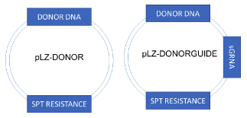

Materials

- Starter plates (IX, IX/ARA)
- Four unused agar plates
- Incubator
- Plasmid samples (pLZDonor (pD), pLZDonorGuide (pDG))
- Transformation solution (TS)
- LB nutrient broth
- 1.5 mL Microcentrifuge tubes
- Inoculating loops
- Micropipette (p50)
- Micropipette tips (1-200 µL)
- Heat block
- Ice
Sample | Bacteria  Source | Plasmids | Cas9 | DNA Repair System | Added plasmid? | Predicted Change
A | IX | pLZDonor (pD) | + | OFF
B | IX | pLZDonorGuide (pDG) | + | OFF
C | IX/ARA | pLZDonor (pD) | + | ON
D | IX/ARA | pLZDonorGuide (pDG) | + | ON

Procedure
1. Label FOUR microcentrifuge tubes A-D and place on ice
2. Add 250 µL of transformation solution (TS) to each tube
3. Using a sterile tip, pick three to five colonies from the IPTG/X-gal (IX) plate. Swirl the tip in tube A for at least 1 minute until all bacteria are dispersed in the solution. Immediately place tube back on ice.
4. Repeat STEP 3 for tube B

5. Using a new sterile tip, pick five colonies from the IPTG/X-gal/Ara (IX/ARA) plate. Swirl the tip in tube C for at least 1 minute until all the bacteria are dispersed in the solution. Immediately place tube back on ice.
6. Repeat STEP 5 for tube D.
7. Add 10 µL pLZDonor (pD) plasmid to tube A. Close the tube, flick the tube three times to mix, and place on ice.
8. Repeat STEP 7 for tube C.
9. Add 10 µL pLZDonorGuide (pDG) plasmid to tube B. Close the tube, flick three times to mix, and place on ice.
10. Repeat STEP 9 for tube D.
11. Let samples stay on ice for 10 minutes.
12. Bring samples to 60℃ heat block. Place tubes in heat block for exactly 50 seconds.
13. Remove samples and place quickly on ice. Let sit for 2 minutes
14. Add 250 µL LB nutrient broth to each tube. Close each tube and gently flick three times to mix.
15. Let sit at room temperature for 20 minutes.
16. While your cells are recovering, label your agar plates A-D with your initials and the date. Your agar plates contain IPTG, X-gal, and the antibiotic spectinomycin.
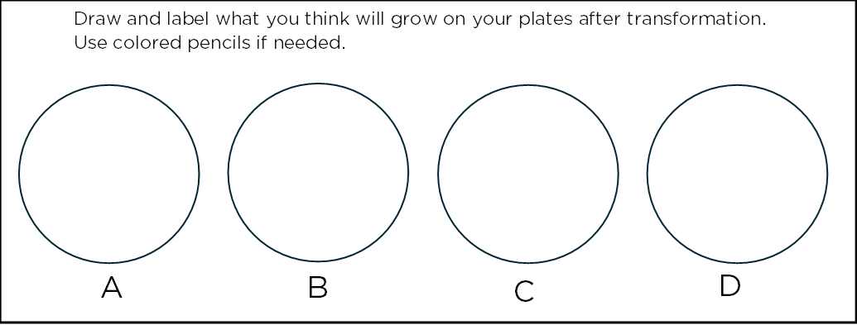

17. Gently flick tube A to resuspend the bacteria and transfer 100 µL of sample A onto plate A.
18. Use a sterile spreader to disperse bacteria across the top of the agar.
19. Repeat for samples B-D.
20. After 5 minutes, stack, tape, and label your plates and place upside down in 37°C incubator for 24 hours
RESULTS: Use this space to write out your results section. Be sure to provide evidence or data to support your claims. Questions you should answer:
- Did you see evidence of the lacZ gene having been cut by Cas9? On which plates?
- Which plates also show evidence of the DNA cut having been repaired using HDR and the donor?
- If you have any unexpected results, list them here and provide a hypothesis for how they occurred.

____________________________________________________________________________________________________________________________________________________________________________________________________________________________________________________________________________________________________________________________________________________________________________________________________________________________________________________________________________________________________________________________________________________________________________________________________________________________________________________________________________________________________________________________________________________________________________________________________________________________________________________________________________________________________________
________________________________________________________________________________________________________________________________________________________________________________________________________________________________________________________________________________________________________________________________________________________________________________________________________________________________________________________________________________________________________________________________________________________________________________________________________________________________________________________________________________________________

Part II: Confirming our CRISPR Knockout
DNA Extraction
To be able to analyze the sequence of DNA, it requires the isolation of an organisms’ DNA away from all the other parts of the cell. This process is called DNA extraction. This chemical process separates the lipids and proteins away from DNA. This is important because cells contain enzymes called DNAses that will degrade DNA if they aren’t removed. Additionally, most of the excess cell matter just gets in the way and blocks the ability to due downstream analysis and reactions.
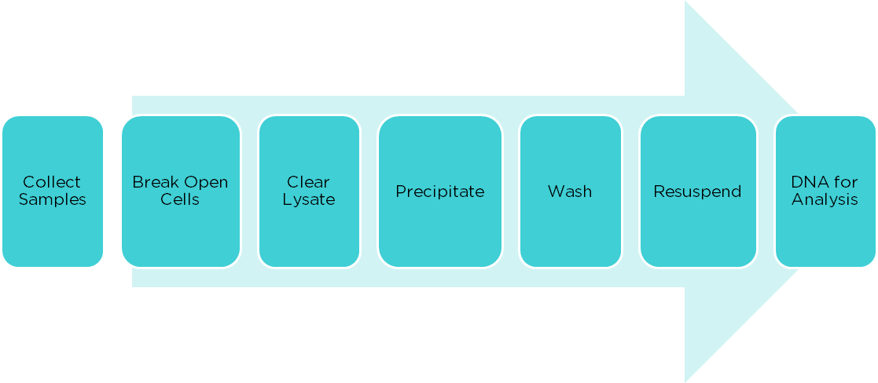
Typical DNA extraction works in a few basic steps:

- Using what you know about cell structure, brainstorm some ways we can break them open. Hint: What surrounds the cell/nucleus? What is it made of?

The next steps are precipitating out the DNA by changing the levels of salts. When high levels of salt are added, the cell debris and proteins precipitate out and separate from nucleic acids. Then alcohol, usually isopropanol or ethanol, is added to precipitate the DNA.

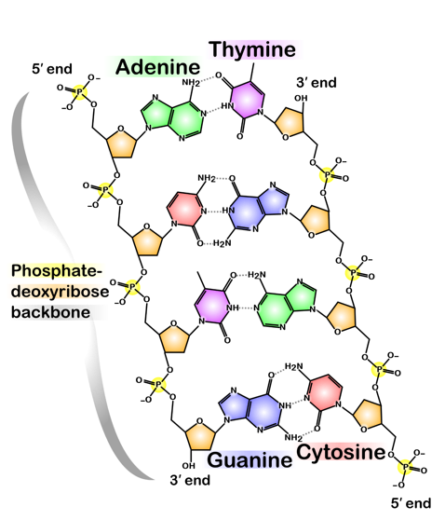
- Look at the figure of DNA. Why do you think we use alcohol to precipitate DNA from aqueous solutions? What part of the structure plays a role?

This is a long multi-step process that can lead to loss after each step. When you need results fast, such as when studying infectious diseases or in forensics, this also isn’t the most efficient method. Therefore, for our DNA we are going to use a resin called Chelex100. This
resin binds nucleases, proteins, and metals that can inhibit
PCR reactions, allowing you to get high quality DNA without precipitation.

Materials

- Screw-cap tubes
- Vortexer
- Centrifuge
- DNA Binding Matrix (IG)
- Heat Blocks at 56℃ and 95℃
- Micropipette (p1000)
- Micropipette tips (100-1000 µL)

Procedure
1. Label four screw-cap tubes S (for starter plate), C, D1, and D2. Add your initials.
2. Resuspend the matrix (IG) by gently flicking the tube and then add 250μl to your 4 screw top tubes
3. Use a sterile pipette tip to select a single blue colony from the starter plate. Swirl it in tube S.
4. Use a new pipette tip to pick a single blue colony from the C plate. Swirl the pipet tip in tube C.
5. Use a new pipette tip to pick a single white colony from plate D and swirl into tube D1.

6. Repeat step 5 for tube D2
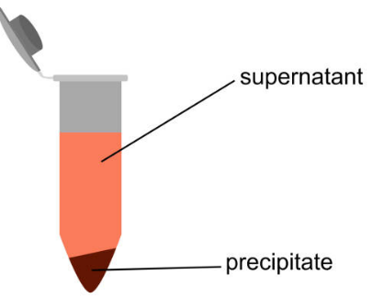
7. Close caps completely and vortex for 10 seconds.
8. Incubate tubes at 56℃ for 15 minutes
9. Vortex tubes for 10 seconds
10. Incubate tubes at 95℃ for 8 minutes.
11. Centrifuge tubes at 12,000g for 2 minutes
12. While the tubes are spinning, label 4 new tubes S, C, D1, D2,
13. Transfer the supernatant to the new tubes, avoiding the resin.

Part 3: PCR Verification of DNA editing
When we looked at our transformation plates for whether or not LacZ function was knocked out, we looked for blue or white colonies. This is looking at the phenotype of a reaction. However, using this method we can only know if we removed the function of the LacZ gene but not that we created the gene edit that we desired. It is possible that there were off target effects that disrupted the function of the gene in unwanted ways, or the DNA cut repaired without the donor being added. Therefore, we will need to look at the DNA sequence to determine what happened at the genome level.
For absolute confirmation we would send out our DNA to be sequenced, however with so many transformants, we want to narrow down to the most likely candidates using Polymerase Chain Reaction or PCR.
PCR is the process of duplicating a small piece of DNA repeatedly in order to create millions of copies. It is based on the process of DNA replication. When a cell divides into two, it needs to create two identical copies of DNA, one for each daughter cell. Cells contain enzymes called DNA polymerases that work in concert with other proteins to create the two copies of DNA. PCR technology takes advantage of the abilities of DNA polymerases to copy DNA but puts it an in vitro setting.

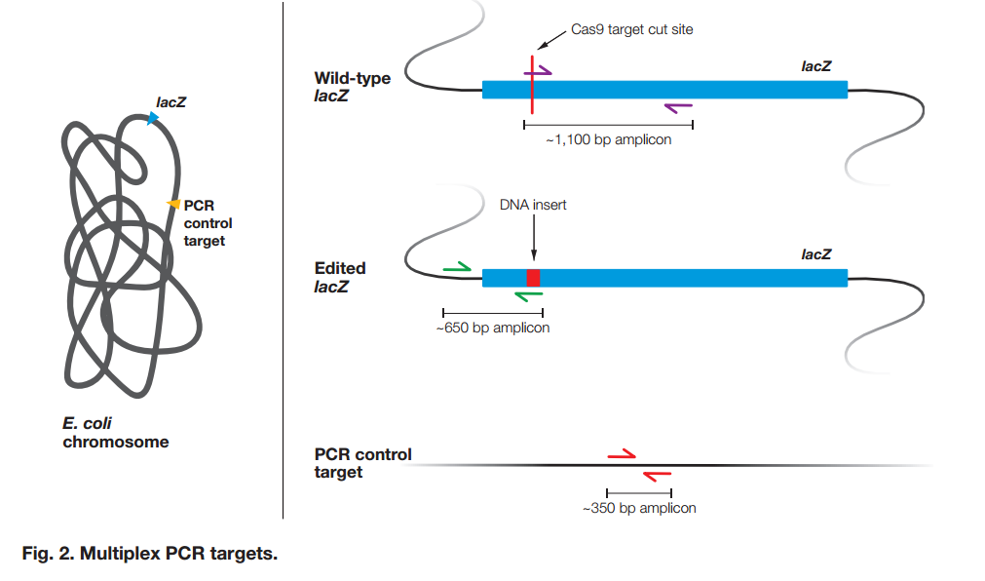
Figure from BioRad CRISPR PCR Extension Student Workbook
To identify if we correctly cut the DNA and inserted the donor sequence, we are going to use multiplex PCR. Multiplex PCR is when you use multiple pairs of primers in one PCR reaction.

- The first primer set is designed to detect unmodified lacZ. One primer in the set will bind directly to the Cas9 target cut site. If the target cut site was modified, the primer will not bind. If the target Cas9 cut site was NOT modified, then this primer set will yield a ~1,100 bp amplicon
- The second primer set is designed to detect modified lacZ. One primer in the set will bind to the insert from the donor template DNA. If the target cut site was successfully repaired using the donor template DNA that was introduced to the bacteria, then this primer set will yield a ~650 bp amplicon
- A third set of primers will amplify an unrelated region far downstream of the lacZ gene as a control to verify that chromosomal DNA is present in the sample. If chromosomal DNA was successfully extracted and PCR was successful, whether lacZ was modified, then this primer set will yield a ~350 bp amplicon

Materials

- PCR tubes
- Master mix + primers
- DNA samples
- Thermocycler
- Micropipette (p10)
- Micropipette tips (1-10 µL)

Procedure
1. Label 6 PCR tubes for your procedure: S, C, D1, D2, +, and - .
2. Use the chart below to make up your reactions:
PCR Tube | Master Mix + Primers (MMP) | DNA Sample
S | 10 μL | 10 μL S
C | 10 μL | 10 μL C
D1 | 10 μL | 10 μL D1
D2 | 10 μL | 10 μL D2
+ | 10 μL | 10 μL Pos Control
- | 10 μL | 10 μL H2O

- Place your tubes in the thermocycler and Run CRISPR Protocol.

CRISPR PCR Protocol
Initial denature 94°C 5 min
Denature 94°C 30 sec
Anneal 62°C 30 sec
Extend 74°C 1 min
Repeat for 35 cycles

Final extension 74°C 5 min
Hold 4°C

Source Plate | Colony  appearance | lacZ Gene Status | 1,100 bp | 650 bp | 350 bp
IX/ARA plate
(starter plate)
Plate C
Plate D
Table 1: Predicted Results of Multiplex PCR

Predictions:
- If only a 350 bp amplicon were produced in a particular sample, what could you conclude about the lacZ gene in that DNA sample?

- If the 350 bp amplicon was not present in the results for a particular sample, what could be an explanation? What additional information could confirm your explanation?
Part 4: Gel Electrophoresis of Results
Materials

- 1X TAE
- Agarose
- Gel Red/Green
- Loading dye
- DNA ladder
- Electrophoresis equipment
- UV transilluminator/Blue Light

Make A Gel
1. Mix 1% TAE gel in 100mL flask
- 30 mL 1X TAE
- 0.3 g Agarose
- Microwave and shake for 30-60 seconds or until agarose is fully dissolved
- When agarose mixture is no longer hot (around 60C), add 3μl of Gel Red(Green)
3. Pour into prepared gel tray with comb at top of gel

Run the Gel
Sample | Well #
1. Remove samples from PCR machine
2. Add 5μL of loading dye with DNA stain to each sample
3. Add 10μL of DNA ladder in well 1
4. Load 20μL of each sample into the next six wells. Enter which samples are in which well into the provided chart.
5. Run gels for about 20 minutes or until bands separate
6. View results on UV transilluminator or Blue Light
7. Draw out your results in the table below.

Results
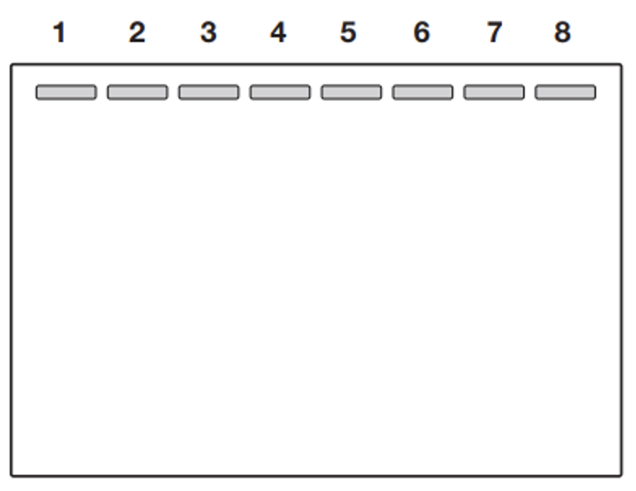

Conclusions
- Did any of your colonies show excision at the LacZ gene? If so, provide evidence of how you know.

- Look back at Table 1. Do your results agree with your predictions? If they don’t provide reasoning to explain what you see.

- Use remaining space to make a claim(s) about the role of CRISPR gene editing in modifying the lacZ gene in bacteria grown on experimental plates C and D. Include evidence from both your bacterial transformation and multiplex PCR experiments. Make sure you make your claim NOT on your predictions but based on your experimental results.

Things to remember:
What can you claim or not claim?
With what data can you support your claim?
Are there any alternatives to explain your data?
__________________________________________________________________________________________________________________________________________________________________________________________________________________________________________________________________________________________________________________________________________________________________________________________________________________________________________________________________________________________________________________________________________________________________________________________________________________________________________________________________________

____________________________________________________________________________________________________________________________________________________________________________________________________________________________________________________________________________________________________________________________________________________________________________________________________________________________________________________________________________________________________________________________________________________________________________________________________________________________________________________________________________________________________________________________________________________________________________________________________________________________________________________________________________________________________________________________________________________________________________________________________________________________________________________________________________________________________________________________________________

